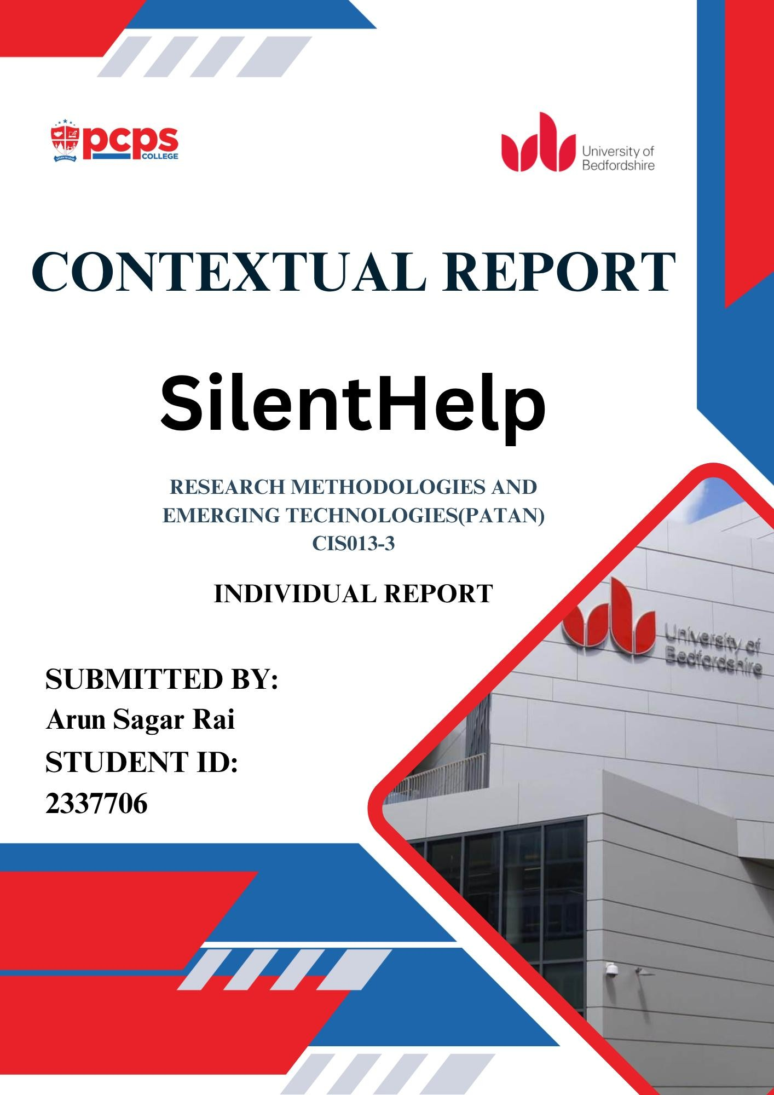

1

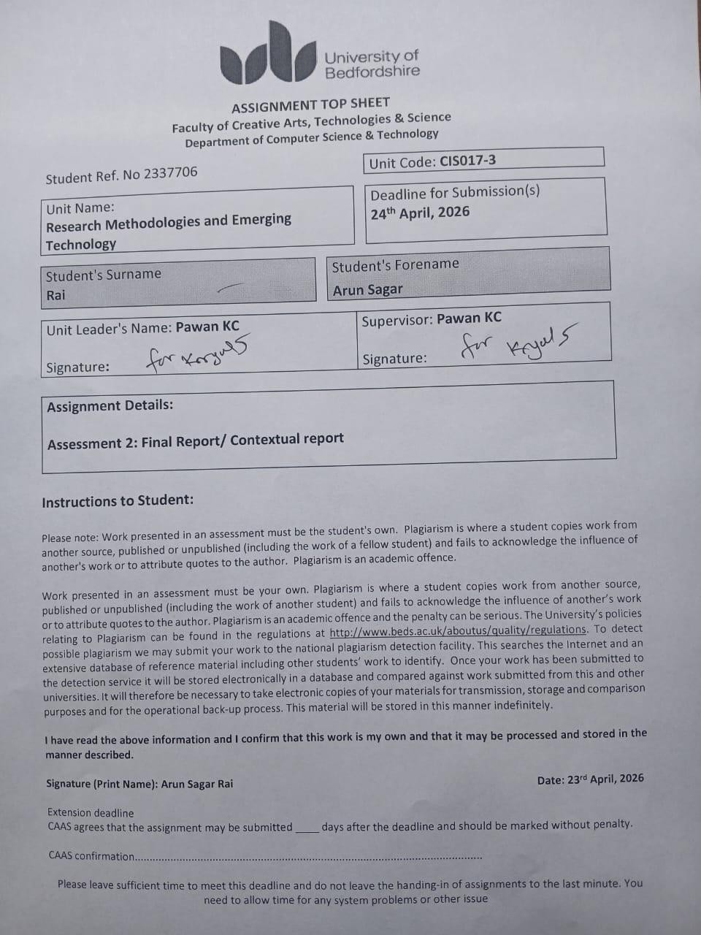
Project Name: SilentHelp

University ID: 2337706

Name: Arun Sagar Rai

2

ABSTRACT
SilentHelp is an app that helps people in emergency situations. It is designed to be very quiet and secret, so people can use it when they need help but cannot talk loudly or make a normal emergency call. The people who made SilentHelp want to help individuals who are in danger from someone they know, like someone who is being hurt at home or followed by someone. SilentHelp does not look like an emergency app; it looks like a normal calculator on the phone. It has special ways to send emergency messages, like typing secret codes into the calculator, shaking the phone or using voice commands (Organisation, 2024). When someone uses one of these ways to send a message, the app sends a help message (Anon., n.d.) to the chosen people, along with the user's location (Anon., n.d.). The people who made SilentHelp want to make sure the SilentHelp app is safe, something you can count on and easy to use. They want the SilentHelp app to be simple so you can use the SilentHelp app when you need it. SilentHelp is being made with tools called Flutter and Firebase, so it will work on Android phones (Anon., n.d.). The goal of SilentHelp is to help people stay safe without putting them in danger. SilentHelp is a tool that can really help people in bad situations. SilentHelp will make a difference in people's lives by providing them with a safe way to get help when they need it (Organisation, 2024).

ACKNOWLEDGEMENT
They gave me the encouragement. Help, I needed to keep going. My supervisor also gave me feedback that made my work better. Thanks to them, I could. Make my work better. I am grateful to my supervisor for their help. My supervisor supported me. I got the help I needed. They checked my work. Told me how to improve. I am very grateful. I couldn't have done this project without the instructors from the BSc (Hons)
Software Engineering program. They showed me what I had to learn. My family and friends helped me too. They inspired me. They gave me ideas. Feedback. Support. My supervisor, the lecturers of the BSc (Hons) Software Engineering course and my family and friends all helped me. I am thankful to the Software Engineering course lecturers, my supervisor, my family and friends for their help. Thus, I am pleased to take this opportunity to thank everyone who assisted me with the completion of my final year project, SilentHelp. I want to thank the BSc (Hons) Software Engineering course lecturers for their help. I also want to thank my family and friends for their support. I want to thank my supervisor again for all that they did for me. I am grateful to everyone who helped me with this project, including the people who gave me ideas and feedback and the people who supported me in various ways.
Arun Sagar Rai
10 April 2026

Table of Contents
ABSTRACT ...................................................................................................................................................... i
ACKNOWLEDGEMENT ................................................................................................................................... ii
Table of Figures........................................................................................................................................ vi
List of Tables .......................................................................................................................................... viii
Chapter 1 – Introduction .............................................................................................................................. 1
1.1 Background .................................................................................................................................. 1
1.2 Problem Statement ....................................................................................................................... 2
1.3 Proposed Solution ........................................................................................................................ 2
1.4 Aim and objectives ...................................................................................................................... 3
1.5 Scope ........................................................................................................................................... 4
1.6 Intellectual challenge ................................................................................................................... 4
1.7 Rationale ...................................................................................................................................... 5
1.8 Contribution ................................................................................................................................. 6
1.9 Structure of Thesis .............................................................................................................................. 7
Chapter 2- Literature Review (LR) ....................................................................................................... 8
2.1 Overview/Background ................................................................................................................. 8
2.3 Literature Review ................................................................................................................................ 8
2.3.1 Discrete Emergency Alert Apps ................................................................................................... 8
2.3.2 Domestic Violence and Safety ..................................................................................................... 9
2.3.3 Personal Safety Applications ...................................................................................................... 10
2.3.4 Violence Against Women ........................................................................................................... 11
2.3.5 Mobile Health ............................................................................................................................. 12
2.3.6 Emergency Response Systems ................................................................................................... 13
2.3.7 User-Centred Design .................................................................................................................. 13
2.3.8 Privacy and Data Security .......................................................................................................... 14
2.3.9 Location-based services (LBS) .................................................................................................. 14
2.3.Sensor ............................................................................................................................................ 15
2.3.11 Human ...................................................................................................................................... 15
2.3.12 Agile Development ................................................................................................................... 16
2.3.13 Computer Technology Application .......................................................................................... 17
2.3.14 Methods of Discrete Communication ...................................................................................... 17
2.3.15 Mobile Application Security Frameworks ............................................................................... 18
2.3.16 Android Operating Systems ..................................................................................................... 18
2.3.17 Real-Time Communication Systems ........................................................................................ 19
2.3.18 Cloud Computing in Mobile Applications ............................................................................... 20
2.3.19 Usability in Safety-Critical Systems ........................................................................................ 20
2.3.20 False Trigger Detection and Error Handling ............................................................................ 21
2.3.21 Ethical Issues in Safety Applications ....................................................................................... 22 2.5 Justification ....................................................................................................................................... 22
Chapter 3- Primary Research ...................................................................................................................... 27
3.1 Objective of primary research ........................................................................................................... 28
3.1.1 Market Research (existing products) .............................................................................................. 29
3.2 Survey questionnaire ......................................................................................................................... 31 3.3 Data collection and analysis .............................................................................................................. 37
Chapter 4 – Project plan ............................................................................................................................. 49
4.1 Gantt chart- Semester 1, Semester 2 ................................................................................................. 49
4.2 Risk Analysis ..................................................................................................................................... 51 4.3 Workflow diagram ............................................................................................................................. 52
Chapter 5- Artefact planning ...................................................................................................................... 53
5.1 Requirement Analysis ....................................................................................................................... 53
5.1.1 Functional Requirement ............................................................................................................. 54
5.1.2 Non-functional Requirement ...................................................................................................... 55
5.2 Software Requirement ....................................................................................................................... 56
5.3 Hardware Requirement ..................................................................................................................... 56
5.4 Feasibility Study................................................................................................................................ 57
5.5 System Architecture .......................................................................................................................... 59
5.4 System Design ................................................................................................................................... 61
5.4.1 Use case ...................................................................................................................................... 63
5.4.2 ERD ............................................................................................................................................ 65 5.4.3 Activity Diagram ........................................................................................................................ 66
Chapter 6- Quality Assurance Evaluation ................................................................................................... 67
6.1 Testing Strategy/ plan ........................................................................................................................ 67
6.1.1 Test Cases ................................................................................................................................... 67 6.2 Evaluation Strategy /Plan .................................................................................................................. 68
Chapter 7- Critical Analysis and Implementation Plan ............................................................................... 69
Chapter 8- Conclusion ................................................................................................................................. 71
References .................................................................................................................................................. 72
Appendix ..................................................................................................................................................... 76
Project Proposal (Scanned) ..................................................................................................................... 76
Ethics form (Scanned) ............................................................................................................................. 81
Gantt Chart Image ................................................................................................................................... 84
PRIMARY MARKET RESEARCH OUTCOMES ................................................................................ 85
Anything related to LR (Screenshot of relevant resources) .................................................................... 95
Survey form (questionnaire and the report) ............................................................................................ 98
Raw Data (All collected data that is not processed) ................................................................................ 98 Weekly reports (scanned weekly reports) ............................................................................................... 98
Raw Data (All collected data that is not processed) .............................................................................. 104 Weekly reports (Scanned Weekly reports) ............................................................................................ 113

Table of Figures
Figure 1: Flutter Logo ................................................................................................................................. 23
Figure 2: Dart Logo ..................................................................................................................................... 23
Figure 3: Android Studio Logo ................................................................................................................... 24
Figure 4: Firebase Logo .............................................................................................................................. 24
Figure 5: Figma Logo.................................................................................................................................. 25
Figure 6: GitHub Logo ................................................................................................................................ 25
Figure 7: Android Phone Logo .................................................................................................................... 26
Figure 8: Global Personal Safety App Market Image ................................................................................. 30
Figure 9: Survey Questionnaire1,2,3 .......................................................................................................... 31
Figure 10: Survey Questionnaire 4, 5, 6, 7.................................................................................................. 32
Figure 11: Survey Questionnaire 8, 9, 10, 11 .............................................................................................. 33
Figure 12: Survey Questionnaire 12, 13, 14................................................................................................ 34
Figure 13: Survey Questionnaire 15, 16, 17, 18 .......................................................................................... 35
Figure 14: Survey Questionnair 19, 20, 21, 22 ........................................................................................... 36
Figure 15: Data collection and analysis image 1 ......................................................................................... 37
Figure 16: Data collection and analysis image 2 ......................................................................................... 37
Figure 17: Data collection and analysis image 3 ......................................................................................... 38
Figure 18: Data collection and analysis image 4 ......................................................................................... 38
Figure 19: Data collection and analysis image 5 ......................................................................................... 39
Figure 20: Data collection and analysis image 6 ......................................................................................... 39
Figure 21: Data collection and analysis image 7 ......................................................................................... 40
Figure 22: Data collection and analysis image 8 ......................................................................................... 40
Figure 23: Data collection and analysis image 9 ......................................................................................... 41
Figure 24: Data collection and analysis image 10 ....................................................................................... 41
Figure 25: Data collection and analysis image 11 ....................................................................................... 42
Figure 26: Data collection and analysis image 12 ....................................................................................... 42
Figure 27: Data collection and analysis image 13 ....................................................................................... 43
Figure 28: Data collection and analysis image 14 ....................................................................................... 43 Figure 29: Data collection and analysis image 15 ....................................................................................... 44
Figure 30: Data collection and analysis image 16 ....................................................................................... 44
Figure 31: Data collection and analysis image 17 ....................................................................................... 45
Figure 32: Data collection and analysis image 18 ....................................................................................... 45
Figure 33: Data collection and analysis image 19 ....................................................................................... 46
Figure 34: Data collection and analysis image 20 ....................................................................................... 46
Figure 35: Data collection and analysis image 21 ....................................................................................... 47
Figure 36: Gantt chart- Semester 1 ............................................................................................................. 50
Figure 37: Semester 2 Gantchart Image ...................................................................................................... 51
Figure 38: Work Flow Diagram .................................................................................................................. 52
Figure 39: System Architecture ................................................................................................................... 59
Figure 40: System Design ........................................................................................................................... 61
Figure 41: Use Case Diagram ..................................................................................................................... 63
Figure 42: ERD Diagram ............................................................................................................................ 65 Figure 43: Activity Diagram ....................................................................................................................... 66

List of Tables
Table 1: Structure of Thesis .......................................................................................................................... 7
Table 2: Functional Requirements............................................................................................................... 54
Table 3: Non-Functional Requirements ...................................................................................................... 55
Table 4: Software Requirement ................................................................................................................... 56
Table 5: Hardware Requirement ................................................................................................................. 57
Table 6: Testing Strategy/ plan .................................................................................................................... 67
Table 7: Test Cases ...................................................................................................................................... 68
Table 8: Evaluation Strategy /Plan .............................................................................................................. 68
Table 9: Semester 1Implementation Plan .................................................................................................... 69
Table 10: Semester 2 Implementation Plan ................................................................................................. 70

Chapter 1 – Introduction
People are getting hurt in the world. It is a big problem. Some people are in situations like being hurt at home, or someone is following them, or they are being bothered, and they need help. They can really help us stay safe (Organisation, 2024). Our phones can show us where we are, and we can talk to people away. A lot of the apps that are supposed to help us in an emergency are easy to see, and we have to touch the screen to use them. This is not good if someone is trying to hurt us, and we need to be quiet. That is why we made SilentHelp. It is an app that looks like a regular calculator on our phone. So if someone is looking at our phone, they will just think it is a calculator. It has special things inside, like secret buttons, and we can even shake the phone to get help (Anon., n.d.). We can also talk on the phone to send a message to people we trust. We worked hard to make SilentHelp a good app (Anon., n.d.). SilentHelp is an idea, but it can really help people. SilentHelp is an app that helps people in situations, and it is very important for people who need it. SilentHelp can really make a difference in people's lives (Anon., n.d.). That is why I will make SilentHelp.

1.1 Background
Personal safety has become a significant factor in recent times, especially because of the rise in the number of occurrences of domestic abuse, harassment, and security threats. According to reports from all over the world, many people, especially women (Organisation, 2024), are in a difficult situation where they are unable to seek help in a timely manner because the perpetrators are keen observers of their victims, and sending a message or making a call could put them in a worse situation. Therefore, these people are in dire need of alternative communication tools (Dr Claudia García-Moreno, 2015).
As a result, conventional methods of responding to emergencies, for example, by contacting the police or other emergency services, are useful in many situations, depending on the ability of the person in question to communicate freely. In a similar vein, existing mobile safety apps have features that are immediately noticeable, for example, a panic button or alert button. Although these apps are useful, especially in situations where safety is a priority, they are limited in situations where discretion is a requirement. However, with the development of smartphone technology, a variety of features are now possible in contemporary smartphones, such as location tracking through GPS (Whipple et al., 2009), motion detection through accelerometers, and voice recognition through the use of a smartphone's microphone. This makes it possible to develop creative and hidden safety solutions. These features can be used for the development of solutions that enable users to seek help in a hidden manner.
The importance of user privacy, security, and ethical issues in the development of mobile applications is another factor that is becoming increasingly important in the development of applications in this field. Applications that deal with sensitive information, for example, contact information and location, should be able to handle these issues well, and therefore, a solution designed in this field should be able to achieve a balance between privacy and security features. The rationale behind the development of the SilentHelp solution lies in the resolution of these problems through the use of modern mobile technologies and hidden user engagement mechanisms. This represents a paradigm shift in software engineering, as context-aware and user-centric safety solutions are considered (Sommerville, 2016).

1.2 Problem Statement
Therefore, a person might not be able to seek help in an obvious manner in a number of situations related to domestic abuse, stalking, harassment, or other personal threats. Although a number of safety apps are currently designed for use on different smartphones, most of these apps are affected by the fact that they are based on an obvious SOS feature (Anon., 2021), mechanisms or direct user interaction, which makes them unsuitable for use in a stealthy and dangerous situation. This calls for the development of a stealthy and reliable support system in a way that a person in need of help can request support without drawing attention, as well as sending alarms and location information promptly to trustworthy contacts.

1.3 Proposed Solution
The project proposal of the SilentHelp is to create a discreet mobile application to enable users to request assistance in unrestrained conditions under high-risk situations, to address the constraints so that they may not alert an aggressor. SilentHelp is an application that exists on a mobile phone in the form of an ordinary calculator, such that it does not make one suspicious when using it every day. The application has various hidden emergency activation systems behind a simple interface, including patterned calculator input, phone shaking recognition, which uses the device accelerometer and optional voice activation (Sarkar et al., n.d.). They are made in such a way that they are easy, quick and easy to remember so that the users can make use of emergency help without attracting any attention to them. After the triggering, the application takes some steps in the background without any notice. Some of these include the real-time location of the user as determined by the GPS (Whipple et al., 2009) services and sending an alert message to the pre-defined trusted individuals. It is made to be efficient even when it is running in the background, so that alerts are delivered in a timely manner. The application is also dedicated to ensuring the user's privacy and the reliability of data because it safely deals with sensitive information like location data and contact details. The development of SilentHelp is based on the latest mobile technologies, such as Flutter to develop a cross-platform application and Firebase to support the back end, such as authentication and real-time communication. The design strategy is user-centred and modular in order to guarantee reliability, scalability and ease of use. The proposed solution, on the whole, is to offer a convenient, non-obtrusive and efficient emergency aid system that would improve personal security but reduce risk and be applicable in sensitive and dangerous environments.

1.4 Aim and objectives
Aims:
The vision behind the development of the SilentHelp app is to create a mobile application that helps users in calling for emergency help in critical conditions, all the while keeping the perpetrator unaware of the situation. In this regard, the app will be disguised in the form of a calculator and will be designed in such a manner that it does not arouse any suspicion in the perpetrator.
Objectives:
- The app will also have the feature of various secret emergency activation methods, including the calculator input sequence, the shake of the phone, and the use of voice activation.
- This way, the app will send emergency alerts to the user’s trustworthy network in no time.
- In addition to this, the app will also have the feature of sharing the location in real-time, thus allowing the emergency contact to locate the user’s location in no time.
- With the app’s keen focus on the safety and security of the user’s data, the development process will be focused on creating a simple and dependable mobile application that is best suited for the complexities of the real world.

1.5 Scope
The project called SilentHelp is intended to develop a covert emergency assistance app for Android smartphones. This app will resemble the look and feel of a typical calculator application, but it will also include features which will allow users to activate "emergency alerts" without being visible to others when in a dangerous or harmful situation. The application will have an intuitive interface to view and manage emergency contacts; hidden trigger mechanisms for alert activation using detected triggers such as shaking the phone and entering specific calculator input patterns; real-time location sharing; secure alerts sent only to trusted contacts; and more. The project will produce a fully functional prototype that effectively demonstrates primary safety functions within the application. Using the Flutter framework and Firebase DB, the prototype will be built with the Android Studio IDE. The testing of the app will take place on older, more accessible Android phones. Before we dive into why this is important, let’s take a step back and remind ourselves that the current version of this project is not compatible with iOS (Fernández-López, 2013) devices and does not give users the ability to communicate directly with police or emergency responders. The goal of this project is to provide anyone who may be facing an unsafe situation with a discreet and safe way to request help.

1.6 Intellectual challenge
The development of SilentHelp requires numerous intellectual challenges that involve careful problemsolving and advanced software engineering techniques. Finding a way to make the application look completely normal to users while still performing very important emergency tasks in the background is one of the biggest challenges of this work. To accomplish this desired level of usability and lack of visibility, a solid foundation of Human Computer Interaction (HCI) knowledge and well-thought-out User Interface (UI) design will be required.
This is difficult to accomplish, especially when creating a UI that is intuitive and easy for people to use in potentially sensitive and/or high-risk environments. Creating reliable hidden trigger mechanisms, such as gesture-based triggers and calculator input patterns, that do not interfere with the normal operation of the application will also be a major challenge on top of designing a successful application. This involves realtime data processing (including mobile device sensors), so that triggers are both accurate and responsive without the potential for false activations.
Further complicating matters, developers must take into consideration both the limitations of the hardware used to run the application and the battery that powers those devices, in order to achieve reasonable response times, should background processes (e.g., location tracking, emergency text messaging, etc.) need to be performed. Another significant intellectual challenge that exists when developing the SilentHelp application is to ensure the confidentiality and integrity of the data handled by the application. This is also where private information about the user, such as where the user is located and what emergency contacts they have, must be protected.
All of the information provided to the application will need to be securely transmitted and securely stored. Developers will have to show that they have an understanding of proper software development practices and safe data management technologies/methodologies. The end goal of the project is to combine multiple technologies into one reliable solution. The mobile application’s backend service will be Firebase, and the application used on mobile devices will be called Flutter. The technical design of a system will require proficient System Design (Graham C. Goodwin, 2000) skills to be able to integrate those technologies efficiently while ensuring interoperability between systems and providing scalability and maintainability of the entire system. Overall, this project will challenge developers to apply theoretical concepts learned in school to a practical application, as well as solve real-world safety issues through innovative and ethical systems design.

1.7 Rationale
SilentHelp was developed to address the need for an inconspicuous, reliable device to provide personal safety in dangerous situations where traditional methods of emergency response may only draw attention to the victim and potentially increase the level of risk (for example, if the victim is being subjected to domestic violence or abuse, or is being stalked or harassed). In many cases - especially those involving domestic violence or abuse - the ability to properly obtain emergency assistance does not match the need for assistance. SilentHelp serves as an emergency support device resembling a traditional calculator with covert means of generating alerts.
The development of the project is significant because it creates a functional device for personal safety by combining mobile technology, background services, location tracking, and controls based on user-centred design. Furthermore, the resulting device promotes privacy and usability, which are both essential in highrisk situations where seconds equal survival.
This project is relevant to software engineering as it employs technical expertise to solve a real-world social problem and serves as a valuable example of the application of secure data handling, sensor integration, mobile application development, and system architecture. These factors make SilentHelp an appropriate and worthwhile senior project with both scholarly and practical implications.

1.8 Contribution
Through the development of a covert emergency assistance smartphone app, the SilentHelp app creates a new field of engineering technology and life -personal safety technologies. Instead of using an obvious means to call for help, as is done with many up-front emergency calling applications, the SilentHelp App provides a means to provide assistance without being seen or heard. Therefore, the SilentHelp project also aims to design an emergency call system integrated with advanced technologies to be developed as a more contextually aware and user-focused redesign of the delivery of emergency services to users.
From a technical perspective, the SilentHelp project exemplifies how multiple technologies can integrate; i.e., developing a smartphone app that is a mobile application developed with Flutter technology, user interaction with sensors such as accelerometers, tracking user location in real time using GPS, and providing an app to connect with Consumers via Firebase. Demonstrate how various technologies can work together to provide a functional app continuously running in the background and to provide safety to users in emergency situations.
The project is also addressing major issues within the safety-critical application realm by addressing critical concerns about privacy, security, and usability. SilentHelp provides an all-inclusive, responsible and practical solution through effective management of sensitive data and easy-to-use engagement with endusers. Additionally, this research will serve as an educational resource as well as a model for future research and development of covert safety applications. This research promotes increased innovation within the realm of covert safety applications through an example of how software engineering principles can solve real-world problems that have a social impact.

1.9 Structure of Thesis
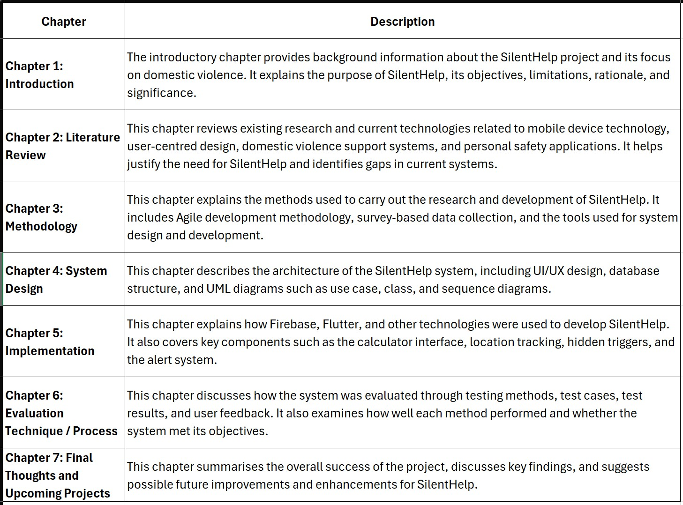
Table 1: Structure of Thesis

Chapter 2- Literature Review (LR)
The Literature Review (LR) portion of a thesis reviews the previous publications, books, articles, journals, and other reliable materials to assess what has been accomplished so far in regard to the topic. This section will assist in explaining the present state of affairs concerning domestic violence, hidden emergency systems, personal security applications, and weaknesses in current technologies through the SilentHelp project. It will also illustrate the need for this project and its contribution to prior advancements.

2.1 Overview/Background
Before moving on to more specific information, the Overview/Background section serves the purpose of giving the readers a general idea about the problem area being discussed, including why the need for emergency help software arose, what safety problems it addresses, and how the SilentHelp project can fit within the context of such issues.

2.3 Literature Review
The literature review of SilentHelp provides insight into the available knowledge concerning mobile technology, covert emergency services, personal safety apps, and domestic violence. It illustrates that despite the availability of many safety apps providing location tracking and alerting features, most remain visible and require active user interaction, which could be dangerous in threatening situations. The importance of user-friendly, reliable, and secure emergency applications has been highlighted in the literature review as well. The necessity for developing a covert calculator emergency app, such as SilentHelp, has been justified with the help of this literature review, and it also highlights the gap that exists in the alternative options.

2.3.1 Discrete Emergency Alert Apps
Silent emergency notification applications represent mobile platforms designed to help users send distress signals secretly, especially in cases where there might be intimate partner violence. Such apps often have hidden interfaces, such as calculator-based interfaces, or are sensor-activated, meaning that triggering them may involve actions such as shaking a phone or using a voice command (Mishra, 2016). According to the World Health Organisation, nearly one-third of all women across the globe experience violence, making it essential to have reliable, confidential mechanisms to seek help (Organization, 2024). Features which are common for such apps include panic buttons and GPS location. However, in some cases, it is possible that the process of activation can become too apparent, making the person feel awkward when using this option. While many apps allow users to locate themselves instantly, very few offer an opportunity to do this offline or discreetly. It is essential to consider numerous factors connected to technologies used for this purpose, the security of the data which would be sent and the convenience of the whole process while developing such software. On the one hand, the Android system (Anon., n.d.) does not allow background location permissions, and thus, it would be essential to gain them and work on the software development. On the other hand, it is necessary to mention that recent research has indicated that the use of such apps may cause problems connected to users' personal data protection, as many of them do not provide adequate security measures. To conclude, the development of a reliable, safe, and convenient app is not an easy task.
The literature is extremely useful for developing the SilentHelp because it impacts both the design and the development of this system. For instance, the concept of disguise used in creating the hidden interface can be utilised when designing a disguised user interface based on a calculator-like one, so that people will be able to operate the app discreetly. In addition, the concept of gesture and voice activation mentioned in the literature can be used in order to create different ways to turn on the emergency alerts. Moreover, the background tracking of the location of people can be implemented in the SilentHelp by using the APIs (Zhao, et al., 2022) for Flutter and Android. Real-time locations can thus be sent to the contacts of people when they find themselves in an emergency situation. At the same time, limitations in terms of battery usage and other issues need to be considered and taken into account. Furthermore, security practices, such as encrypted data transfer and data minimisation, should be employed in order to enhance users' privacy protection. Lastly, principles of usability should be applied in order to make sure that even during stressful situations, people would be able to send alerts to their contacts through the app.

2.3.2 Domestic Violence and Safety
Domestic violence is a major global issue affecting many people, particularly women and other vulnerable populations; it also presents a public health emergency and a human rights issue. There are a number of different kinds of violence that can occur in domestic violence (Johnson, 2005), including financial, emotional, psychological, and physical violence. Those who've experienced domestic abuse tend to be from the same household and often rely on their own network or friends for help. However, a number of reasons can hinder them from obtaining necessary support — including the victim's fear of the abuser, their fear of being believed, a social stigma attached to the abuse, and the abuser's controlling behaviour, which interferes with the victim's ability to ask for help appropriately. Traditional and formal methods of finding assistance, such as reporting a crime or calling 100, can be an obstacle as a result. Mobile safety apps offer potential solutions for those suffering as a result of domestic violence to get assistance through new ways of accessing help, such as by using their smartphones with features such as gesture-activated emergency alarms, real-time two-way conversations with an organisation/homeowner who has the app, and discreet notifications to contact a family member or friend in case of an emergency. These mobile safety apps may help provide greater safety for victims of domestic violence by providing timely assistance to enable those victims to obtain assistance from other domestic violence victims. Research supports that features such as immediate-response alerts and GPS (Whipple, et al., 2009) Tracking significantly reduces emergency response times. Therefore, developing a range of covert emergency alarm systems is essential to overcoming the existing limitations of traditional methods of obtaining help.
This literature is highly valuable when designing the SilentHelp system, since it provides guidance, both theoretical and practical, on how to develop a discreet approach to an emergency solution. Firstly, the idea of hidden communication techniques contributes to the development of hidden UI elements (Gargenta, n.d.) and trigger-based interface activation within the application. Secondly, functions such as location tracking, instant alert generation, and pre-written emergency messages could be applied based on the findings revealed by previous research. Moreover, knowledge about privacy and security concerns related to mobile applications can help create a reliable and trustworthy platform. This literature will be extensively used during both system design and implementation processes in order to ensure that SilentHelp will function effectively and meet real-world needs. The importance of this area of focus lies in the ability of these technologies to provide protection to a vulnerable population and improve emergency response systems through the combination of technological advancements and social good.

2.3.3 Personal Safety Applications
Mobile application personal safety apps (Dr. Sridhar Mandapati, n.d.) are applications that can be used to assist an individual when in a moment of threat, such as when faced with domestic violence or other forms of violence. Features found in personal safety applications include, but are not limited to, panic buttons, alert messages, and location sharing. Due to the sensitive nature of a victim's situation, there are times when the victim cannot speak openly, use an app that would be visible to another individual (such as a close friend), or contact help by telephone. According to the World Health Organisation, “Violence against women is a serious health and human rights issue for which there is insufficient political will, control, or hope.” (Organization, 2024)Several studies have shown that there is no widely accepted guideline or method of measuring violent preventative applications, and while many applications provide an alert to violence, the types of alerts and the information provided can vary. Additionally, some health and safety applications contain privacy issues because the manner in which an application handles data may leave a victim susceptible to having their personal whereabouts exposed to others. For these reasons, personal safety applications serve a very important purpose by providing a social, secure, user-friendly, and convenient means of receiving emergency assistance in a convenient manner through a mobile device. A knowledgeable user will be able to apply their mobile safety application in order to receive immediate, rapid and discreet assistance when they encounter dangerous situations.
SilentHelp may achieve its design goals with the help of written material that includes information on how to develop an effective and efficient system for use as an emergency response system that is both covert and easily operated by users in emergency situations. This research will allow the identification of areas where the system could be used and under what conditions. Some examples of the circumstances where there is likely no opportunity for an open conversation to take place would be where there is a history of domestic violence, stalking, or harassment. When using this material, it is also expected that the reviewed literature proves there is a need for covert triggers, geolocation capability, and back-end notification capability within the system. As it relates to this feature, particular care should always be taken when implementing a background notification feature according to the guidelines set out by the Android Developers, which suggest it is acceptable to use this type of feature, but only when required for a legitimate purpose (Anon., n.d.).

2.3.4 Violence Against Women
Violence against women due to gender discrimination is a serious global issue affecting many women and disadvantaged communities in many societies worldwide. GBV can take many forms: physical violence, emotional violence, psychological violence and financial violence (Organization, 2024). Disparities in power, discrimination, and unequal treatment in society are the principal factors that contribute to genderbased violence (GBV). Family members or sexual partners may commit acts of violence against their partner. Victims often are not able to access assistance in person for fear of retaliation from the abuser and from being stigmatised. Therefore, they cannot always use traditional methods of help-seeking (Organization, 2024), such as calling or reporting publicly, as these methods can put them at further risk. Previous studies of mobile safety apps show that covert alert systems, hidden interfaces and locationspecific assistance may provide victims with a means of discreetly communicating in an emergency. The issue of privacy continues to be important since many safety applications store sensitive personal data and location tracking information. As a result of GBV being a serious issue, there is not only an urgent need for safe, private, and timely digital help, but also GBV has become a major social issue, combined with that urgent need.
This literature will assist the SilentHelp project by providing guidance on designing a discreet emergency alert system designed specifically for high-risk emergencies. The findings show that those are the contexts in which the application is best suited, particularly in cases of domestic violence, stalking, harassment and any emergency situations (Organization, 2024)where it is not safe to communicate directly. This research provides support for covert activation methods, rapid notifications, and sharing real-time location, all of which are vital components of the SilentHelp project. The Android background location policy can be helpful for an application in understanding how the app can handle permissions/background services from the perspective of the Android operating system (Anon., n.d.). These resources will be useful when designing and implementing this application by providing information on how to make sure that the application meets security standards, offers operational efficiency, provides ease of use for all users, and protects the user’s privacy.

2.3.5 Mobile Health
Health apps are mobile health-related services that offer a variety of applications, such as health monitoring, medical information provision, emergency response, and health care provider consultations. The mobile phone's reach enables Health (Bruno M.C. Silva a, n.d.) to improve accessibility to health care services, which is especially important for remote and high-risk communities. mHealth apps, however, compromise users' privacy, as they collect sensitive data such as health records, contact information, and geo-locations. These apps are especially concerning for privacy breaches due to the insufficient security measures and data governance, which reduces user trust.
Because the SilentHelp Project deals with user emergency contacts and location services, the user privacy and data protection risks are relevant to the SilentHelp Project. To gain user trust and protect users from data misuse, security and privacy protection mechanisms are necessary. SilentHelp has integrated Health concepts, such as the design of a secure alarm system, user data storage, and controlled access to sensitive user data. These elements contribute to the anticipated safety (Organization, 2024) and reliability of the application during emergencies, as well as the secure design of the data protection features. The system satisfies security concerns about sensitive personal information by implementing appropriate security measures.

2.3.6 Emergency Response Systems
Emergency response systems are designed to facilitate the quick delivery of assistance. The emergency response case serves as a point of communication between the victim and the emergency responder and serves to identify a given emergency and transmit appropriate alerts. Mobile applications, sensors, and GPS (Whipple, et al., 2009), and notification systems are integrated into these systems. They aim to reduce the time taken to respond and offer the assurance to users that assistance is provided as quickly as possible.
Most of these systems function as background applications and require real-time data to operate optimally.
The significance of this topic is obvious, as an emergency communication delay may significantly increase the risk to the user. Most personal mobile safety applications, medical assistance applications, emergency management systems, and personal safety applications utilise emergency response systems. The SilentHelp project uses this methodology to allow users to send an emergency SOS (Anon., 2021) alerts and location information to designated trusted contacts. It enhances the system’s reliability, responsiveness, and overall functionality in actual safety-critical situations. By employing emergency response system features, SilentHelp is expected to improve user safety and accelerate the assistance provided.

2.3.7 User-Centred Design
User-Centred Design approaches system design prioritising the needs, demands, and use cases of end users. Designers study users' thoughts and actions concerning a system instead of designing by assumption. Moreover, this approach incorporates user system testing and further adjusts the design based on user feedback. The end result is a design that is more applicable, efficient, and effective in real-world scenarios.
This is important in this case because users may potentially have to use the SilentHelp app under threat and stressful scenarios, and may not have the time to think through their choices before using the app. UserCentred Design (Renee Wever, 2008) It is commonly used in emergency tools, mobile apps, systems in healthcare, and other safety software where critical usability is a must. In designing SilentHelp, UCD principles are applied to ensure that the calculator disguise is simple, the hidden functions are easy to access, and the emergency procedures are quick and reliable. The application of UCD principles in design makes the software practical, simple, and effective in real life.

2.3.8 Privacy and Data Security
Data security and privacy (Chen & Zhao, 2012) Outline protection concerns about loss, misuse, and illegal access of sensitive data, which includes user identity, contact information, location, and emergency data in mobile apps. These measures protect sensitive data from access by unauthorised systems or individuals. These measures will be achieved through having secure storage, authentication, and encryption. It must be realised that data on the apps under discussion is very confidential and could put the user at risk in case it gets out. This makes privacy even more important.
SilentHelp is an example of such an app and is particularly important in terms of privacy, given its dealing with emergency contacts and real-time location. Privacy and security are particularly important in mobile banking, health care systems, emergency apps, and personal safety apps, all of which involve the storage or transmission of sensitive information. The above concepts provide the basis for the privacy policies of SilentHelp, especially regarding warnings, contact details, and locations (Whipple, et al., 2009). A good security measure creates user trust in the app and increases its use in high-risk situations. Data and privacy protection contribute to making the app more credible and moral.

2.3.9 Location-based services (LBS)
Location-based services (LBS) are those technologies which identify the location of the device in use through GPS and other positioning services. The use of LBS (Whipple, et al., 2009) is very common in many mobile applications, where it becomes necessary for the application to know about the location of the user for various purposes. The satellite system, mobile network, and internet services can be employed to provide such location-based information. There are many applications that include maps, navigation systems, delivery tracking, and emergency services, among others, which are dependent on LBS (Whipple, et al., 2009). In safety applications, LBS ensures that the location of the user is determined accurately, which can help send location information whenever necessary.
The use of location-based information will help to contact the user faster in case of emergencies, making this subject very important indeed. Many apps, such as transport booking, health monitoring apps, disaster relief apps, navigation, and security apps, use LBS. When there is an alert created using SilentHelp, LBS helps to send the current position of the user to trustworthy individuals. It helps to receive immediate help in dangerous situations and improves the efficiency of SilentHelp in such real-life situations. LBS (Whipple, et al., 2009) helps when the user is not able to communicate in an honest manner or cannot put forward their point of view clearly.

2.3.Sensor
Using the accelerometer, gyroscope, and microphone, as well as other smartphone sensors, to detect gestures, movements, or any other activities from the user is referred to as sensor-based interactions. There would be no need to use touch as input due to these sensors. This type of interaction proves to be useful in situations where the user cannot make physical contact with the display or button clicks. Motion control (Connor, n.d.), voice control, and shaking are all available. Sensor-based interactions have been created to enhance the performance and responsiveness of the applications. This technique will prove useful if immediate action needs to be taken.
Due to its ability to facilitate the delivery of emergency notifications through SilentHelp without showing any noticeable activity on the screen, this is an essential area of discussion. Many other applications, including fitness devices, security systems, health monitors, and emergency kits that allow users to act in a hands-free mode, incorporate sensor-based triggers in their design. In the case of SilentHelp, these triggers are executed subtly; for instance, shaking the device and executing an SOS (Anon., 2021) request with a special movement pattern. This makes SilentHelp easier to utilise in dangerous situations when a person cannot use the phone openly. Moreover, because this process is faster and more discreet, it is even more useful.

2.3.11 Human
The objective of HCI in emergencies is to develop computer programs that can be understood and used appropriately by human beings in a crisis situation. The study of HCI focuses on the way human beings behave during an emergency situation where they require immediate help. The users can face situations where they become confused or may not have enough time to think about the actions they should take.
Therefore, the interface should be simple and clear. Another important aspect of HCI (Isaias, 2022) is the reduction of errors as well as the identification of vital tasks. This helps designers build systems which are compatible with the requirements of users.
It is very important in terms of the fact that there may be cases where it would be impossible for the user to spend time trying to get through complex screens or menus, and hence the safety application SilentHelp could be employed. The fields of emergency, health-care applications, mobile-banking, security, and any other application where the user needs fast and reliable access rely heavily on HCI. All HCI principles are applied in SilentHelp in making the process of activation easy and quick, making sure that the hidden menu and hidden calculator interface are easy to operate. This means that with such an interface, the user will be able to activate the program easily in times of danger.

2.3.12 Agile Development
Agile development refers to a development approach where adaptability and iterative enhancement are prioritised in the process. The entire process of development is divided into small periods called iterations or sprints, as opposed to the creation of the whole system at once. Every iteration involves planning, development, testing, and feedback. The development approach encourages collaboration between the users and developers to ensure the system meets their requirements. It also simplifies any changes to be made during the development phase of the system. Thus, Agile development (Shore, n.d.) It is suited for projects where the requirements may shift during development.
The testing and development of the SilentHelp project are vital for ensuring reliability in cases of emergencies, making this topic an important one. Agile methodology can be applied in web and mobile application development and software engineering projects where flexibility is required. In SilentHelp, Agile methodology is employed in feature iterations such as the alert feature, emergency trigger, and calculator interface. Regular testing and feedback aid in identifying problems and enhancing system performance. Additionally, it guarantees that the developer can modify the features in accordance with usability and safety standards.

2.3.13 Computer Technology Application
Computer technology application (Ali Tahmaseb, n.d.) Solving societal problems, including those related to health, education, security, and even economics, is referred to as social impact technology. The social impact technology strategy should ensure efficacy and speedy response in challenging situations. Social impact technology can help humans access relevant information and link to important resources using the information. In times of adversity, social impact technology must ensure both efficiency and timely execution. The social impact of technology will allow individuals to access relevant information and link up with useful sources. Moreover, nowadays, there is growing attention to using technology to improve society’s life.
This topic is important because the purpose of SilentHelp is to find a practical solution to a social problem concerning emergency assistance and personal safety. Such areas as the healthcare system, disaster management, educational applications, and safety apps are only some of the many areas where technology is widely used for social good. This concept is applied in SilentHelp through the use of mobile technology (Zhao, et al., 2022) as a convenient tool for consumers to contact help services anonymously in risky situations. SilentHelp minimises risks by allowing consumers to secretly notify their trusted contacts. At the same time, it promotes appropriate use of technology and awareness about safety solutions. Thus, it turns into a useful tool through its emphasis on social significance.

2.3.14 Methods of Discrete Communication
Methods of discreet communication (Cohen, n.d.) have been developed to ensure that the user is able to issue alerts or communications without revealing his or her identity. These methods become very useful in situations such as domestic violence and personal threats, when engaging in visible communication may make things more dangerous. The information conveyed in these methods is done covertly by use of gestures, codes, or actions that go unnoticed. It does not involve doing anything obvious, such as calling or texting, unlike conventional communication systems. Being able to seek help without revealing oneself is the most important thing in these methods. The emergence of mobile devices has made them more important than ever before.
This topic is important because it actually helps to achieve the main aim of the SilentHelp project. The use of covert communication technologies is used in emergency messaging platforms, security, and health monitoring (Organization, 2024), and safety applications. The topic is realised in the SilentHelp program through the inclusion of features like silent alert messaging, shake-to-call (Sarkar, et al., n.d.) function, and a hidden message through the calculator function. Through the use of this tool, it is possible to call for emergency help without anyone realising this. It comes in handy, especially where the user is being monitored or restricted from doing something openly.

2.3.15 Mobile Application Security Frameworks
Mobile application security frameworks (Anwar, 2023) Refer to systematic approaches and tools that have been employed to help protect mobile applications from threats, which include any attempt at accessing them illegally and data breaches, among others. Security frameworks adopt various techniques such as data protection measures, secure APIs, encryption, authorisation, and authentication. They are designed in a way that ensures the safety of data transfer and data storage on a particular device. It is true that there have been many concerns regarding security issues because of the fast growth of mobile applications. Frameworks have proven very helpful since they ensure that there are no weak links during app development. Overall, security frameworks (Dr Claudia García-Moreno, 2015) play a very important role in mobile application development.
This topic is vital because the SilentHelp application handles sensitive data that must be protected from misuse, such as user location and emergency contacts. In cases where data protection is vital, security frameworks for mobile applications are commonly implemented in financial applications, health care software, e-commerce sites, and safety applications. Security frameworks are employed in SilentHelp to ensure the application’s safe interaction with the backend services, encryption of location data, and protection of user identification. They also aid in preventing unwanted access to emergency features and stored data. By ensuring that security precautions are implemented, the program may preserve user confidence and dependability. This ensures users will be at ease when using the application in emergencies.

2.3.16 Android Operating Systems
Background Service represents the feature of Android operating systems that allows applications to perform certain actions without any user input. It ensures the reliability of SilentHelp during emergencies when it becomes impossible for the user to launch the application manually. Usually, such services are used for purposes like continuous monitoring, data syncing, location services, and push notification services
(Khamis, n.d.). In Android, there are numerous types of services designed for specific functions, including periodic service, background service, and foreground service, etc. More strict limitations are placed on modern Android systems regarding (Singh, n.d.) The optimisation of the performance of the system and its battery usage.
That being said, developers need to create their background processes according to system policy requirements. To sum up, background services are essential for apps. This aspect is vital because SilentHelp must be capable of locating itself and sending notifications even when it is idle. Fitness apps, messenger services, mapping applications, and emergency services extensively use background tasks. Background processes are employed in SilentHelp to send emergency alerts, real-time location tracking, and monitoring of secret triggers without needing to manually engage in any process. Moreover, it would also ensure the proper functionality of the program without altering the look and feel of the interface of the calculator. With the appropriate implementation of background tasks, SilentHelp becomes more efficient and effective during emergencies.

2.3.17 Real-Time Communication Systems
The technologies used to facilitate immediate and timely transfer of information among people, devices or applications are known as real-time communication systems. They are designed in such a way as to facilitate the transmission of alerts, sound, video, and other information without long periods of processing. Various tools and methods, including online conferencing, mobile applications, emergency assistance, and live tracking, among others, employ these real-time communication systems (Baillieul & Antsaklis, 2007) extensively. The main goal is to ensure that effective communication is fast and reliable when it becomes necessary. A real-time communication system facilitates instant updates through continuous exchange of information. For a real-time communication system, the networks, server and alert services must work together efficiently.
Real-time communication is very important in the SilentHelp project. Through its ability to send communications immediately, real-time communication technologies (Cohen, n.d.) have been known to provide savings of time and sometimes save people’s lives. These systems can play an important role in various contexts such as hospitals, emergencies, schools, the workplace, disaster management, security, and other areas where speed is a critical requirement. This technology could prove to be very useful in the development of SilentHelp technology since it will be able to send out any distress calls and positioning messages without requiring the user to speak. It can prove beneficial for individuals who find themselves in such conditions that deprive them of the ability to communicate through speech. This is especially true in critical moments when communication with the other party becomes imperative.

2.3.18 Cloud Computing in Mobile Applications
With the use of cloud computing, mobile applications are now able to collect, process, and maintain their data via cloud servers, rather than simply within the phone. Through the use of internet-enabled services such as storage, databases (Spatio-Temporal, 2010), and processing, the operation of the application is made easy. This means that a consumer is not restricted to using one device and can access their data from anywhere. As the data processing takes place through the cloud, mobile applications become much more lightweight. Exchange of data between multiple devices, backups, live syncing, and authentication are also done through cloud computing. Cloud computing is often employed in modern applications that necessitate remote usage.
Cloud computing helps to keep emergency data available whenever SilentHelp is needed. With the help of cloud computing technology, mobile applications can now process, analyse, and even manage their information using remote servers instead of relying on the phone alone. Cloud computing (Deepti Sahu,
n.d.) uses resources from the internet, such as storage, databases, and processing capabilities, that aid in making the process of running the application easier. What this means is that users can have access to their information without being tied down to one particular device because all this will be done through the cloud. The cloud takes care of all the tough parts, thus helping mobile applications to be faster and lighter. Data transfer, data backup, syncing, and authentication of information are also some of the capabilities of cloud computing. It is normally used in applications that need remote access.

2.3.19 Usability in Safety-Critical Systems
The usability of the safety-critical technology used to prevent any accidents, injuries, or emergencies is described as the efficiency and ease with which the user interacts with the technology. The safety-critical technology will only be effective and safe for consumer use when it has an easy navigation system. It is important that these technologies reduce errors while making sure the users complete the task effectively, despite the pressures or stresses that may be involved. Safety-critical systems are commonly used in industries such as health care, airlines, emergency services, and security. Examples of good safety-critical systems (Whipple, et al., 2009) include clear instructions and warnings, as well as easy access to certain parts of the system. Another important characteristic of a usable safety-critical system is accessibility, allowing people with different abilities to make use of the system easily. Usability is essential for SilentHelp to ensure proper alert transmission.
As poor design may cause severe consequences, such as delay in response or inappropriate actions, usability plays an important role in safety-critical systems that can be applied in hospitals, emergency applications, and disaster management systems, where human safety relies heavily on effective communication (Cohen,
n.d.). The usability may apply to the SilentHelp system through designing a simple interface, which involves simple icons, one-click emergency notifications, and easy navigation. It becomes especially important when users might face any risks that require prompt action, and when those users are in shock or not able to communicate. Everyone can efficiently operate the system as it is user-friendly. Furthermore, there will be no risk of sending wrong messages and forgetting to send help messages.

2.3.20 False Trigger Detection and Error Handling
The theme of False Trigger Detection and Error Handling is concerned with detecting accidental, unintended, or wrong actions by a system. It helps a system to recognise those situations in which an order, a call, or a warning was mistakenly given. The primary objective is to eliminate needless alerts or avoid losing valuable time on false alarms. Error handling (Aditya Pakki, 2020) is also responsible for dealing with any kind of unexpected technical glitches, input mistakes and system crashes. The significance of this theme lies in applications where the safety of users depends on precision and reliability. For improving its efficiency, it utilises system logging, timeouts, validation, and confirmation messages. False Trigger Detection and Error Handling make sure that warnings related to emergencies are issued for the SilentHelp project only if needed.
The prevention of confusion, panic, and misuse of the system makes a false trigger (Aditya Pakki, 2020) Identification and error handling very important. In critical systems, any false alarm would make the user and response team worry unnecessarily. Alert systems on the move, security systems, healthcare systems, and emergency systems all use this topic. This topic could help SilentHelp detect unintentional tapping repeatedly or confirm sending out an alert. This topic can also help SilentHelp handle bad internet connections, device malfunctions, and failed message transmission. The accuracy, reliability, and usability of SilentHelp improve with the handling of these issues. Without this topic, SilentHelp will not be reliable and usable.

2.3.21 Ethical Issues in Safety Applications
Moral responsibilities relating to the development and application of technology to protect people in dangerous situations are what are termed ethical issues in safety applications. Issues like privacy, informed consent, equality, protection of the data, and proper use of emergency data are some of those issues. Data such as location, contact details, and history of alerts can easily be obtained from any safety application. It is thus important that developers consider the manner in which the data will be handled. Data should never be used improperly or to endanger users. Furthermore, the technology must be developed in a manner that respects the user. As the program focuses on emergency communication, ethics become important in the SilentHelp project. Given that safety applications are used in situations where people’s lives, privacy, and trust are involved, ethics become extremely important (Vladislav Volarevic, n.d.).
People may feel under surveillance, afraid, and put into unnecessary danger in the absence of proper ethics. This topic can apply to digital security systems, health care, monitoring solutions, and emergency applications. SilentHelp can implement ethics by avoiding unnecessary data transmission, limiting access to only trusted individuals, and protecting user data. In addition, providing control over user settings and notifications becomes important. Secure messaging and permission processing make the application more responsible and reliable. If the application wants to remain reliable, respectful, and safe for its users in difficult times, then ethics become extremely important.

2.5 Justification
The selection of the right technologies will play an important role in implementing the SilentHelp application in a successful way since it will make sure that the app can be created, tested properly, and delivered as a reliable mobile software product. The selected technologies have to enable the developers to perform mobile programming, create interfaces, communicate with the back end, and ensure safe processing of data because the key focus of this project is developing a covert emergency help system. Flutter, Dart, Android Studio, Firebase, Figma, GitHub, and an Android phone will be ideal in this regard because they provide the complete development framework. (Anwar, 2023)

Figure 1: Flutter Logo

The main reason why Flutter is recommended to be used in the SilentHelp project is its capability to make an application with one codebase while providing it with a dynamic and smooth user interface. It is especially important considering the fact that in this particular case, it should look like an ordinary calculator. Moreover, to maintain this disguise, it is required to be able to develop perfect-looking screens with a natural interaction pattern that is possible with Flutter (Anon., n.d.). Besides, it provides fast development and easy modification opportunities for the enhancement of such features as alerts, triggering mechanisms, and secret menus.

Figure 2: Dart Logo

Since Dart has the ability to interface with Flutter and has a simple yet highly productive way of implementing the application logic, it is the optimal programming language for the purpose. Dart will make the implementation of such functionalities easy and systematic. The SilentHelp application would need logical code for trigger actions, management of contacts, sending emergency messages, and location sharing capabilities. Further, since it is efficient and easy to read, it makes it easier to maintain the source code during the entire development process of the project. Moreover, it streamlines the project and still has advanced features since it is being developed by a student (Anon., n.d.).

Figure 3: Android Studio Logo
Since it encompasses everything that one needs to design, debug, test, and execute the program on Android devices, it makes it the best IDE (Whipple, et al., 2009) to use for SilentHelp. In addition, it works well with Flutter applications. In the process of developing software, it allows one to interact with emulators, device logs, performance analysis, and project management systems. One can perform the testing of triggers, services, and alert systems in a realistic environment since SilentHelp is a mobile Android application. Moreover, it helps in detecting errors quickly, thus improving its quality.


Figure 4: Firebase Logo

The reason why Firebase (Spatio-Temporal, 2010) is a good candidate for the backend in this case is that there are cloud services provided by Firebase that will prove valuable in the development of SilentHelp as an emergency app. These services include Firestore, Firebase Authentication, and Cloud Messaging. All these services provided by Firebase will enable the application to safely store data related to the users and trusted contacts.


Figure 5: Figma Logo
Being able to create the UI prior to actual coding, Figma proves useful when designing the application. Designing is critical because SilentHelp must resemble an ordinary calculator. Using Figma, one can prepare wireframes and prototypes to examine and modify before coding begins. This means it will also make it easier to test the appearance of the application and ensure its disguise is credible and easy to use.
Moreover, being able to design the app first will save time while developing it.


Figure 6: GitHub Logo
Version control and project management are made easy by GitHub. It becomes necessary to ensure that there is no mistake due to changes in the code since SilentHelp has many features and modules. It makes the process of backing up the code files easier, and also helps to revert to the earlier versions if necessary. Furthermore, it provides good collaboration and documentation, and this becomes beneficial when your peers or supervisors need to review your work. GitHub is a good developer and makes life easier while working on the thesis project.

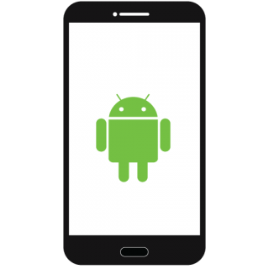
Figure
7
:
Android Phone Logo

Finally, since some features of SilentHelp, like shaking detection, background alerts, and location information, require real-world testing, having a physical Android phone is important. In other words, it will be capable of storing information without the need for creating an additional server. Also, the use of Firebase is ideal for this purpose because of its scalability and real-time communication capabilities, which are essential during emergencies. This tool is useful at the beginning of project design, but cannot correctly replicate background and sensor operations. The use of a physical Android phone allows checking the application in realistic conditions. It also helps ensure that location services, alert triggers, and calculator camouflage work appropriately in regular use.
Having everything into consideration, these particular technologies and tools can be considered the best choice for SilentHelp because they cover all aspects of the process of creating the product from beginning to end. Flutter and Dart can serve as the base technologies for the development of mobile applications, while Android Studio will assist in development and testing. Back-end services can be provided by Firebase, design can be planned with Figma, GitHub can be used for version control, and Android will be used for testing.

Chapter 3- Primary Research
It is essential to note that primary research provides useful information necessary for improving the SilentHelp application by understanding users' needs, behaviour, and expectations concerning personal safety apps. Contrary to secondary research, which relies on existing information, primary research involves collecting new data directly from participants in order to ensure that the designed system is based on real user experience (Organization, 2024). The SilentHelp project used quantitative and qualitative methods of collecting information. An online survey questionnaire was developed and distributed among various participants, ranging from students and working people to ordinary smartphone owners. The aim of the survey was to determine users' awareness about personal safety concerns, their exposure to any danger, and their readiness to use the application for requesting help discreetly.
The form used for conducting the survey had both multiple-choice and open-ended questions on areas like:
- Awareness of personal safety risks
- Encountering emergencies
- Usage of current safety applications
- Preferred emergency services (SOS (Anon., 2021) messages, location tracking, covert trigger functions)
- Problems concerning the safety and confidentiality of personal data
Apart from surveys, there were several discussions between the researcher and participants that provided additional information about the expectations of potential customers. The main outcome of informal interviews was the significance of discreet usability, since many people emphasised the impossibility of using an app openly in some critical situations.
Information obtained through surveys was analysed using basic statistics methods such as percentage distribution and charts. It has been found that most users prefer rapid, discreet, and easy-to-use emergency functions (shaking detection, dummy interface, instant notification system).
These findings from the preliminary research have had a direct bearing on how the SilentHelp system (Whipple, et al., 2009) was designed and implemented. For example, features such as a hidden interface like a calculator, the tracking of background locations, and one-click emergency alerts were implemented after realising the needs of the users through the research process.
In conclusion, the primary research proved that the SilentHelp system is indeed user-friendly, operational, and meets the real safety needs. Insights gained from the research helped enhance the features of the system.

3.1 Objective of primary research
The major research for the SilentHelp project was conducted to gain first-hand insights about potential users and ensure that the system will be developed in compliance with real-life needs and expectations. The primary purpose of this study is to help create an application of emergency assistance which will be both practical and convenient for the end-users.
Major objectives of primary research are presented below:
- To understand users' consciousness about personal safety problems.
- The research is aimed at understanding how much consciousness users have about their safety risks, especially in cases of violence, harassment (Organization, 2024), or other dangerous events.
- To study the behaviour of users in such conditions.
- This research intends to gather information about situations when users faced a situation requiring quick help but were not able to reach anyone.
- To understand the limits of available methods to ensure safety.
- The purpose of the study is to understand what users think about modern apps designed to help people with safety-related issues, as well as to identify their disadvantages, such as privacy problems, complications, lack of effectiveness during emergency situations, etc.
- To understand the desired characteristics of safety apps.
- The primary aim is to identify what qualities should be present in such an app, e.g., SOS button, ability to share current location, hidden triggering options, quick access, etc.
- To understand the need for a subtle emergency application.
- In order to check whether there is any need for this application which cannot attract too much attention from others.
- To understand the problems of privacy and security for users.
- This research is needed in order to find out whether there are some particular concerns regarding the safety of user data when using these applications.
- To support decision-making about system design and development (Anon., n.d.).
- The results of research are used to define key aspects of SilentHelp development.
- To evaluate the practicability and significance of the suggested concept.

3.1.1 Market Research (existing products)
The market for personal safety devices includes some good options, but the majority of them are designed as visible safety devices rather than concealed emergency mechanisms. As an example, the Personal Safety app by Google on the Android platform (Zhao, et al., 2022) allows users to input information on emergencies, enter emergency contacts, send their location and get crisis notifications; however, it is undoubtedly a recognisable safety application and not a disguised one.
There are some alternative apps that offer similar help using emergency alerts and location tracking. In particular, Still Safe Signal provides users with alerts within the application and even SMS alerts to trustworthy people and automatically sends updates, while BlinkAlert focuses (Connor, n.d.) on emergency notifications, live location sharing, setting up privacy preferences, and choosing triggers.
These applications show the need for safety applications, especially the ones helping users inform about their emergency situations in a timely manner. In addition, there are hardware personal safety devices such as the Clip tracker developed by Pebblebee. They recently introduced the feature allowing the device to become a panic alarm and emit sounds as well as notify about the user's location within an emergency group.
Research conducted by scholars found that many domestic violence applications have limitations. According to the findings, there exist some emergency assistance applications; however, many of them require the victim to press the button manually. In addition, some useful characteristics mentioned include the following: geo-fencing, shake-to-alert, anonymous messages, and encryption.
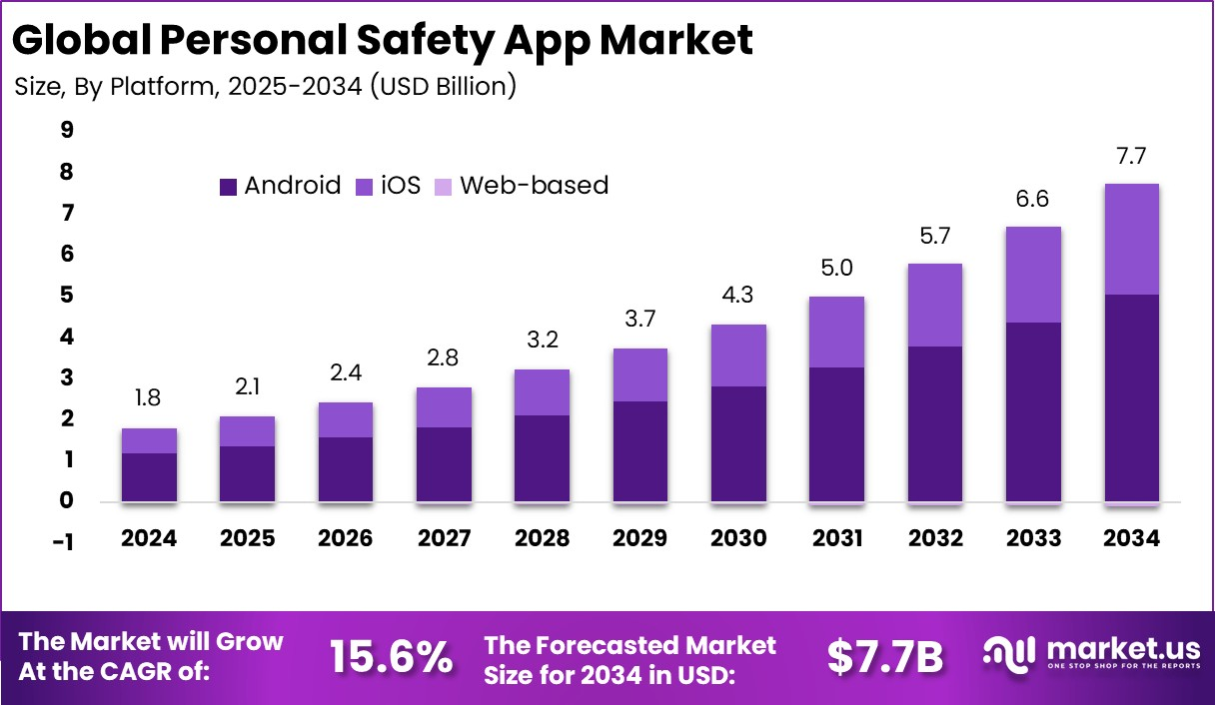
Figure 8: Global Personal Safety App Market Image

3.2 Survey questionnaire
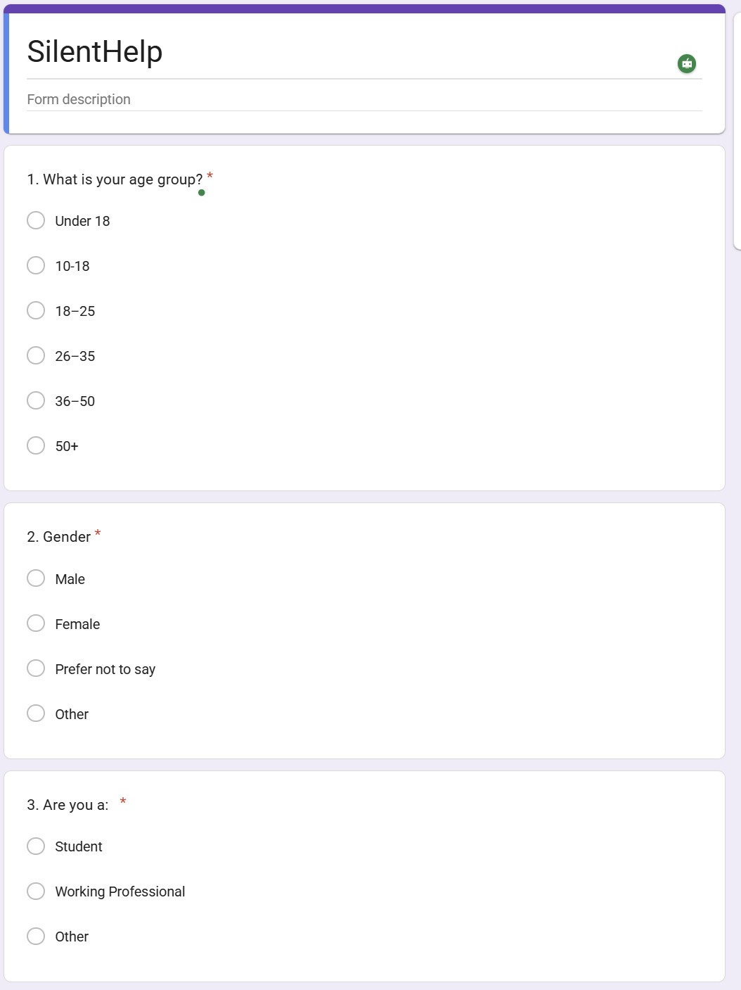

Figure 9: Survey Questionnaire1,2,3
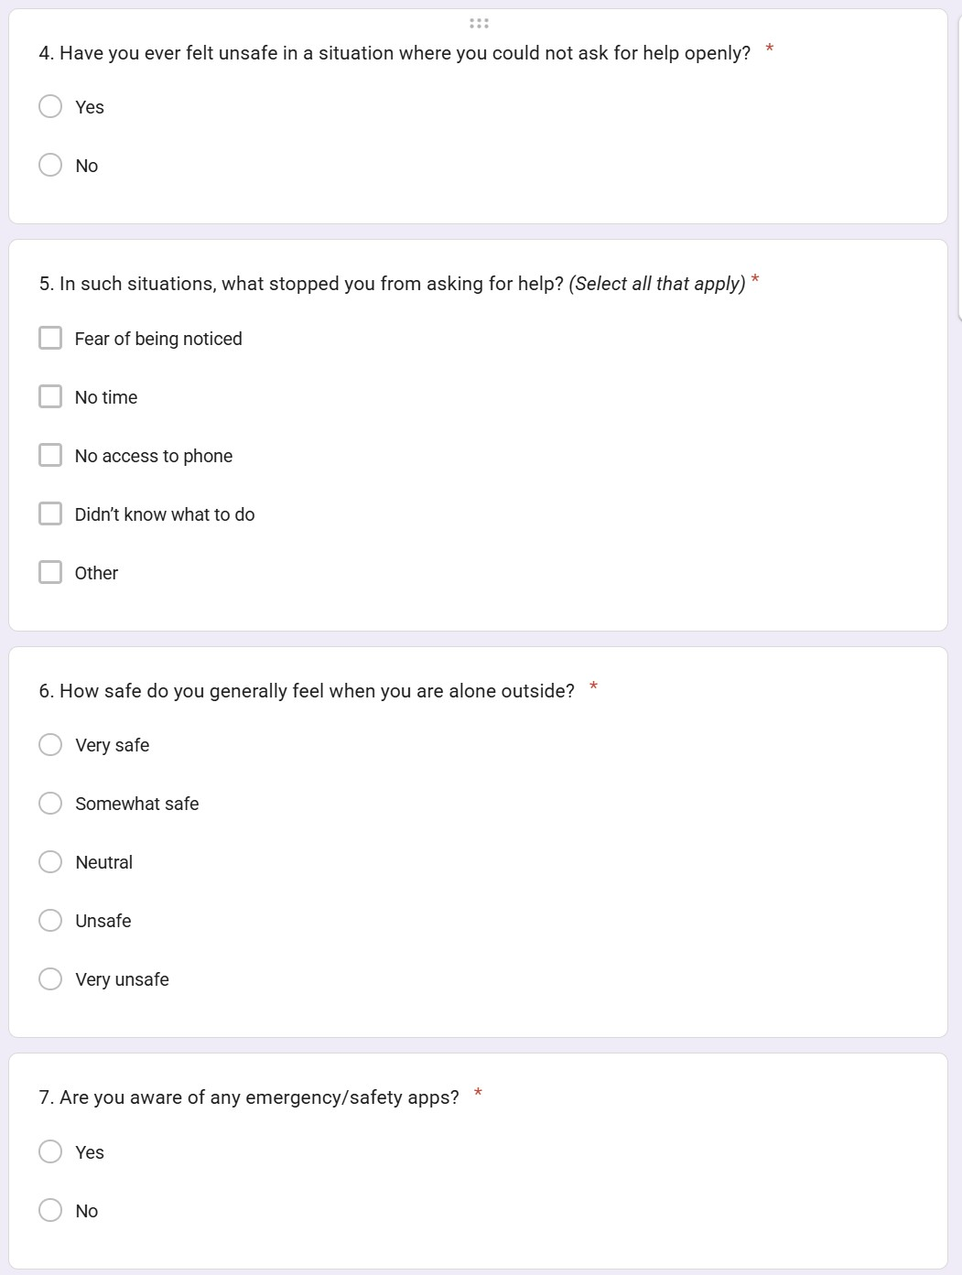

Figure 10: Survey Questionnaire 4, 5, 6, 7
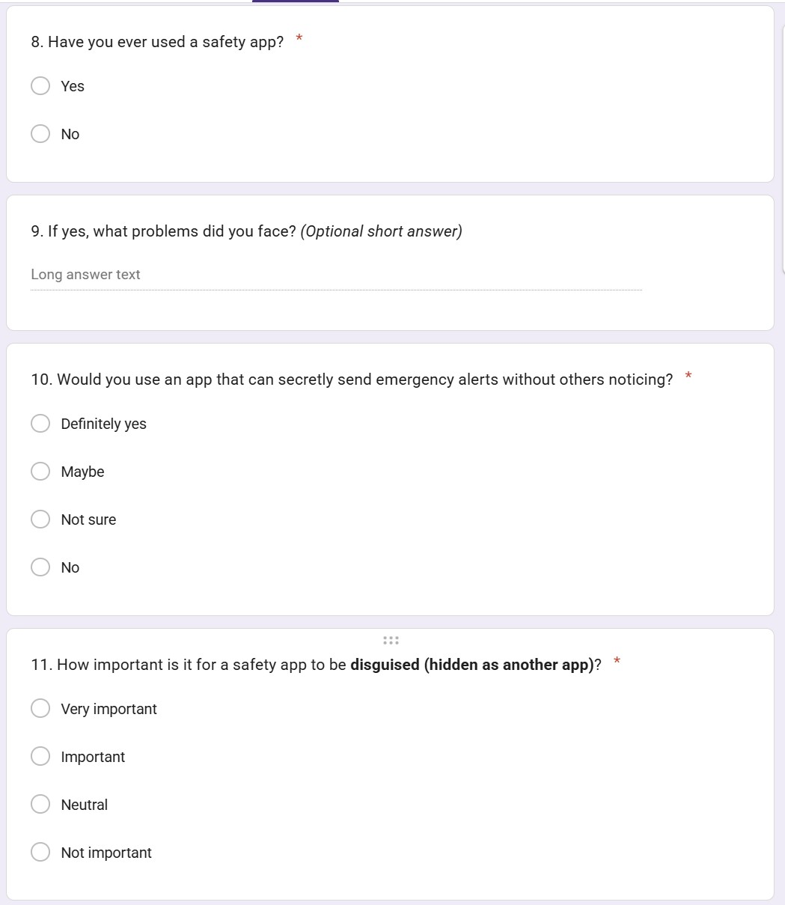
Figure 11: Survey Questionnaire 8, 9, 10, 11
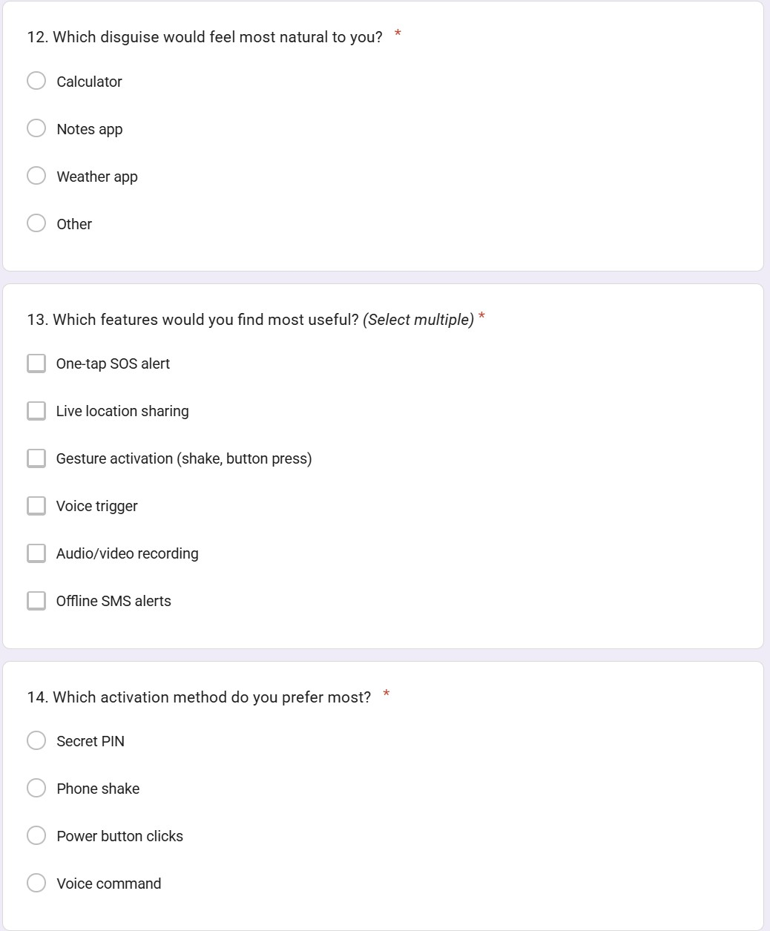
Figure 12: Survey Questionnaire 12, 13, 14
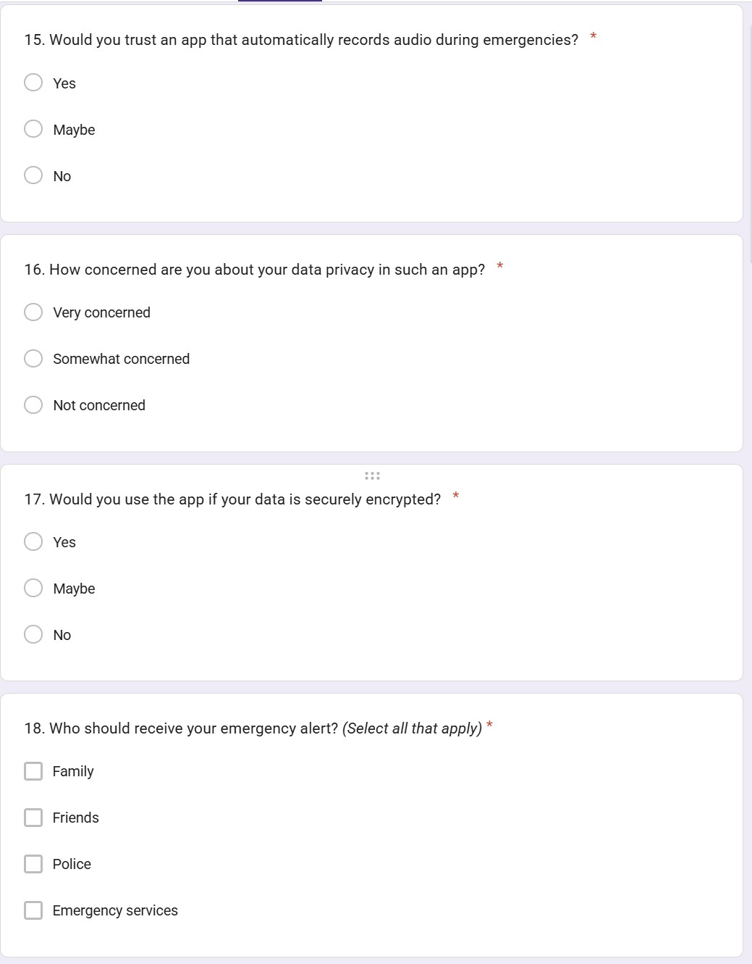
Figure 13:
Survey
Questionnaire 15, 16, 17, 18

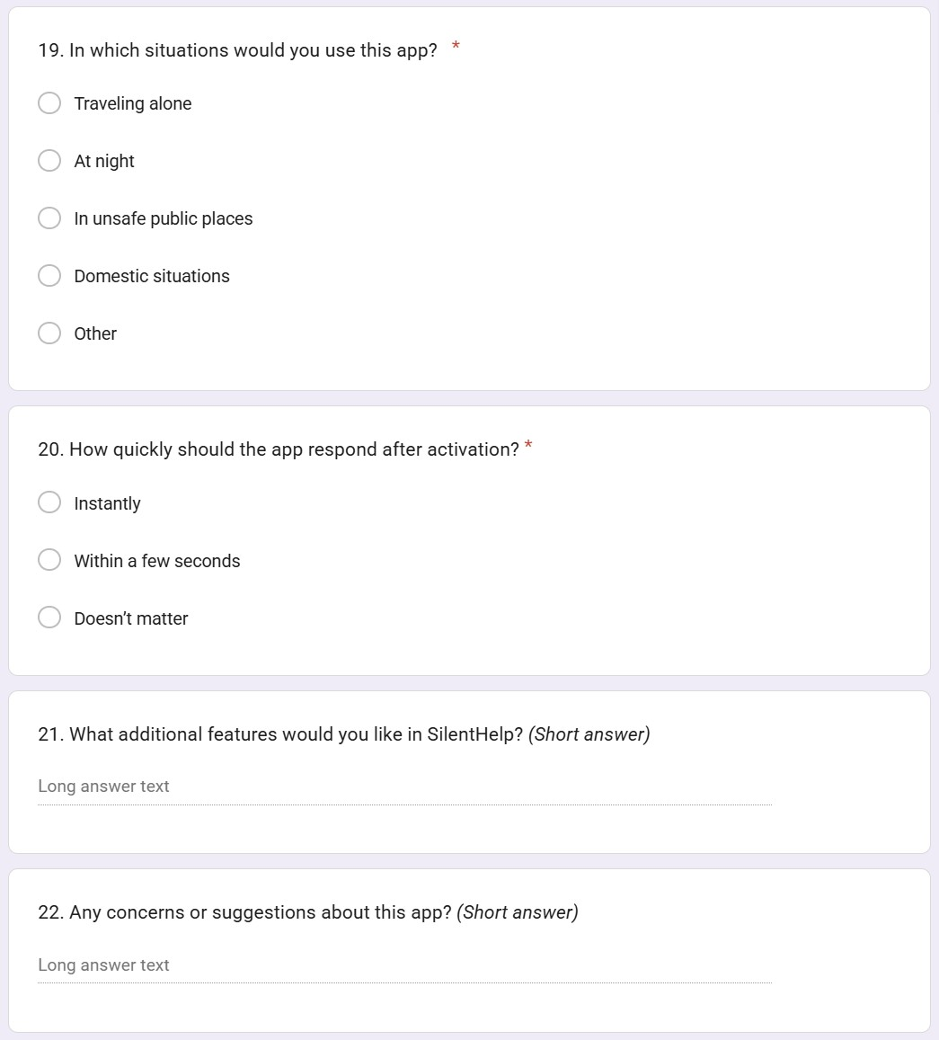
Figure 14: Survey Questionnair 19, 20, 21, 22

3.3 Data collection and analysis
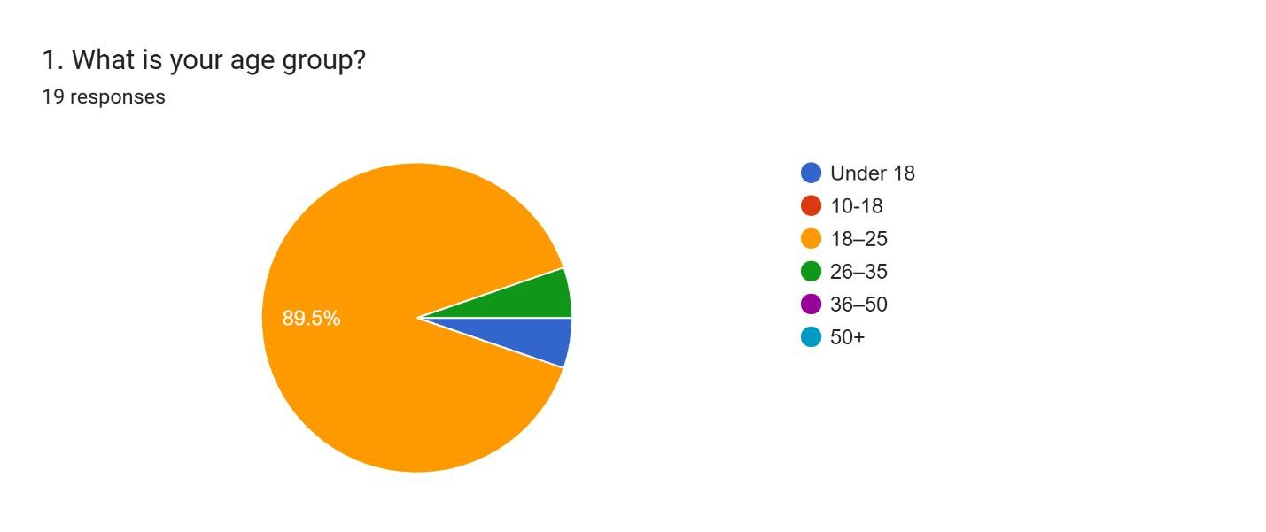
Figure 15: Data collection and analysis image 1
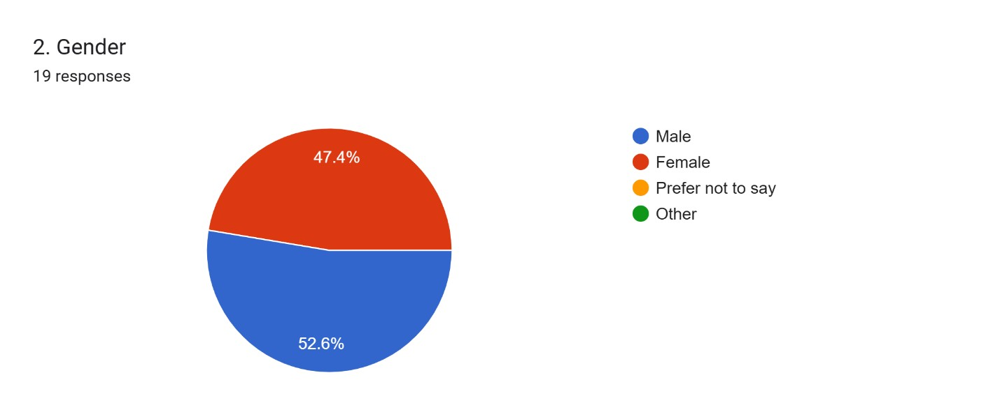
Figure 16: Data collection and analysis image 2
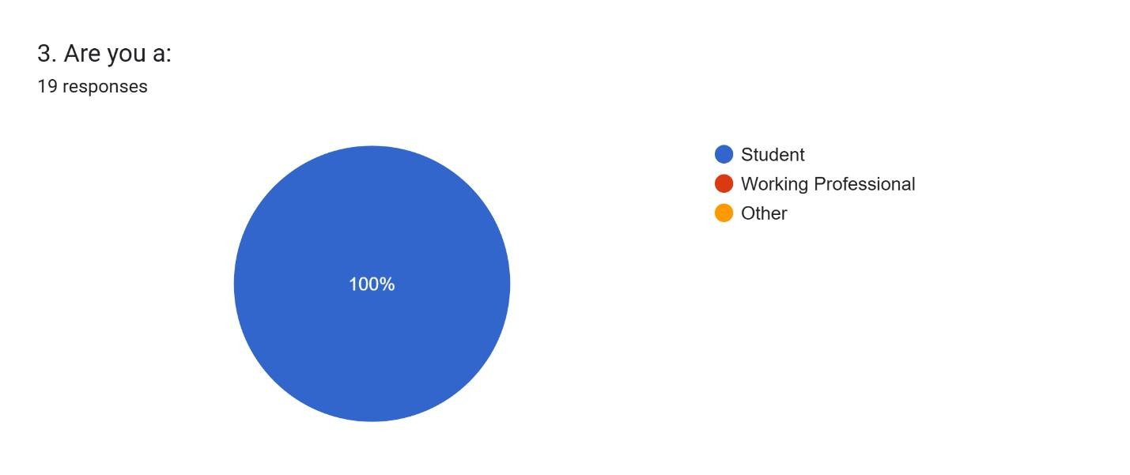
Figure 17: Data collection and analysis image 3
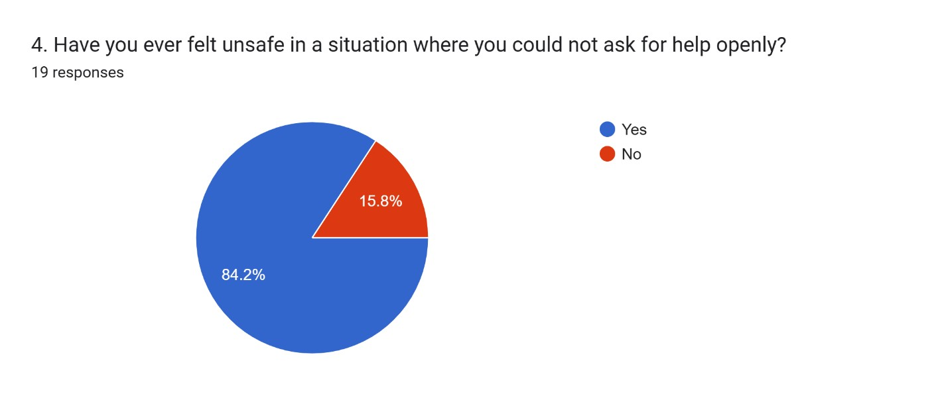
Figure 18: Data collection and analysis image 4
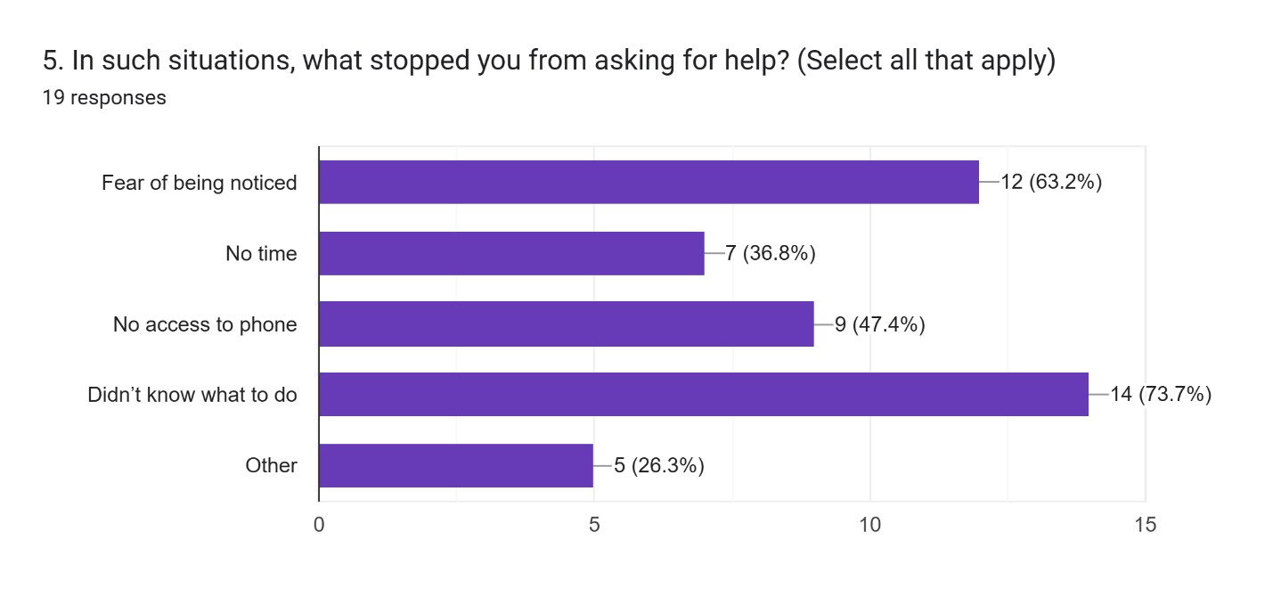
Figure 19: Data collection and analysis image 5
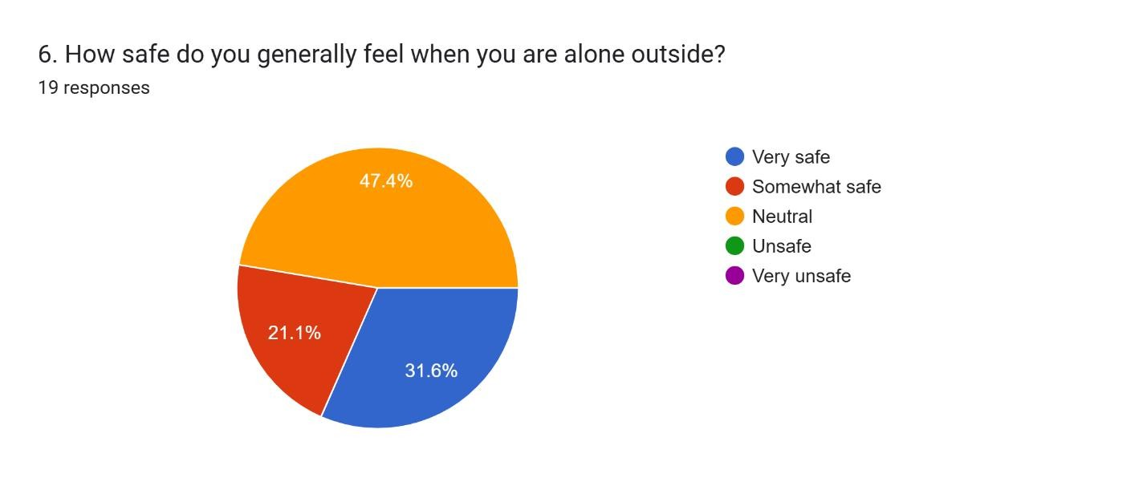
Figure 20: Data collection and analysis image 6
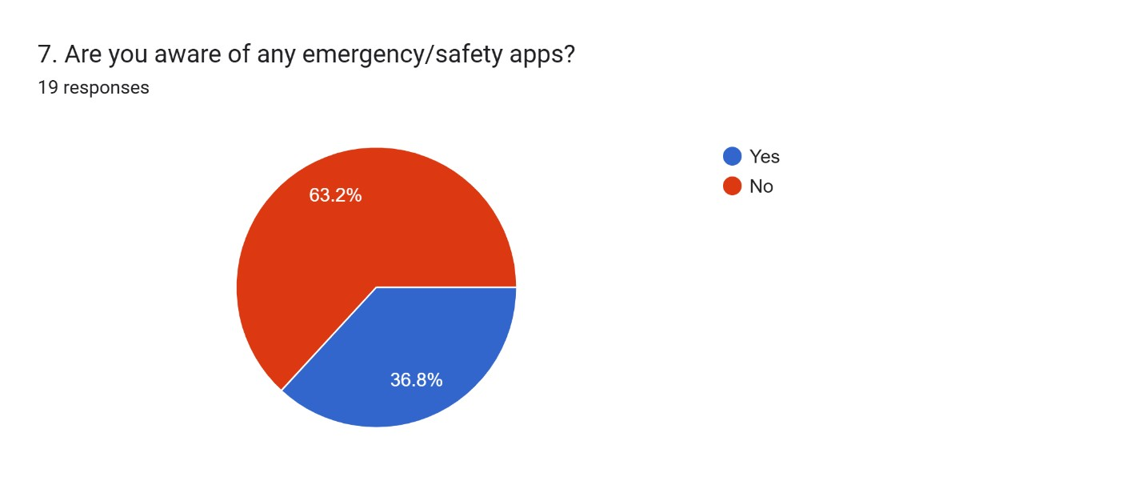
Figure 21: Data collection and analysis image 7
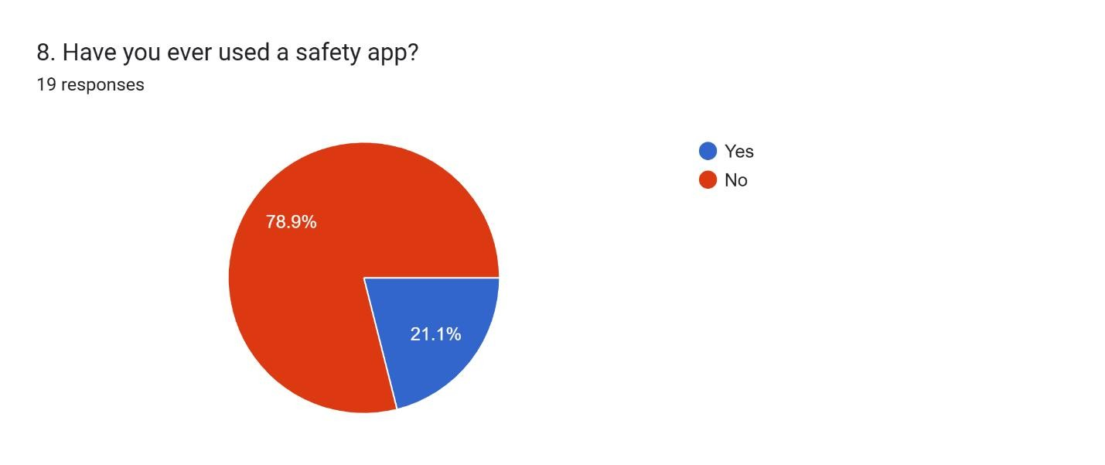
Figure 22: Data collection and analysis image 8
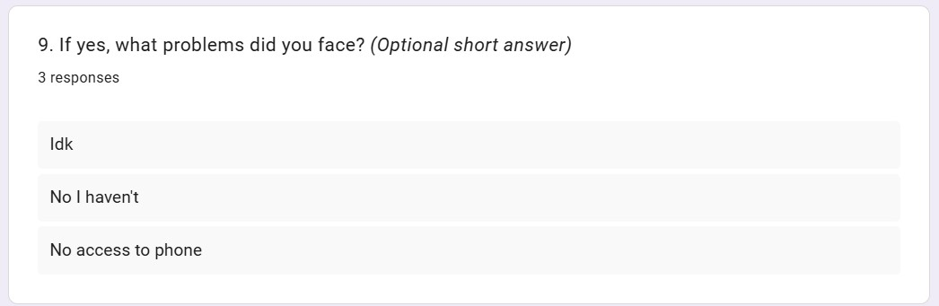
Figure 23: Data collection and analysis image 9
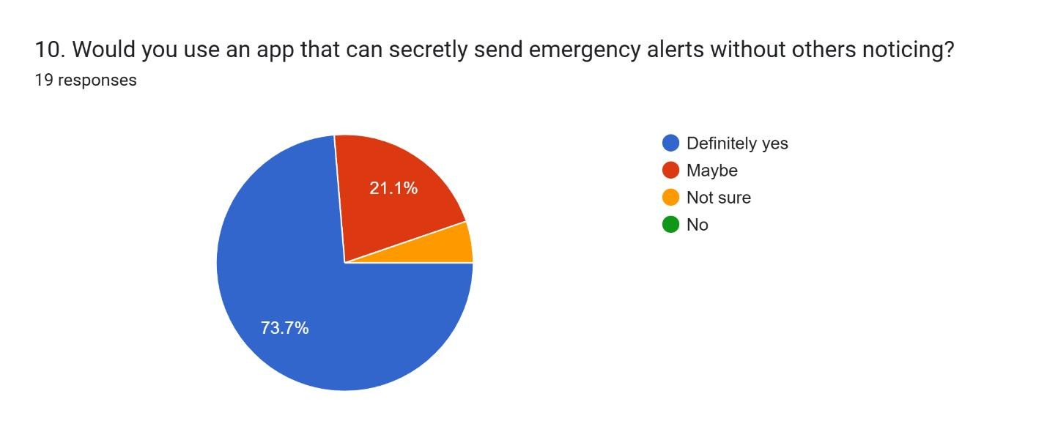
Figure 24: Data collection and analysis image 10
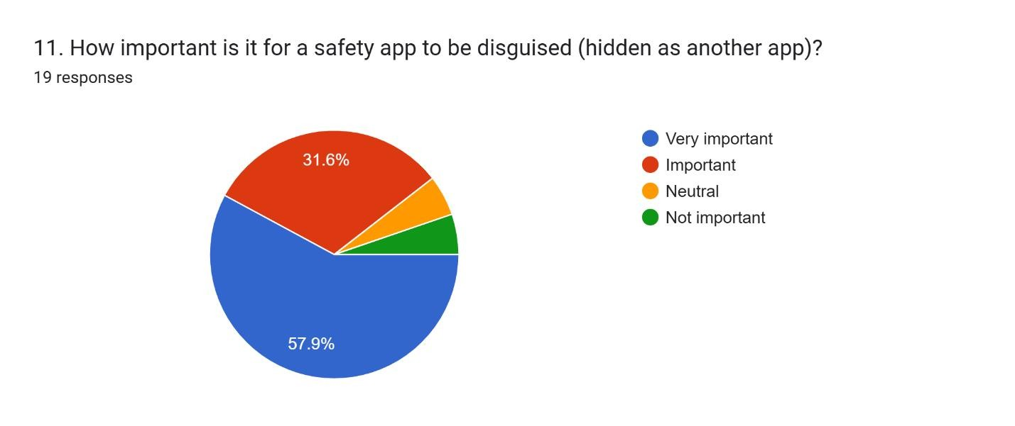
Figure 25: Data collection and analysis image 11
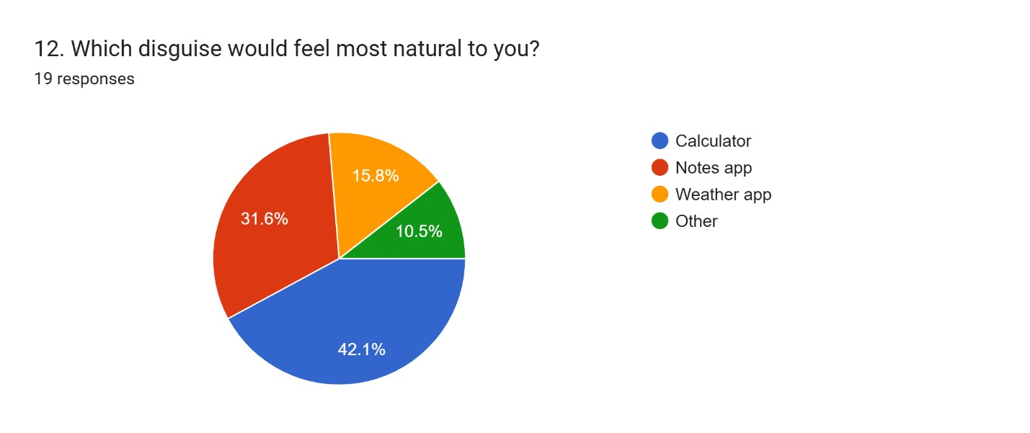
Figure 26: Data collection and analysis image 12
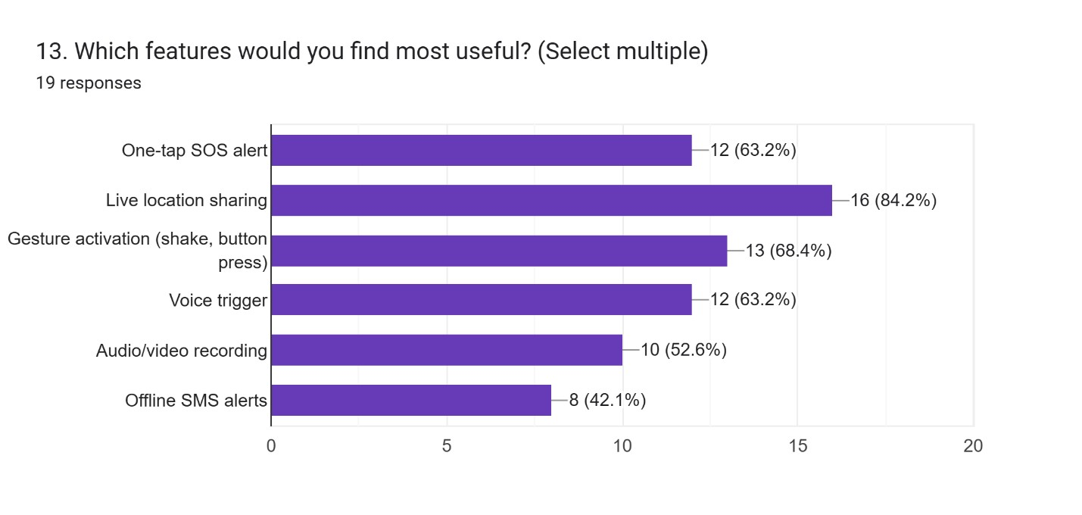
Figure 27: Data collection and analysis image 13
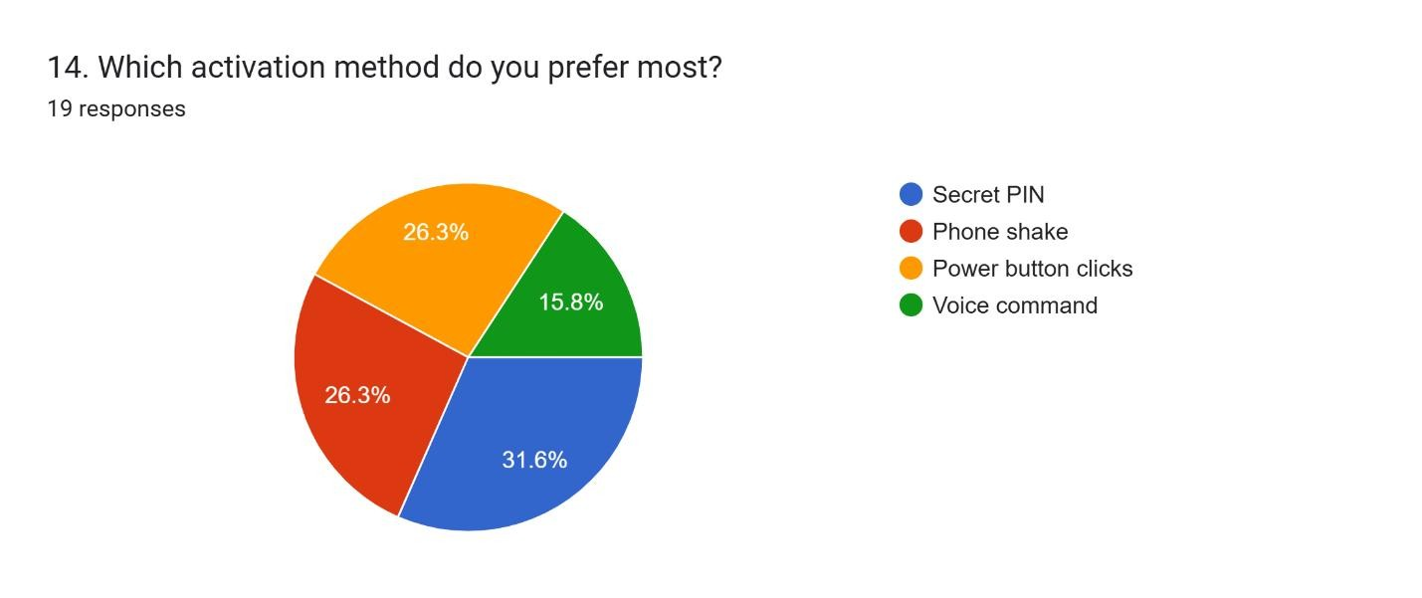
Figure 28: Data collection and analysis image 14
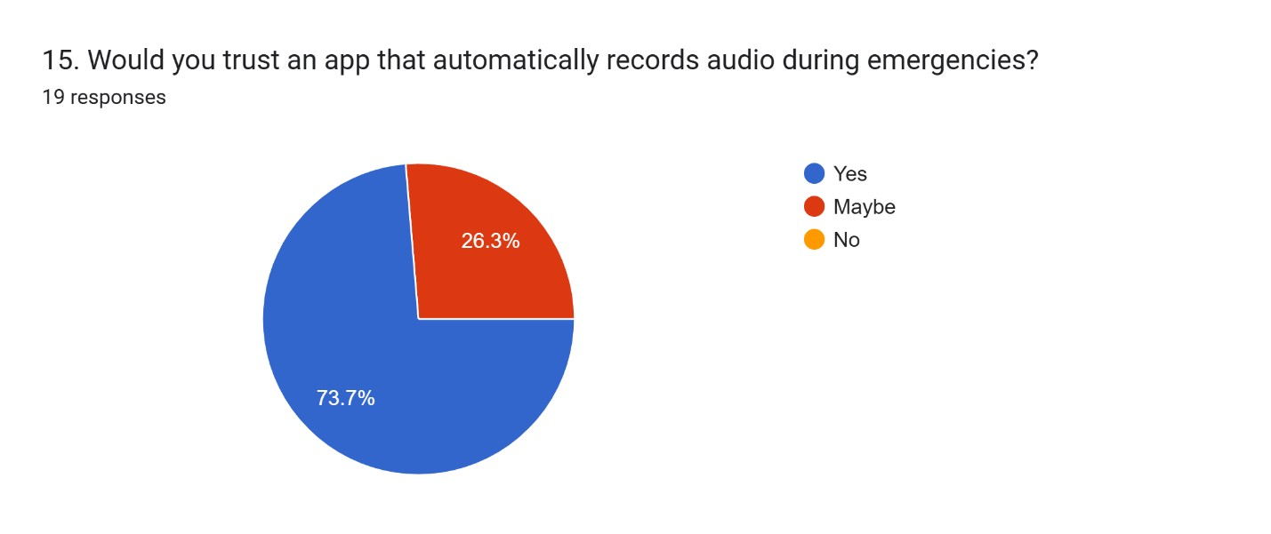
Figure 29: Data collection and analysis image 15
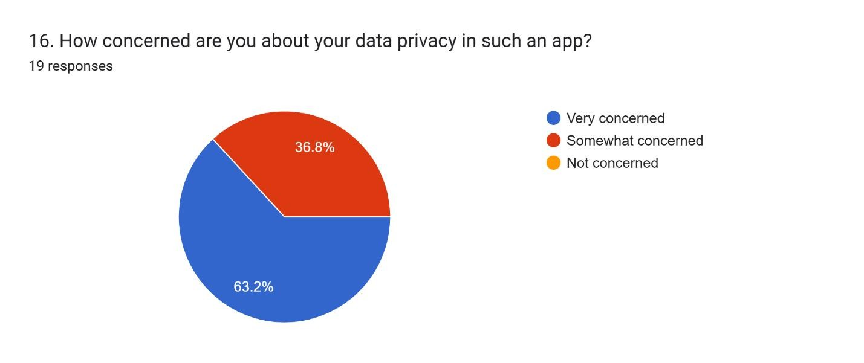
Figure 30: Data collection and analysis image 16
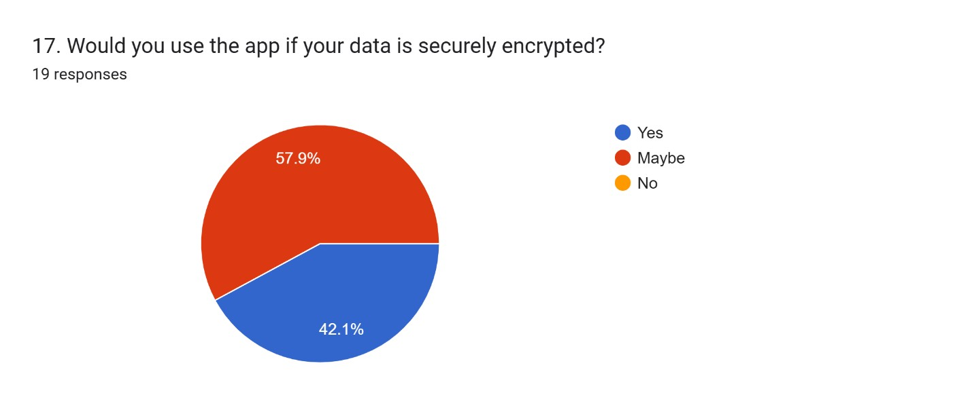
Figure 31: Data collection and analysis image 17
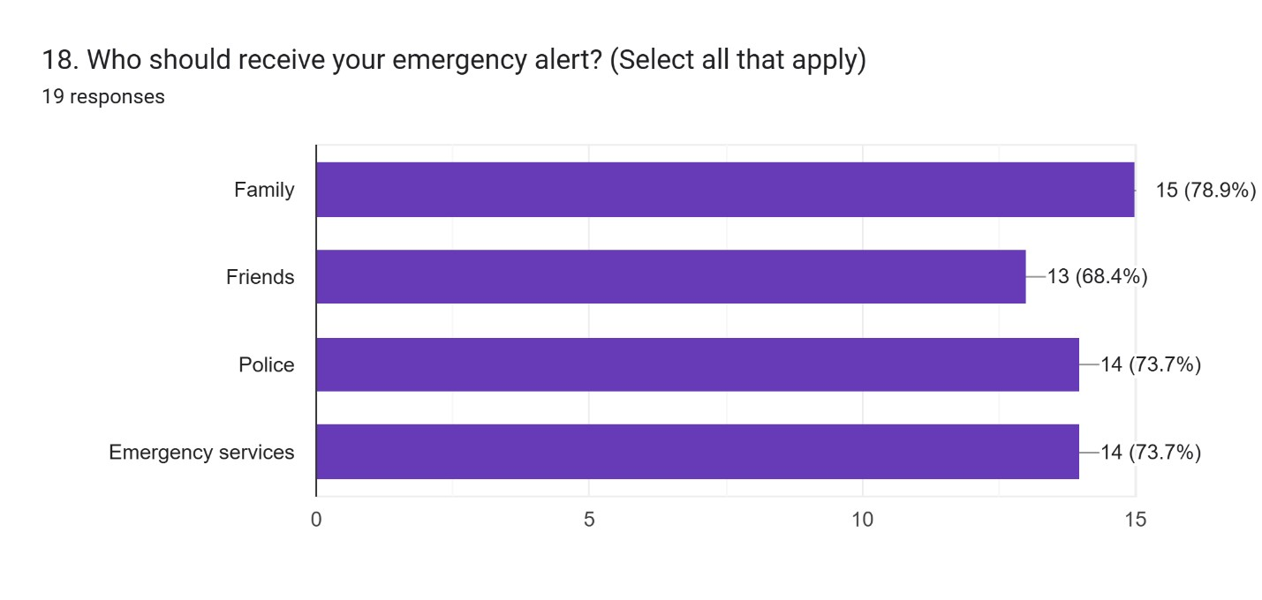
Figure 32: Data collection and analysis image 18
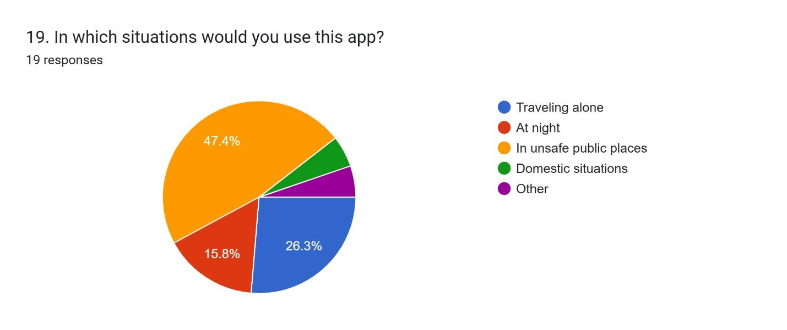
Figure 33: Data collection and analysis image 19
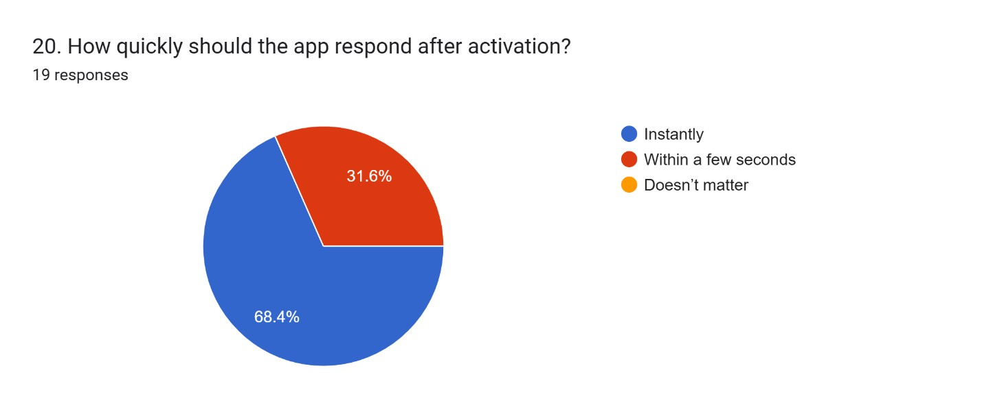
Figure 34: Data collection and analysis image 20
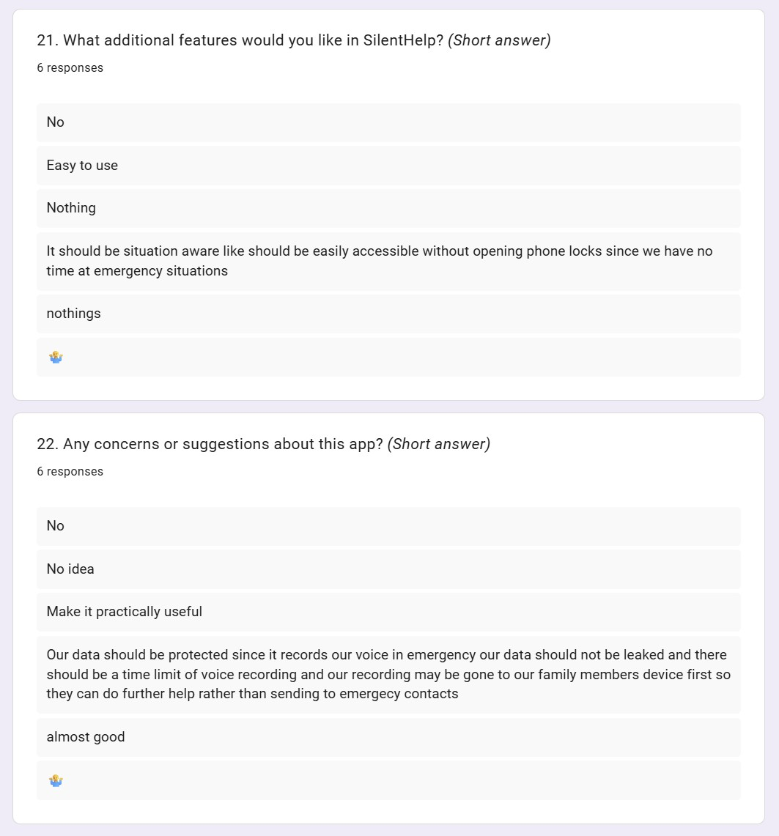
Figure 35: Data collection and analysis image 21
The following questionnaire acts as the core research tool for the SilentHelp project. Information about the age, sex, employment, experience of facing danger, awareness of existing safety applications, confidence in covert emergency alerts, preferred kind of disguise, beneficial app features, privacy-related concerns, possible recipients of the message, and application usage scenarios will be collected. Open questions are intended to gather both quantitative and qualitative feedback (Dr. Sridhar Mandapati, n.d.).
In other words, the goal of the poll is to identify features that people find useful, the disguise that appears to be the least noticeable, and whether there is a need for the existence of such an emergency app. The results obtained from the poll are important for SilentHelp since they can justify the development of the calculator-like interface, geolocation, security measures, and voice/shaking commands. Overall, the importance of the poll for your contextual analysis cannot be overestimated (Vladislav Volarevic, n.d.).

Chapter 4 – Project plan
The SilentHelp project will be thoroughly and methodically developed to ensure that all phases are completed on time and correctly. The first phase includes identifying the scope of the project, reviewing relevant literature, and collecting requirements through surveys & research. This phase will identify the core components necessary to create a covert emergency assistance application.
Once the initial research is completed, the second phase will focus on designing and planning the system. During this phase, all design documentation, such as database schema, system architecture, user interface, etc., will be produced. During this phase, specific strategies will be developed to maintain a simple, safe, and easy-to-use application for its users, specifically with regard to the use of a calculator-style masking, a hidden menu, and a sequence of actions to trigger an emergency.
The third phase will consist of developing the mobile application using Firebase & Flutter. During this phase, the application will implement its core functionalities, including: calculator-style interface, GIS location sharing, trusted contact list, and SOS (Quarantine, Actively and Quietly) Activation. Close attention will be paid to the reliability of the final product, privacy & background use when using the application.
After completing all necessary development work, we will begin conducting Stage Four tests and enhancements to ensure all features are working properly and all unplanned triggers (such as product bugs) are functioning correctly or functioning according to plan. Results from each round of bug testing will provide an opportunity for us to identify errors made during the planning and design phase of production, so that we can fix those errors and/or usability problems found during testing (Aditya Pakki, 2020).
In addition, the final report containing the implementation procedure and the final submission of the SilentHelp project will be the last step. By completing this plan, we will ensure that SilentHelp is developed in a systematic process to meet both of our practical and intellectual goals.

4.1 Gantt chart- Semester 1, Semester 2
The two-semester schedule of the SilentHelp project is shown in the Gantt chart below. In the first semester, the work involves project initiation, requirement gathering, literature review, questionnaire development, analysis and design, development of frontend/backend system, and database/ERD development. Contextual report writing, evaluation and testing, preparation of the final report, project presentation, and final thesis submission are the major activities in the second semester.
In conclusion, the above Gantt chart highlights sequential planning of the SilentHelp project from its first semester to its second semester.
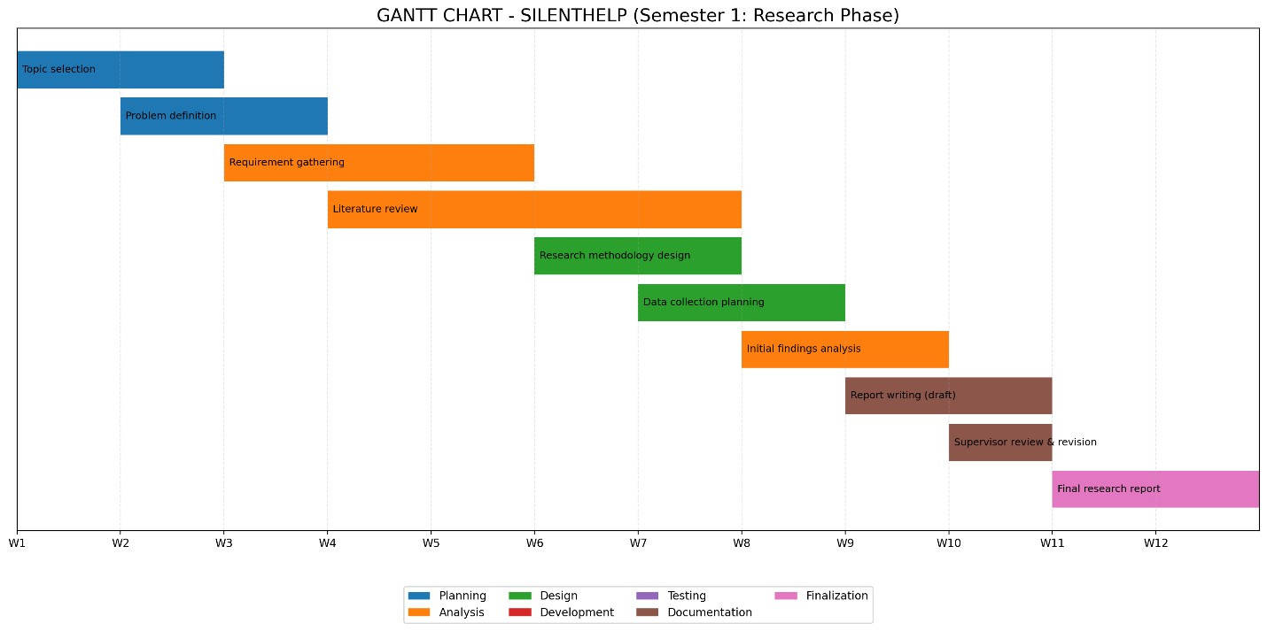
Figure 36: Gantt chart- Semester 1

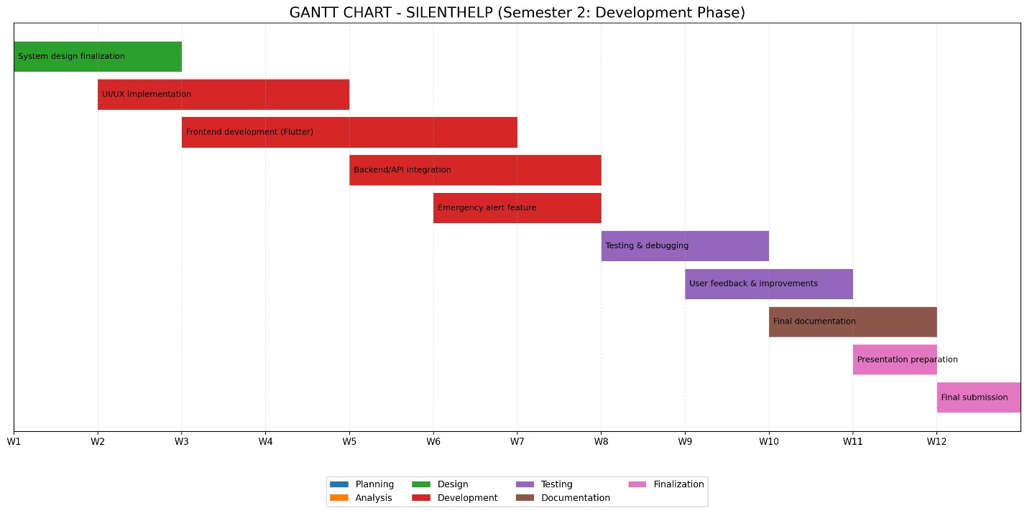
Figure 37: Semester 2 Gantchart Image

4.2 Risk Analysis
The creation of SilentHelp can present challenges that are technical, logistical and ethical. To solve these types of problems, the possible hidden triggers (i.e. voice activation or gesture detection) may not function correctly in all situations due to such issues as device sensitivity, background noise and variations between hardware performance. Testing frequently and allowing for user-defined thresholds will improve reliability, reducing the risk of this type of situation occurring.
The limitations of Android background service functionality will also be a key concern while making SilentHelp work a lot more. This is important since SilentHelp will be running in the background without being displayed, either because of operating system limitations or power-saving settings. To mitigate this problem, a plan for proper foreground and background service functionality will be developed and tested across a variety of Android devices (Anon., n.d.).
In addition to the aforementioned issues, there is also the risk of losing network connectivity while sending out an emergency notification. The delivery of messages and location sharing may be delayed because of a poor or non-existent internet connection. In order to reduce this issue, backup alerting methods and retry mechanisms will be considered to ensure assistance request delivery will take place when internet connectivity has been restored.

4.3 Workflow diagram
The flowchart (Ensmenger, 2016) below describes the operation of SilentHelp. In the first stage, upon launching the app for the first time, it appears to be a normal calculator. Then the system checks whether there was any hidden emergency trigger. The system records the user’s location in case of an emergency, alerting designated individuals using SOS. An SOS message from the individual’s emergency contact marks the completion of the process. The software does not get attention because it behaves like any normal calculator. The steps that occur when using SilentHelp include launching the app as a calculator, identifying hidden emergency triggers, logging the location of the user, sending an SOS alert, receiving the SOS from an emergency contact, and ending the process.
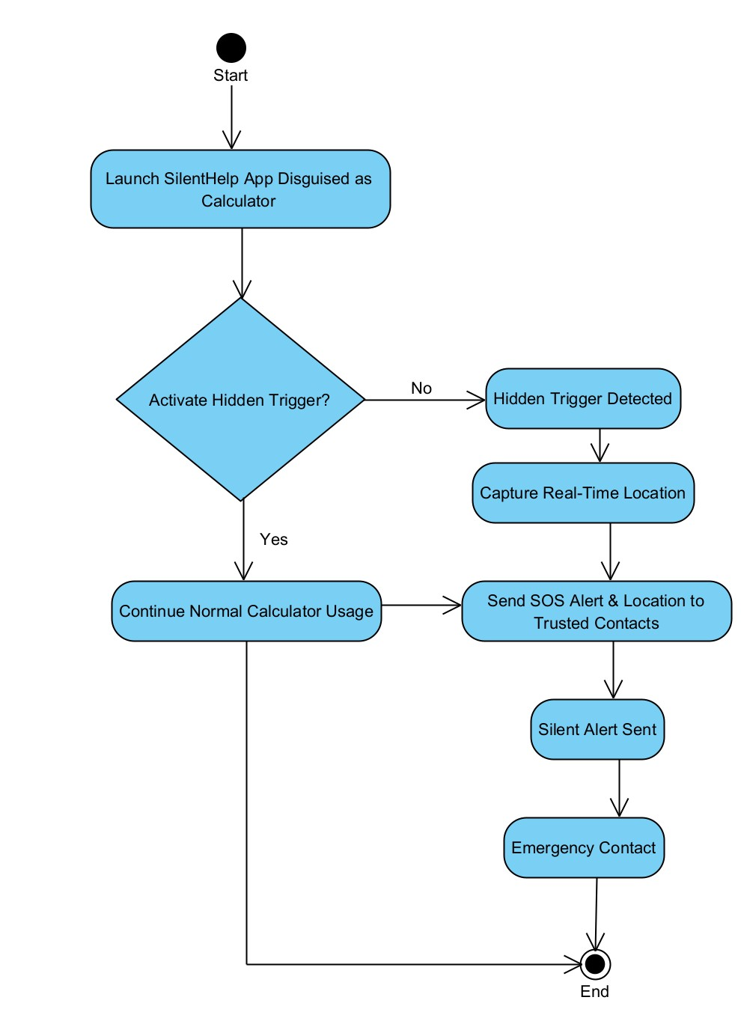
Figure
38
:

Work Flow Diagram

Chapter 5- Artefact planning
The artefact associated with the SilentHelp project is expected to be a mobile app (Bruno M.C. Silva a, n.d.), which will act as an advanced emergency assistance tool. In the planning stage, one should highlight the importance of realising the necessary characteristics, system requirements, and development approach needed for developing an effective product.
The mobile app is expected to be composed of a calculator-style interface, hidden emergency notifications, a contacts management system, and a live location sharing tool. To ensure efficient and effective development of the application, the system should have several components, among them a user interface, a trigger detection system, an alerting mechanism, and a database management module.
An agile development approach is implemented, breaking down the development process into stages such as design, coding, testing, and improvement. Such tools as Flutter, Firebase (Spatio-Temporal, 2010), and Figma can be used to assist in designing and developing the software (Whipple, et al., 2009).
On the whole, artefact planning ensures the effective development and implementation of the SilentHelp application.

5.1 Requirement Analysis
Requirement analysis is significant for the SilentHelp project since it helps determine the features of the system and the user's expectations. The core problem that had to be studied during the requirement analysis stage was analysed deeply in order to understand the safety requirements of people who would not be able to call for help publicly in dangerous situations. The requirements were collected through analysing existing safety systems, reviewing literature, and researching potential user needs based on surveys.
Accordingly, the study found that the system should provide the user with such capabilities as the hidden calculator menu, secret emergency triggering methods, reliable contact management, immediate sharing of one's location, and a safe alert sending feature. Privacy, efficiency, and reliability were seen as highly important since the application would be used in emergencies and other critical situations. Apart from functional requirements, the non-functional ones, such as user-friendliness, background work, and secure data management (Deepti Sahu, n.d.), were also determined.
In conclusion, requirement analysis specified the exact borders of the SilentHelp project and created a basis for further phases of the work.

5.1.1 Functional Requirement
The functional requirements of the SilentHelp project describe the main functions and activities the software must perform in order to provide help to users during an emergency situation. In particular, the application must operate similarly to a common calculator on the surface, whereas some additional security features must be integrated behind-the-scenes. It must allow users to input and manage trusted emergency contact persons, define silent activation procedures, and alert contacts in case of an emergency situation when an emergency trigger is detected. Additionally, the application must collect and share the user's current geographical position with the trusted contact persons in an emergency situation (Organization, 2024). Furthermore, SilentHelp must have the ability to operate silently in order to provide help without alerting others.
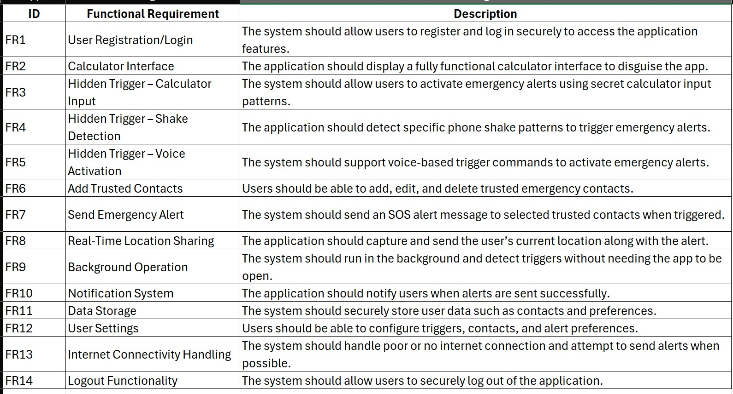
Table 2: Functional Requirements

5.1.2 Non-functional Requirement
Non-functional requirement in the SilentHelp system is the way in which the application operates and not its use. Fast, reliable, safe, and user-friendly is how the application should be since it is an emergencydriven application. In order for the application to stand out, the development of software must be clear and user-friendly. Upon pressing a concealed activation button, the software (Whipple, et al., 2009) should instantly respond while running in the background, consuming no power and having no impact on its efficiency. Secure mechanisms should be adopted in data storage and transfer of contact and location details.
Non-functional requirements play an important role in determining the success of the software.
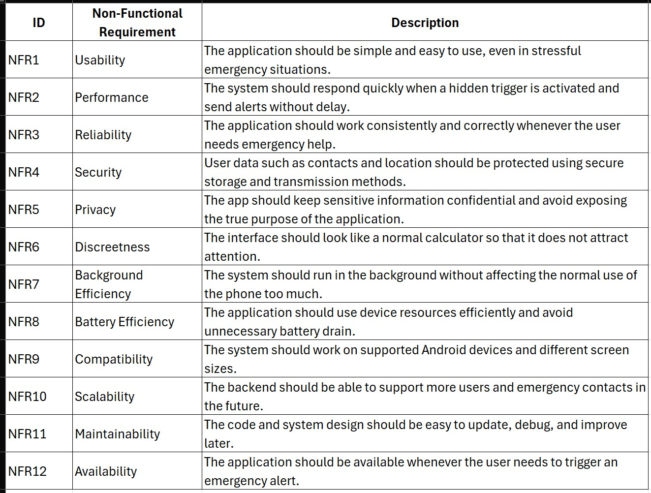
Table 3: Non-Functional Requirements

5.2 Software Requirement
The software requirements for SilentHelp include all platforms, frameworks, and tools that will be used in the designing, developing, testing, and maintenance of the application. SilentHelp will need the use of the Flutter framework and the Dart programming language since the application is a mobile one. Android Studio is the development platform used in coding, debugging, and testing of Android-based applications. For the backend component of the application, the use of Firebase is needed since the system will store and send alerts to users. Before starting to develop SilentHelp, the layout designs for the screens and the UI will be designed with the help of Figma. To ensure security for the project code, version control will be needed through GitHub (Sommerville, 2016).
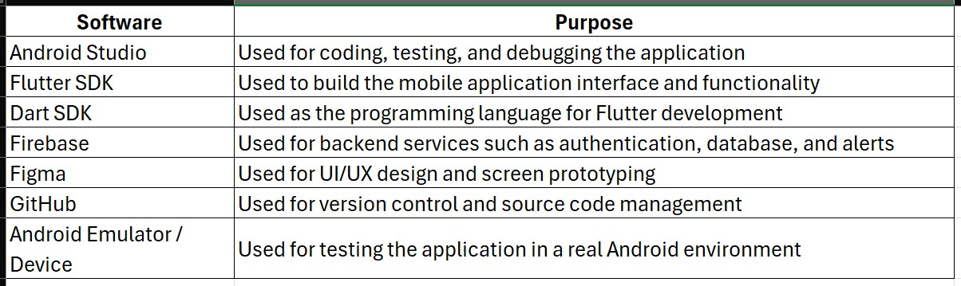
Table 4: Software Requirement

5.3 Hardware Requirement
Physical equipment necessary to ensure that the software can be effectively developed, tested, and used appropriately is contained in the hardware requirements for the SilentHelp project. The installation of the development tools, such as Android Studio and Flutter, necessitates the use of a laptop/desktop computer. In order to effectively test the mobile application, an Android phone is necessary as well, especially considering that it will be equipped with certain features such as the calculator user interface, hidden triggers, and sharing of the GPS (Whipple, et al., 2009) location, and alerts while running in the background. Support for the accelerometer, GPS, microphone, and internet connectivity is also important since the software utilises mobile sensors.
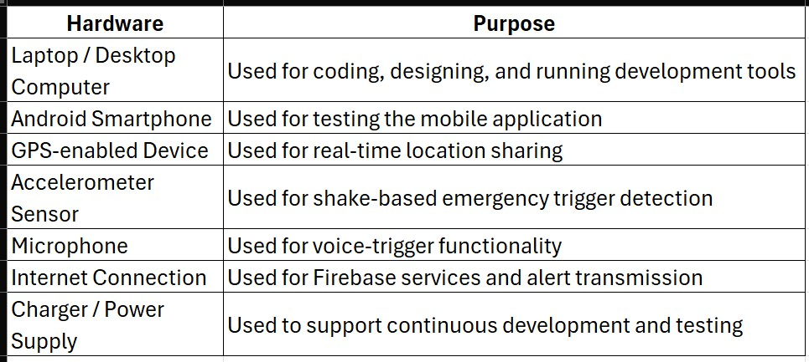
Table 5: Hardware Requirement

5.4 Feasibility Study
In order to determine the viability, feasibility, and appropriateness of the proposed idea as being realistically achievable, a feasibility study is an important element of the SilentHelp project. Considering the nature of the SilentHelp application, which will provide a way to receive silent emergency assistance, the feasibility study should examine whether the system is realistic and can be developed with regard to all factors, such as technical, operational, financial, legal, and scheduling aspects.

Technical Feasibility
SilentHelp is possible from a theoretical standpoint since all the needed technology can be accessed and supported. The system can be built using Firebase to serve as the backend for functionalities such as database management, authentication, and alert communication; Dart as the programming language that houses the necessary logic; and Flutter to handle the mobile interface development. Though Dart has the programming logic to enable secret triggers such as voice activation, shaking, and code pattern entry, Flutter can be used to develop an interactive and responsive calculator-like interface that masks the main purpose of the application. Moreover, smartphones have the necessary sensors that can be used to enable functionality in terms of location sharing and secret activation, such as acceleration and GPS. Therefore, the idea is theoretically possible to implement.

Operational Feasibility
As SilentHelp was developed taking into account real customers' requirements, it has become operational. The software addresses the problems of domestic violence, stalking, harassment, and situations when people need to call for help privately. With its calculation-based concept, the app becomes easy to operate without attracting other people's attention, thus allowing the user to discreetly send alerts for the emergency situation due to the secret triggers of the application. Although the technology appears to be easily understandable for ordinary users, it can become extremely helpful in critical conditions. Therefore, the project is suitable for implementation in reality due to its emphasis on privacy, fast signalling, and simplicity.

Economic Feasibility
The SilentHelp application can be developed using affordable means and can be economically viable. Most of the tools required to develop the system will be available for free or within their freemium packages. If one considers that this is an academic project, then Flutter, Dart, Android Studio, and Firebase can be deployed at little or no economic cost. One can utilise GitHub as a version control software, free of charge, and Figma for designing purposes. Using only the cost-intensive component of the SilentHelp development process, an electricity bill and internet charges, along with the personal use of an Android phone, one can develop the app.

Schedule Feasibility
Moreover, the task is feasible within the timeframe of an academic year. The development process of SilentHelp could be broken down into several stages, starting from the design phase and requirements analysis, followed by frontend and backend development, testing, evaluation, and reporting. Thanks to its modular nature, SilentHelp’s development will proceed at a steady pace as each module can be completed one at a time. As such, there is less risk involved while making effective use of time. Since several common functions can be developed faster than building them all from scratch, SilentHelp’s development can be completed within the academic schedule.

Legal and Ethical Feasibility
Even though SilentHelp meets ethical and legal criteria, it must be developed carefully due to the handling of confidential information, such as geolocation and secure communication. The application should only collect the essential amount of information that it requires in order to fulfil its purpose of safeguarding. It is necessary to ensure that information is sent and stored in a secure manner so that the confidentiality of the user is protected. Furthermore, since the software would be employed during emergencies, it must not mislead the users and increase their risk. In light of the fact that the software concerns protecting life, ethical concerns must be addressed.

Conclusion
Finally, the feasibility study confirms the practicality and profitability of SilentHelp. It is practical within the stipulated time frame, technically possible, operationally advantageous, and economically practical. Furthermore, it is a software application that seeks to solve a major social problem while addressing ethical and privacy concerns. As such, SilentHelp can be deemed a valuable final year project that can turn out to be a profitable mobile application (Gargenta, n.d.).

5.5 System Architecture
SilentHelp's architecture is a three-tier system that provides a discreet and quick means to send emergency alerts from user devices while being secure.
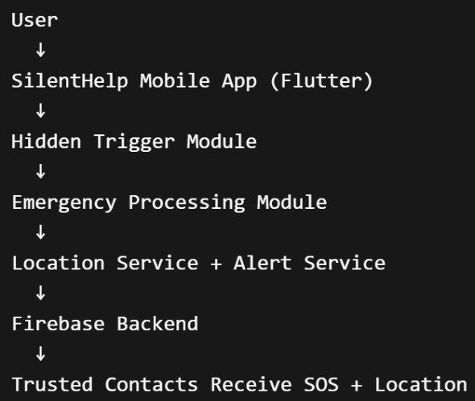
Figure 39: System Architecture

Main Layers

1. Presentation Layer
The user interface portion of SilentHelp consists of what can be seen on the phone's screen (the calculator on the phone's application) (like any other normal calculator). Flutter (Anon., n.d.) has been used in the building of all four of the screens (the calculator, trusted contacts, alert configuration, and hidden settings).

2. Application Logic Layer
The back-end portion of SilentHelp controls all of the application's hidden features and acts as an interface that determines whether to send an emergency alert to trusted contacts once the application detects the physical behaviour of either a voice command (Connor, n.d.), shaking movement or secret calculator input. 3. Sensor and Service Layer
This layer also connects to the accelerometer, microphone and GPS (Whipple, et al., 2009) on the device. In addition, it provides background services that will allow the application to continue to function without being displayed.

4. Backend Layer
The back-end (Anon., n.d.) of SilentHelp uses Firebase as a data repository for emergency alerts, app user settings and trusted contacts and provides secure transfer of data (Spatio-Temporal, 2010) between trusted contacts and users.

5. Notification Layer
The output of SilentHelp can be either Firebase or a messaging service, and it provides trusted contacts with real-time geolocation-based unknown demand alerts (SOS (Anon., 2021)).

How It Works
SilentHelp works as a calculator for the user when the application starts. SilentHelp detects emergencies based on a user-defined emergency (voice trigger), shaking (Connor, n.d.) the phone (e.g., when dropped) and by entering a secret code. When detected, it begins to prepare the user’s SOS (Anon., 2021) message, capturing the current location (Whipple, et al., 2009) and sending it to the user's trusted contact list.

Why This Architecture Fits SilentHelp
The architecture of SilentHelp allows the application to function quickly, consistently, and provide the reliability required to assist users. Because of this, all of these emergency services will operate behind the scenes (in the background) to the user, while the user will see the standard calculator application. The design architecture will also allow for testing (Sommerville, 2016), maintenance, and future enhancements to the overall application.

5.4 System Design
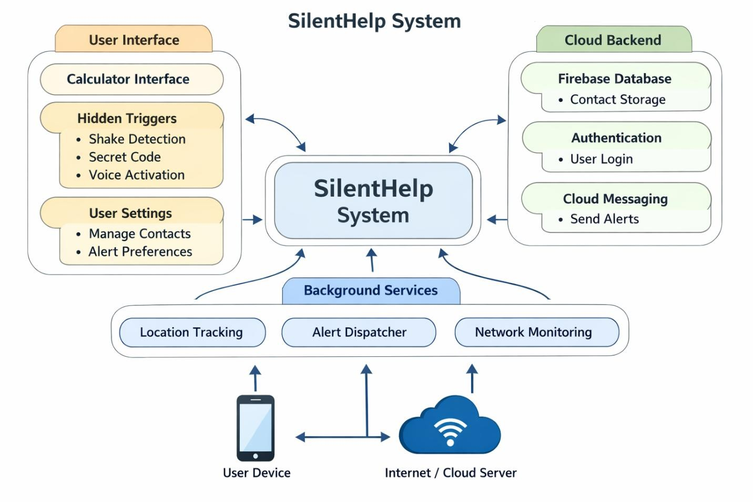
Figure 40: System Design
This design model of SilentHelp demonstrates the cooperation between various elements of the application in providing an emergency assistance system discreetly.
The SilentHelp System, which acts as the principal controller linking all these components, is placed centrally. The user interface (UI) (Isaias, 2022) It is portrayed on the left-hand side of the model and represents the part that the user uses. This interface incorporates silent commands, such as voice commands, shaking the device, and entering a secret key, along with the calculator interface that keeps the true purpose of the app concealed. Users can change their alert settings and manage their contacts using the user interface settings page.
The Cloud Backend (Firebase) manages all data storage, and user communication methods are located on the right side of the model. The Cloud Backend also provides user login authentication, so we can deliver reliable alerts to users by ensuring the correct data has been captured. The Cloud Backend supports sending alerts through Cloud Messaging API (Zhao, et al., 2022), as well as storing contact information in the user's contact database.
Background Services manage tasks, such as monitoring the Internet (to check if the user has a valid and functioning Internet connection), sending SOS (Anon., 2021) alerts (to send SOS messages to your emergency contacts), and locating via GPS (to get your current location based on where your smartphone's GPS receiver determines you currently are) when they run on the background of the application without requiring user interaction, allowing the application to be used when it is not open (Whipple, et al., 2009).
Finally, the Internet/Cloud Server and User Device (or Smartphone) depict how the system connects to other apps and external resources. The application keeps track of where users are located and sends notifications to a list of their trusted contacts when a hidden trigger occurs.
In conclusion, the illustration provides a depiction of how SilentHelp leverages a cloud back end, background services, and a hidden user interface to quickly and reliably detect emergencies, log GPS locations, and send notifications for assistance.

5.4.1 Use case
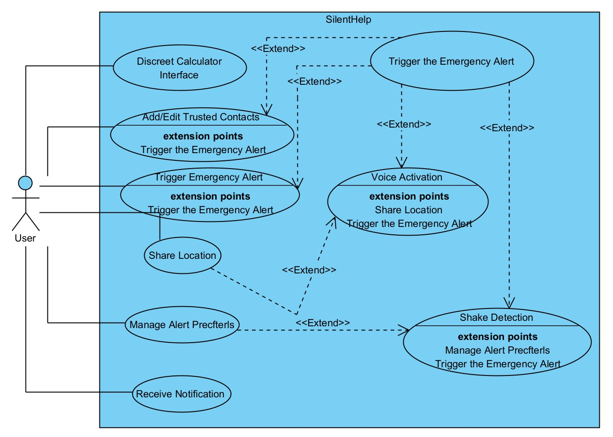
Figure 41: Use Case Diagram

The SilentHelp Use case diagram presents how users interact with the system as well as its functions. Discreet emergency functionalities are the primary functionality of the use case, while the login/register section has no significance in this use case (Anon., n.d.).
The actor on the left is the user, who uses various actions to interact with the system. The user first uses the calculator interface to disguise the app's look and feel as if it were a normal app. In addition, the user can add or edit trusted contacts – the people to whom they will send emergency alerts. Another key feature of the SilentHelp application is managing alert preferences, which allow users to adjust how alerts are sent out.
The primary function of the system is to activate an "Immediate Emergency Alert". In addition to the primary alert function, a variety of hidden methods exist for alerting users, including the following: voice activation/shaking detection. Users have the capability to manage their contacts and alerts via the user settings option from the user interface.
The Cloud Backend (Firebase) is located on the right side of the proposed architecture. This component is responsible for all activities related to data storage and communication. It provides a database for storing contacts, emergency alerts using cloud messaging, and user authentication (Anon., n.d.).
Finally, the user can choose to receive a notification that they have properly triggered the alert. The SilentHelp System completes all of these functions by completing the request and sending the alarm.
As shown in the diagram, the user interacts with a hidden calculator program to initiate emergency alarm signals through secret triggers, sends the user's current location to selected trusted parties, and provides the user with notification of the alert they have triggered (Anon., n.d.).

5.4.2 ERD
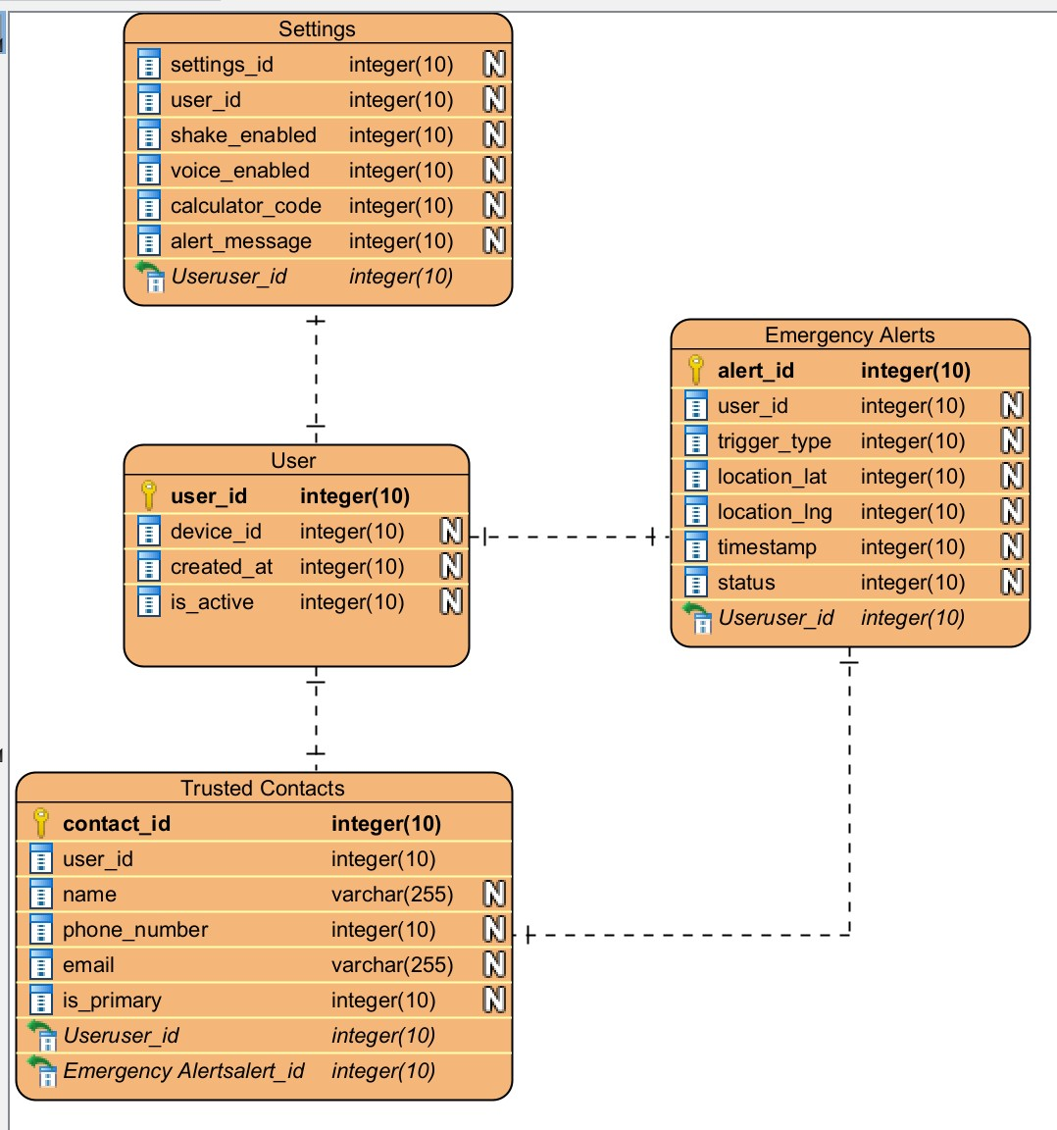
Figure 42: ERD Diagram

The ERD diagram shows how database entities relate to each other. The attributes and their relations are some of the considerations. In database creation, they are useful (Spatio-Temporal, 2010).

5.4.3 Activity Diagram

Figure 43: Activity Diagram

The process flow within a system is shown through an activity diagram. This shows the linkages among different processes, including decisions and conditions. This is useful when trying to understand the system's behaviour slowly (Baillieul & Antsaklis, 2007).

Chapter 6 Quality Assurance Evaluation

6.1 Testing Strategy/ plan
In SilentHelp testing methodology, features such as location sharing, sending alarms, hidden triggers, and the calculator screen will be tested separately, and after all, SilentHelp will be tested as a whole to ensure proper functioning of all its parts in case of an emergency situation. Moreover, in order to make sure that all sensors, background processes, and GPS (Whipple, et al., 2009) work well, SilentHelp will be tested on a real Android smartphone (Singh, n.d.).
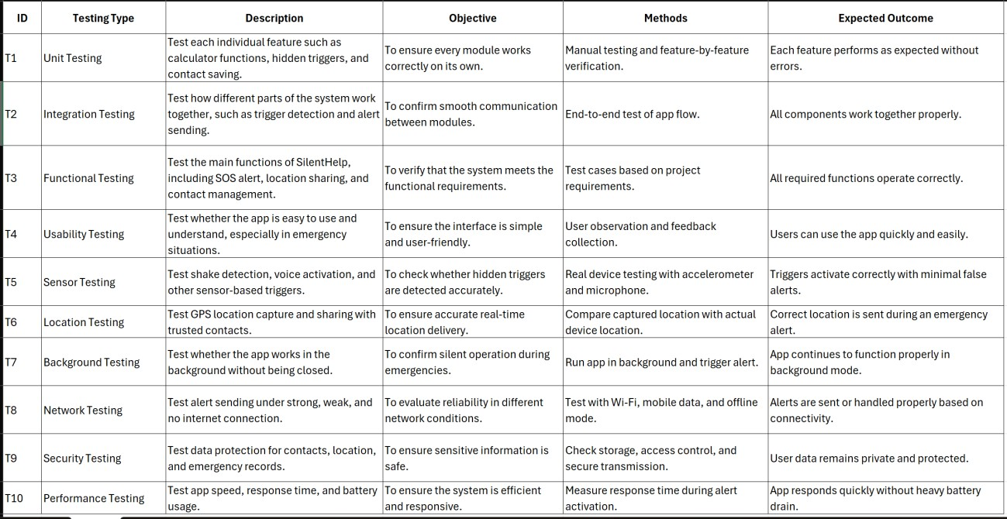
Table 6: Testing Strategy/ plan

6.1.1 Test Cases
The following test cases will be done after the development of SilentHelp to confirm the system works properly or not (Sommerville, 2016).
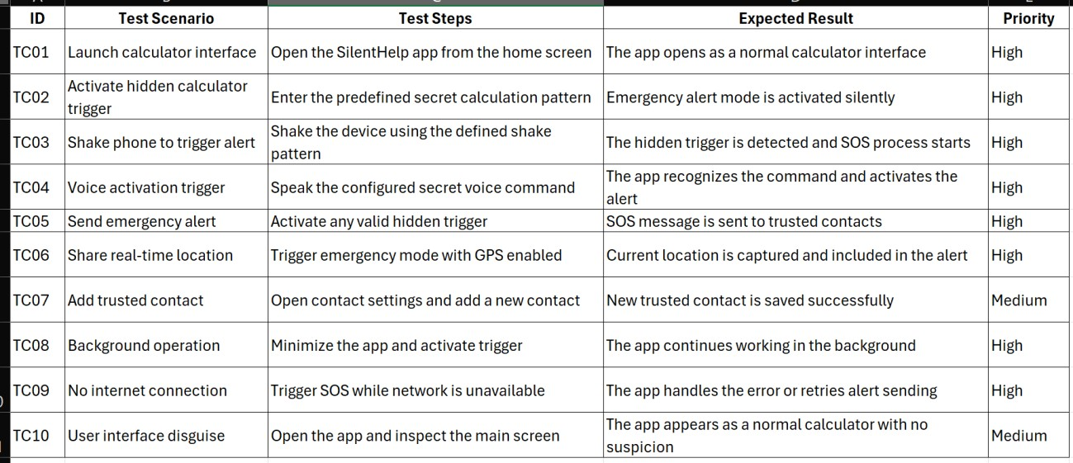
Table 7: Test Cases

6.2 Evaluation Strategy /Plan
The SilentHelp evaluation methodology (Anwar, 2023) will entail assessing whether the application achieves its main aim of providing silent emergency help. This will involve checking the speed at which the alerts are raised, assessing the accuracy of the covert trigger system, and checking how closely the application features meet the specifications (Sarkar, et al., n.d.). To comprehend usability, dependability, and efficacy, user feedback will be taken into account. Lastly, the outcomes will be used to pinpoint areas that need improvement.
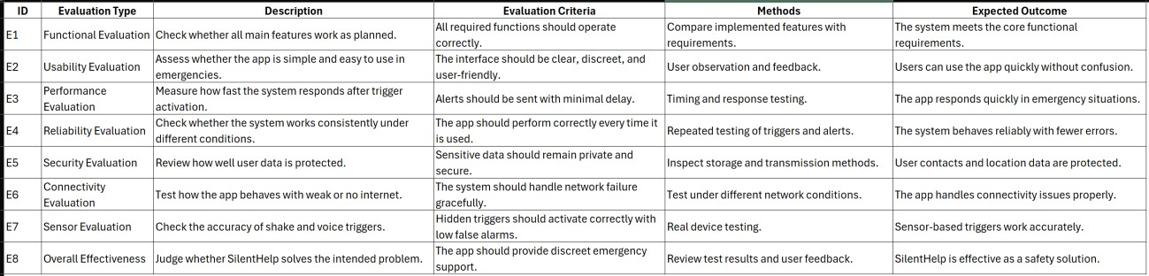
Table 8: Evaluation Strategy /Plan

Chapter 7 Critical Analysis and Implementation Plan
I've learned that the main competitive advantage of SilentHelp is how unassuming it is, allowing the user to call for help without being seen.
I also learned that the calculator disguise is a real benefit of the app, as it provides utility in the most discreet of scenarios, as it doesn’t look out of place.
At the same time, I noticed that some of the functionalities, like voice triggering and shake triggering, if not properly designed, may result in false negatives.
Background and location services being problematic is also a limitation of the app, as these operate differently on different Android versions.
Because of the reliance on the internet for functionality, I view the reliance on it as a weakness, especially because emergency alerts may be postponed if the network is poor or nonexistent. My first plan with the user interface was to use Flutter to make it look real and simple at the front so that I could later perform a hidden integration of the emergency contact management, location sharing, and hidden triggering. After that, I plan to use Firebase to integrate secure data management and alerting. I also planned for my testing to be modular, and I planned to do my testing to see how well the system performed in real-life scenarios. My main objective with this is to provide a practical and real problem that requires a system that is reliable, secure, and easy to use (Connor, n.d.).
Semester 1
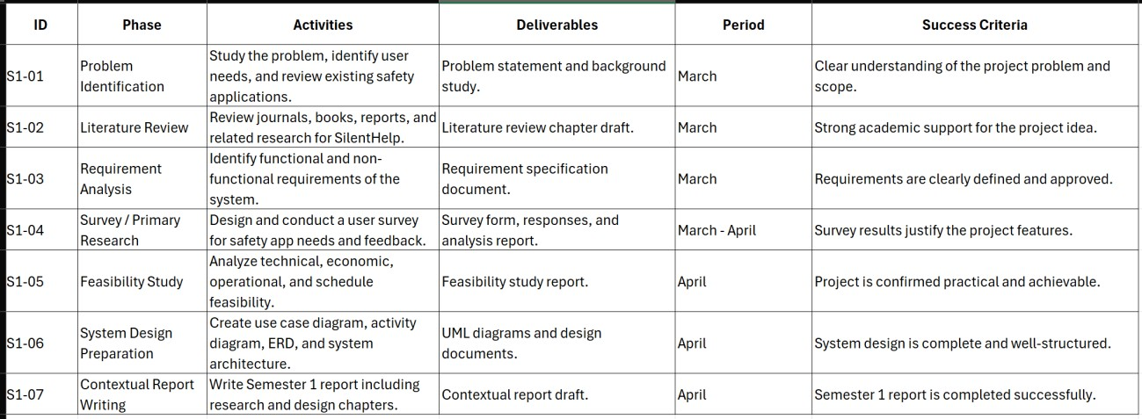
Table 9: Semester 1Implementation Plan
Semester 2
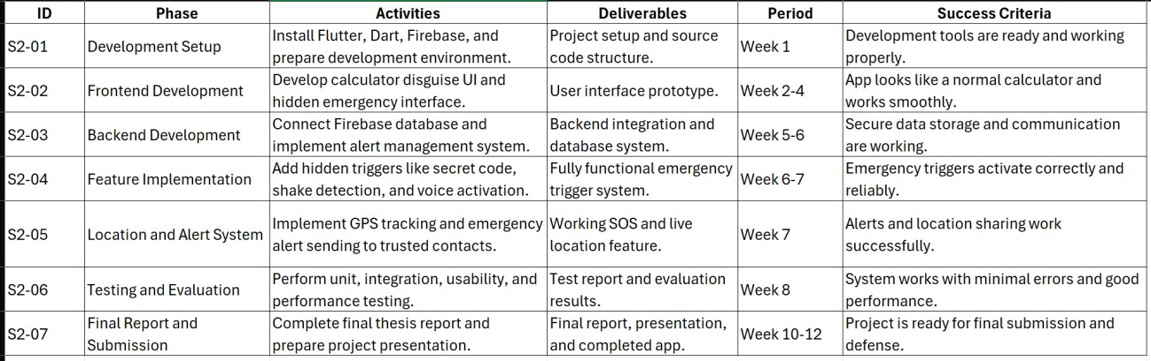
Table 10: Semester 2 Implementation Plan

Chapter 8 Conclusion
In conclusion, the SilentHelp project has addressed the urgent and impactful problem of protecting individuals’ personal safety when they cannot request help. Its construction is in a calculator-style UI with hidden voice activation, shake detection, and secret shake input. These features and design aid the system’s usefulness for people in dangerous situations, as they can send unsolicited emergency messages with their location attached to the system, being discreet.
My background in software engineering, mobile app development, and user design was used in conjunction with system design using reliable technologies like Firebase and Flutter to make a working prototype. I further developed my background in the importance of system design with respect to performance, privacy, and usability of the system, especially when the safety of the application is in question. I also gained more skills in the design, implementation, and testing of a mobile application to solve a specific problem (Isaias, 2022).
There were still some project goals unmet. These included the fact of being unreliable due to internet access, false activation of the application, and also due to different operating systems; the application could not work consistently. However, this shows that there is still a lot of improvement, especially with the precision the system will need to increase, more options for security alerts, and the system will need to provide an offline mode (Whipple, et al., 2009).
There is no doubt that SilentHelp shows the possibility for positive technological solutions for enhanced personal safety. Besides meeting the project goals of the specific research, the work also has potential for real-world use to assist people in dangerous situations.

References
Aditya Pakki, K. L. I. &. C., 2020. Exaggerated Error Handling Hurts! An In-Depth Study and ContextAware Detection.
Ali Tahmaseb, D. W. W. C. W. D., n.d. Computer Technology Applications in Surgical Implant Dentistry:
A Systematic Review. s.l.:s.n.
Anon., 2021. SOS. s.l.:s.n.
Anon., n.d. Developers. [Online]
Available at: https://developer.android.com/develop/sensors-andlocation/location/permissions/background?utm_source=chatgpt.com [Accessed 15 March 2026].
Anon., n.d. Developers. [Online]
Available at: https://developer.android.com/develop/sensors-andlocation/location/permissions/background?utm_source=chatgpt.com [Accessed 15 March 2026].
Anon., n.d. Firebase developer documentation. [Online]
Available at: https://firebase.google.com/docs?utm_source=chatgpt.com [Accessed 14 March 2026].
Anon., n.d. Flutter documentation. [Online]
Available at: https://docs.flutter.dev/?utm_source=chatgpt.com [Accessed 14 March 2026].
Anwar, C., 2023. The Application of Mobile Security Framework (MOBSF) and Mobile Application Security Testing Guide to Ensure the Security in Mobile Commerce Applications.
Baillieul, J. & Antsaklis, P. J., 2007. Control and Communication Challenges in Networked Real-Time Systems. 1 January, Volume 95, p. 28.
Bruno M.C. Silva a, J. J. R. I. d. l. T. D. M. L.-C. K. S. b., n.d. Mobile-health: A review of current state in 2015.
Chen, D. & Zhao, H., 2012. Data Security and Privacy Protection Issues in Cloud Computing. 23 March.

Cohen, A. R., n.d. Communication discrepancy and attitude change: A dissonance theory approach..
27(3).
Connor, J. J., n.d. Structural Motion Control. p. 9.
Deepti Sahu, S. S. V. D. A. T., n.d. Cloud Computing in Mobile Applications. p. 9.
Dr Claudia García-Moreno, M. g. ∙. P. K. H. P. ∙. A. F. L. d. P. ∙. J. K.-M. P. ∙. M. C. P. ∙. P. G. F. M., 2015.
The Lancet Journal. The health-systems response to violence against women, 5 February.385(9977).
Dr. Sridhar Mandapati, S. P. S. A., n.d. A Mobile Based Women Safety Application (I Safe Apps). p. 6.
Ensmenger, N., 2016. The Multiple Meanings of a Flowchart. Volume 51, p. 31.
Fernández-López, Á., 2013. Mobile learning technology based on iOS devices to support students with special education needs. February.
Gargenta, M., n.d. Learning Android. s.l.:s.n.
Graham C. Goodwin, S. F. G. M. E. S., 2000. CONTROL SYSTEM DESIGN. January.p. 1079.
Isaias, T. I. &. P., 2022. Usability and Human–Computer Interaction (HCI). s.l.:s.n.
Johnson, M. P., 2005. Domestic Violence: It's Not about Gender: Or Is It?. s.l.:s.n.
Khamis, H. A. a. A., n.d. DEVELOPMENT OF A LOCATION-BASED APPROACHING NOTIFICATION SYSTEM USING ANDROID PLATFORM. p. 13.
Mishra, N. C. a. P., 2016. Hidden Voice Commands. Austin: s.n.
Organization, W. H., 2024. Violence against women, s.l.: s.n.
Renee Wever, J. v. K. C. B., 2008. User‐centred design for sustainable behaviour. Jun.p. 20.
Sarkar, M., Haider, M. Z., Chowdhury, D. & Rabbi, G., n.d. An Android based human computer interactive system with motion recognition and voice command activation.
Shore, J., n.d. The Art of Agile Development. s.l.:s.n.
Singh, R., n.d. An Overview of Android Operating System and Its Security.
Sommerville, I., 2016. Software Engineering 6TH Edition. s.l.:s.n.
Spatio-Temporal, F. B. t., 2010. Introduction to Databases. s.l.:s.n.
Vladislav Volarevic, B. S. M. M. G. A. V. N. J. N. A. L. A. V. D. M. L. M. S., n.d. Ethical and Safety Issues of Stem Cell-Based Therapy.
Whipple, J., Arensman, W. & Boler, M. S., 2009. San Antonio: IEEE.
Whipple, J., Arensman, W. & Boler, M. S., 2009. A public safety application of GPS-enabled smartphones and the android operating system. 11 October.
Zhao, Y. et al., 2022. APIMatchmaker: Matching the Right APIs for Supporting the Development of Android Apps. s.l.:IEEE Transactions on Software.
Norman, D.A. (2014) The Design of Everyday Things. Cambridge, MA: MIT Press. Available at: https://mitpress.mit.edu/9780262525671/the-design-of-everyday-things/
Sommerville, I. (2021) Software Engineering. 10th edn. Harlow: Pearson. Available at: https://www.pearson.com/en-us/subject-catalog/p/softwareengineering/P200000003258/9780137503148
Devries, K.M., Mak, J.Y.T., García-Moreno, C., Petzold, M., Child, J.C., Falder, G., Lim, S., Bacchus, L.J., Engell, R.E., Rosenfeld, L. and Pallitto, C. (2013) ‘The global prevalence of intimate partner violence against women’, Science, 340(6140), pp. 1527–1528. Available at: https://pubmed.ncbi.nlm.nih.gov/23788730/
García-Moreno, C., Hegarty, K., d’Oliveira, A.F.L., Koziol-McLain, J., Colombini, M. and Feder, G. (2015) ‘The health-systems response to violence against women’, The Lancet, 385(9977), pp.
1567–1579. Available at: https://pubmed.ncbi.nlm.nih.gov/25467583/
Eisenhut, K., Sauerborn, R., Garcia-Moreno, C. and Vollhardt, J.R. (2020) ‘Mobile applications addressing violence against women: A systematic review’, BMJ Global Health, 5(4), e001954.
Available at: https://pubmed.ncbi.nlm.nih.gov/32399255/
O’Campo, P., Smylie, J., Dunn, J.R., Adair, C.E. and Kiran, T. (2021) ‘Design and Development of a
Suite of Intimate Partner Violence Screening and Safety Planning Web Apps: User-Centered Approach’, Journal of Medical Internet Research, 23(12), e24114. Available at:
https://pubmed.ncbi.nlm.nih.gov/34931998/
Tangari, G., Ikram, M., Ijaz, K., Kaafar, M.A. and Berkovsky, S. (2021) ‘Mobile health and privacy: cross sectional study’, BMJ, 373, n1248. Available at: https://www.bmj.com/content/373/bmj.n1248
Lane, N.D., Miluzzo, E., Lu, H., Peebles, D., Choudhury, T. and Campbell, A.T. (2010) ‘A survey of mobile phone sensing’, IEEE Communications Magazine, 48(9), pp. 140–150. Available at:
https://dl.acm.org/doi/10.1109/MCOM.2010.5560598
Caro-Alvaro, S., López-de-Ipiña, D. and Laucirica, X. (2024) ‘Gesture-Based Interactions: Integrating Accelerometer and Gyroscope Sensors in Mobile Apps’, Sensors, 24(3), 1004. Available at: https://www.mdpi.com/1424-8220/24/3/1004
World Health Organization (2024) Violence against women. Available at: https://www.who.int/newsroom/fact-sheets/detail/violence-against-women
Android Developers (2026) Request location permissions. Available at: https://developer.android.com/develop/sensors-and-location/location/permissions
Flutter (2025) Flutter architectural overview. Available at: https://docs.flutter.dev/resources/architectural-overview
Firebase (2025) Firebase documentation. Available at: https://firebase.google.com/docs
Beck, K., Beedle, M., van Bennekum, A., Cockburn, A., Cunningham, W., Fowler, M. and Grenning, J. (2001) Manifesto for Agile Software Development. Available at: https://agilemanifesto.org/
OWASP (2026) Mobile Application Security Verification Standard (MASVS). Available at:
https://mas.owasp.org/MASVS/

Appendix

Project Proposal (Scanned)

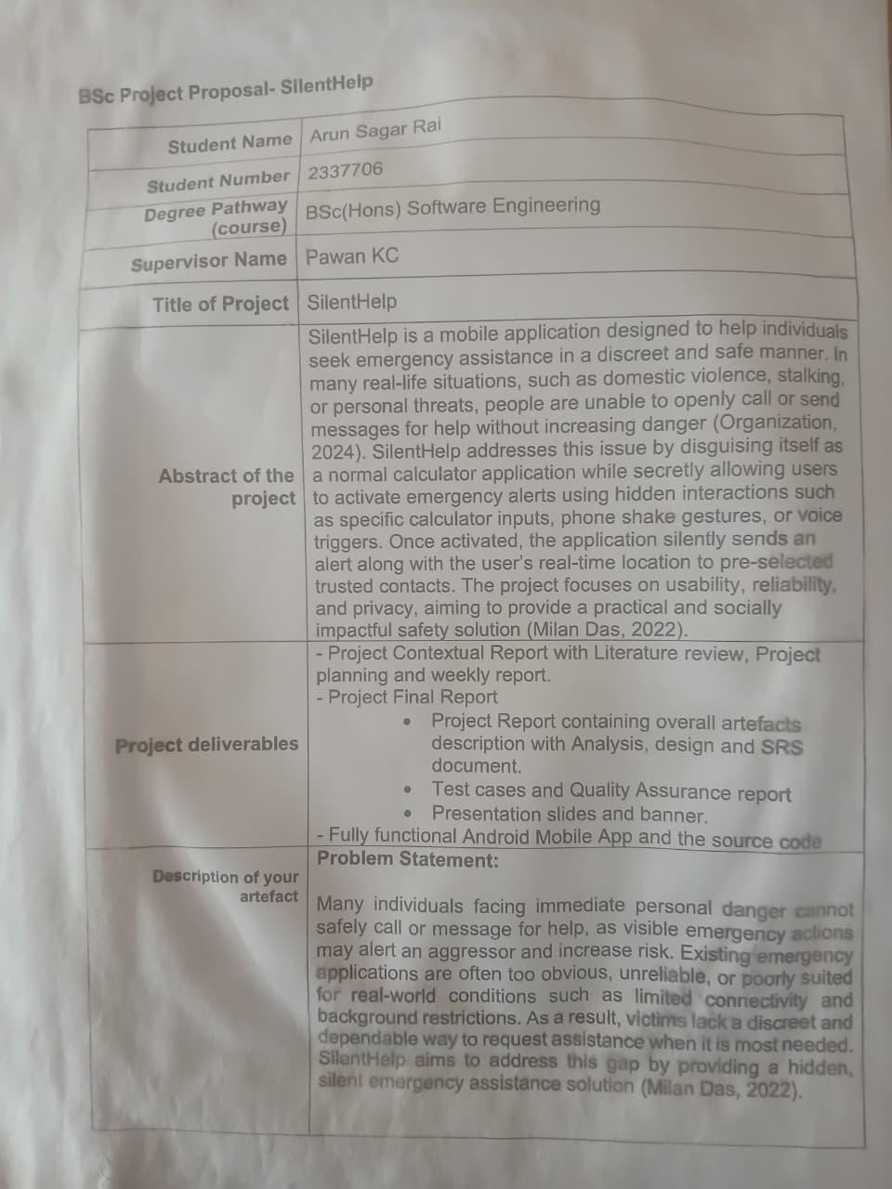
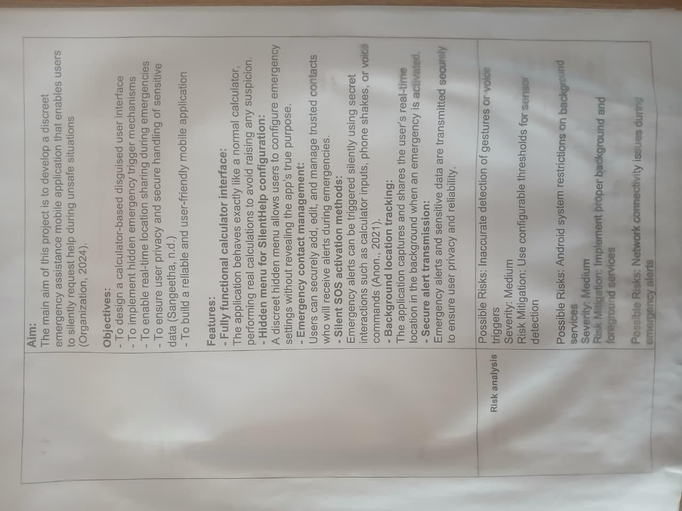

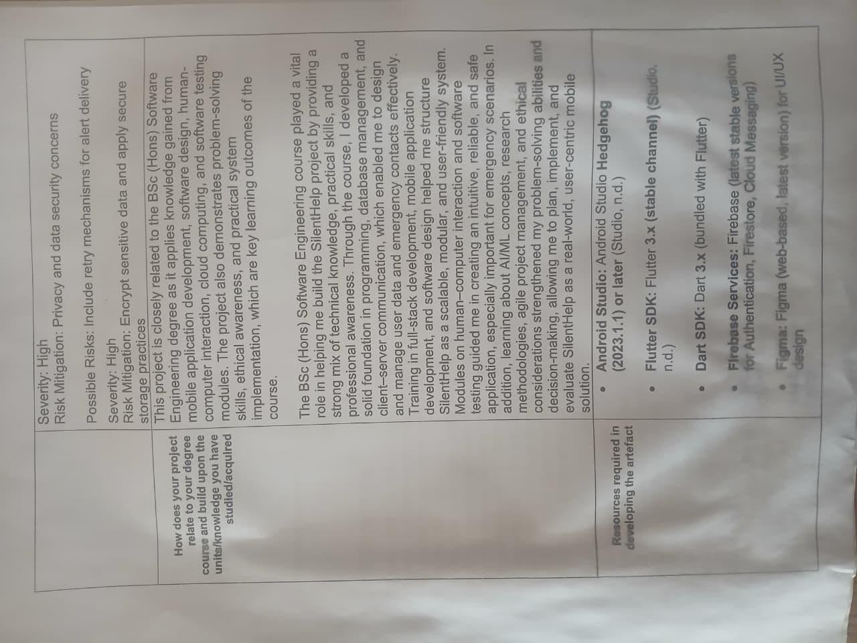
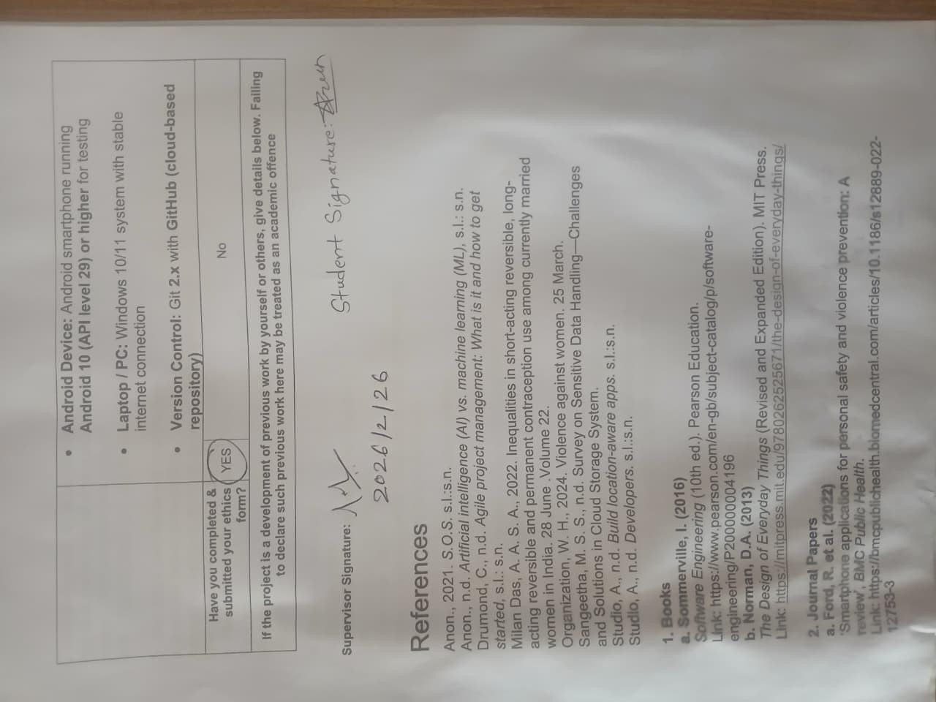
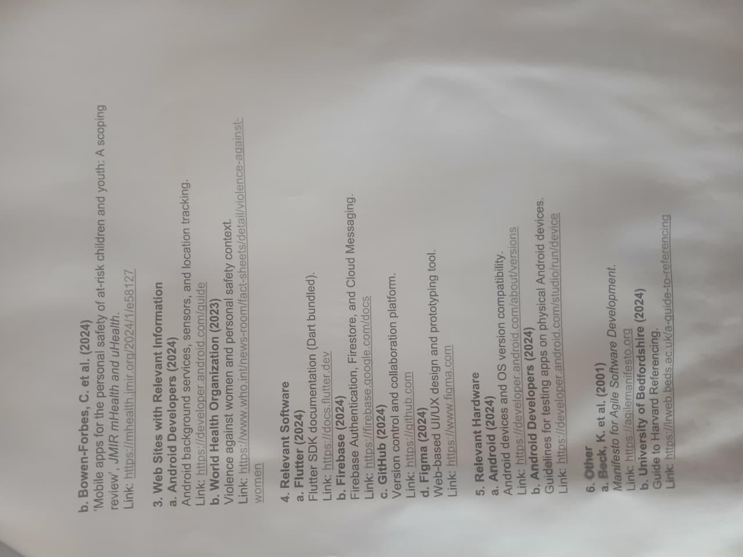

Ethics form (Scanned)
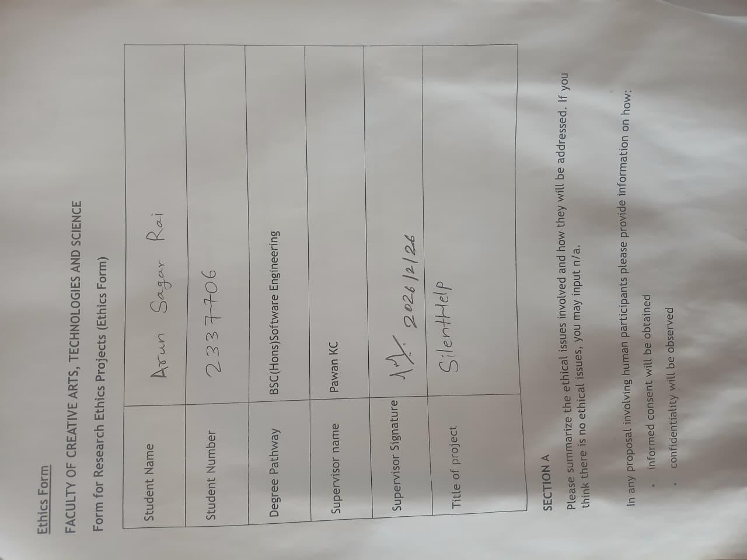
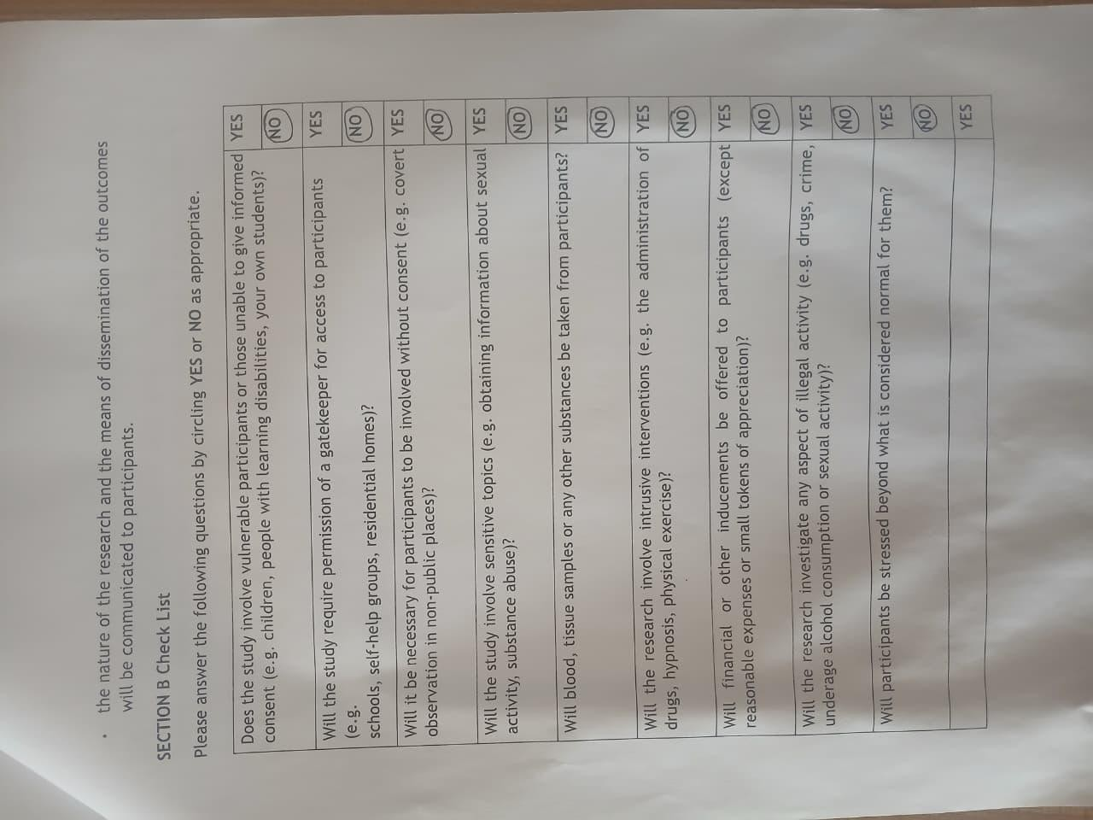


Gantt Chart Image

PRIMARY MARKET RESEARCH OUTCOMES

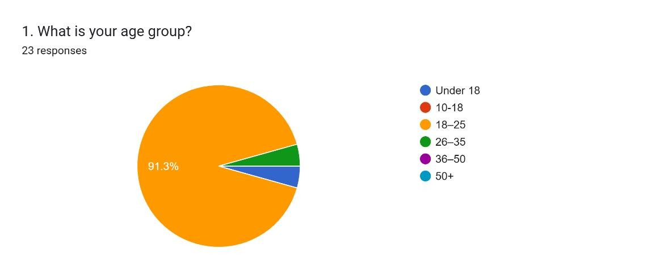
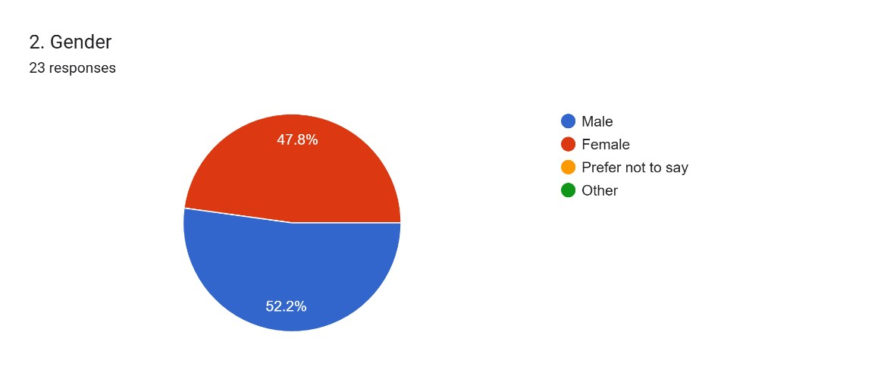
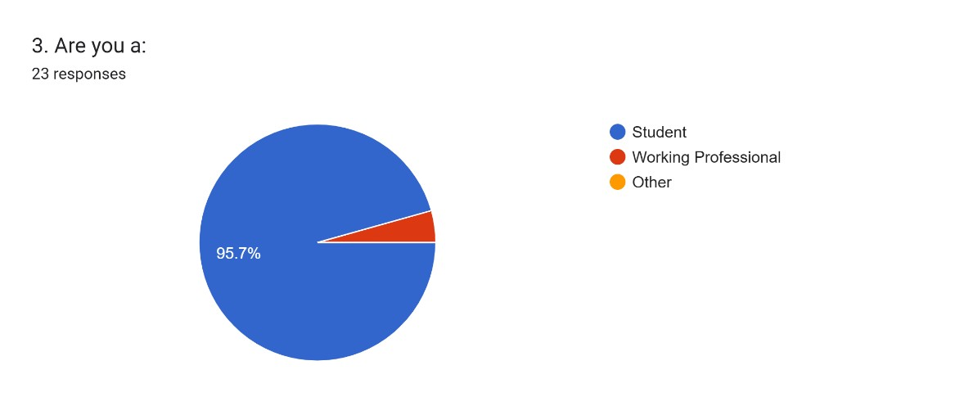
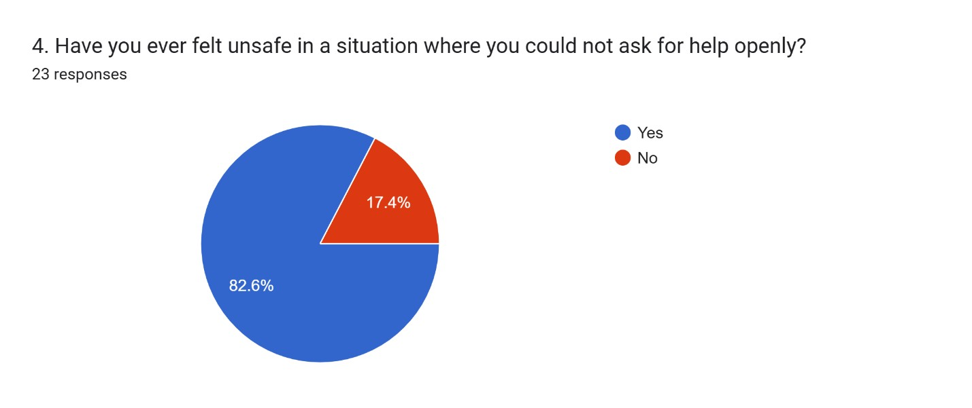
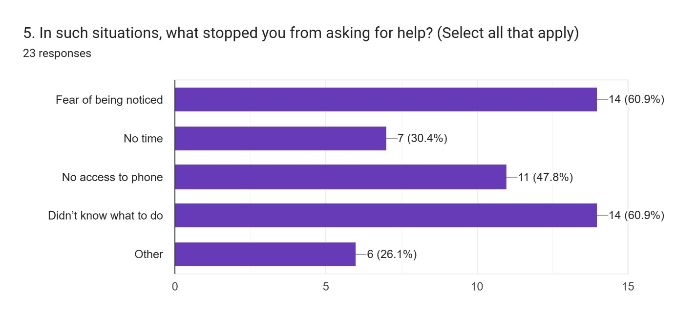
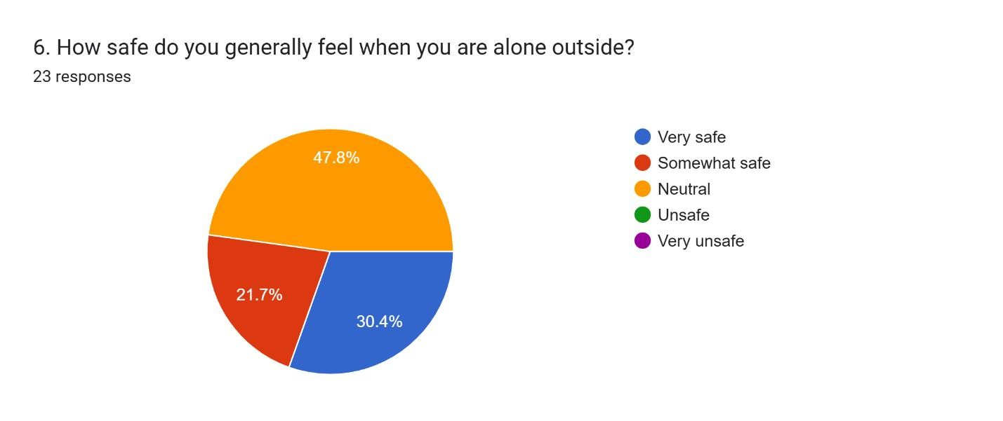
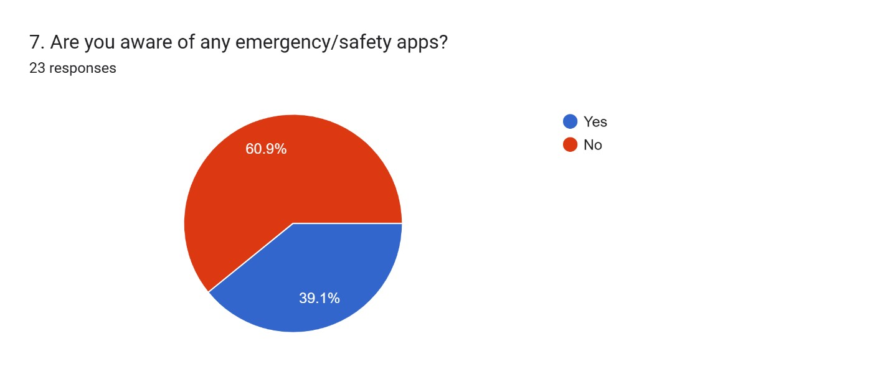
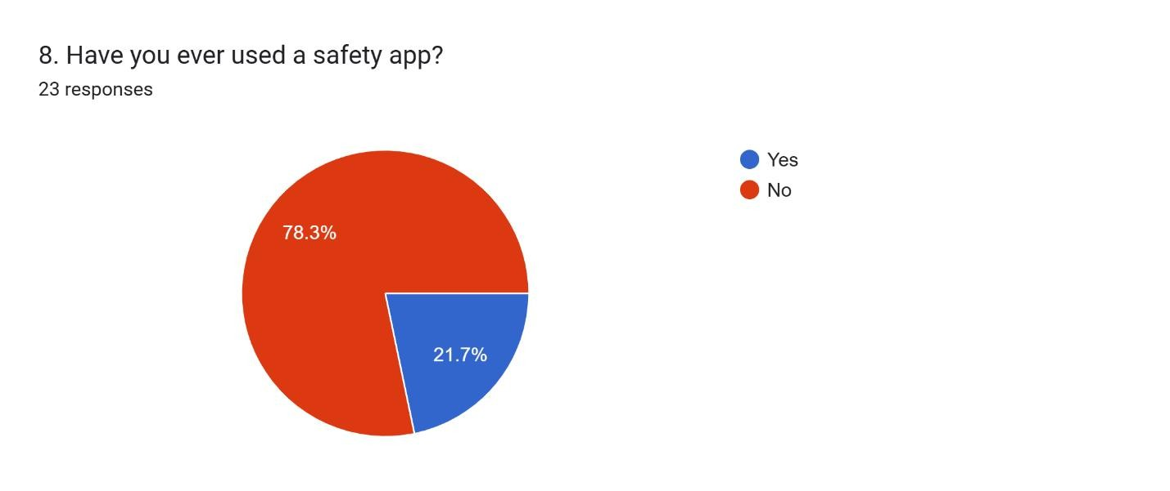
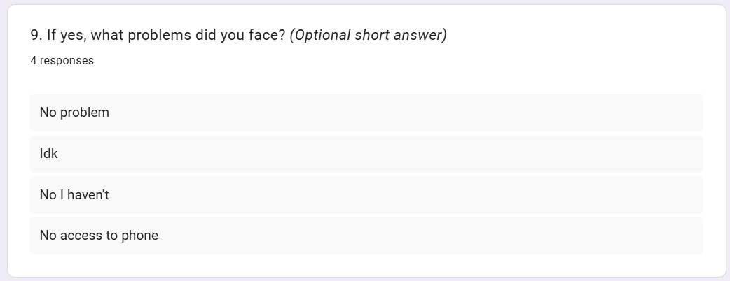
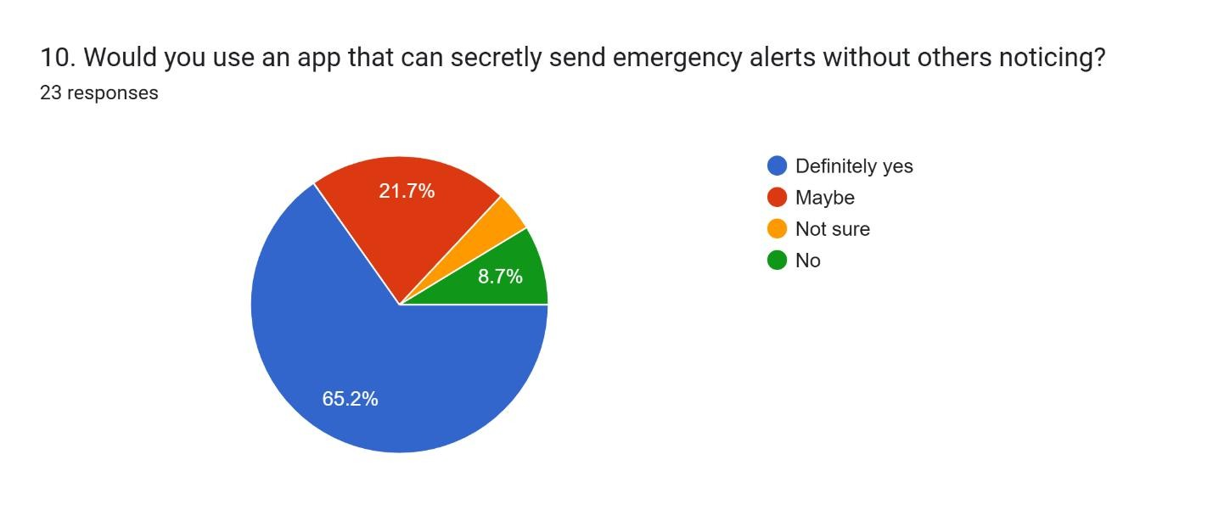
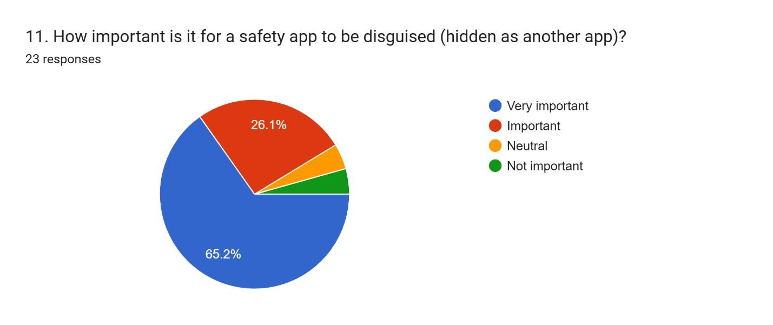
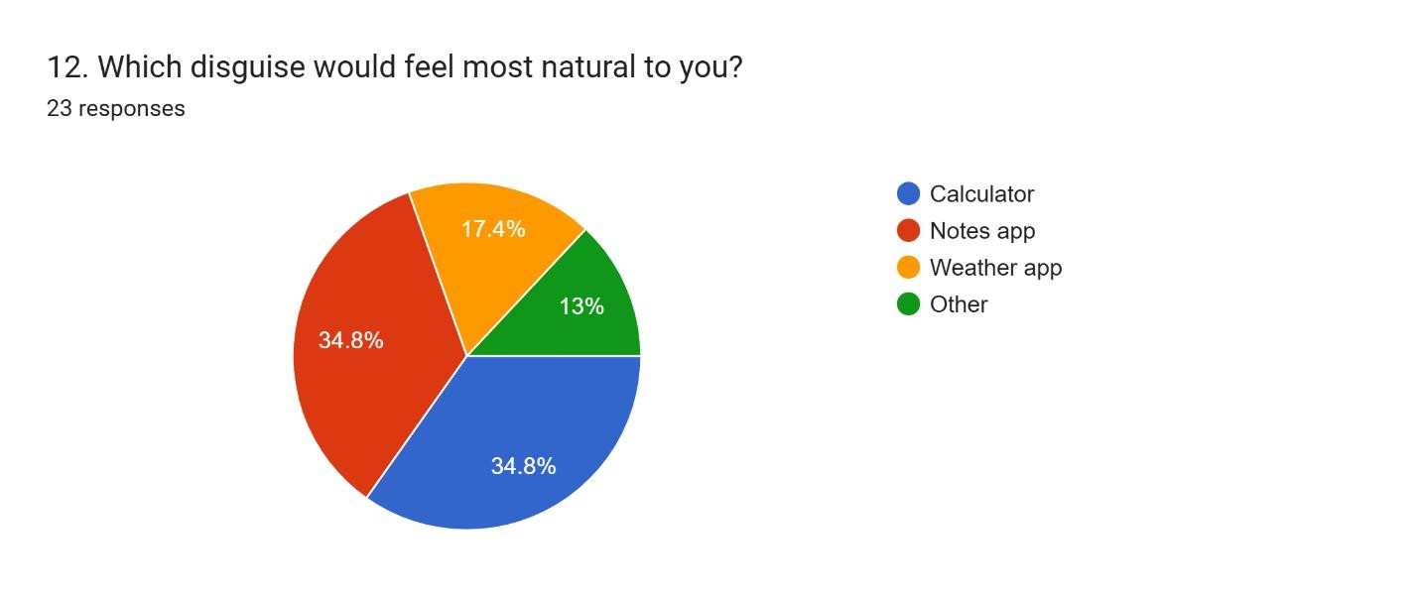
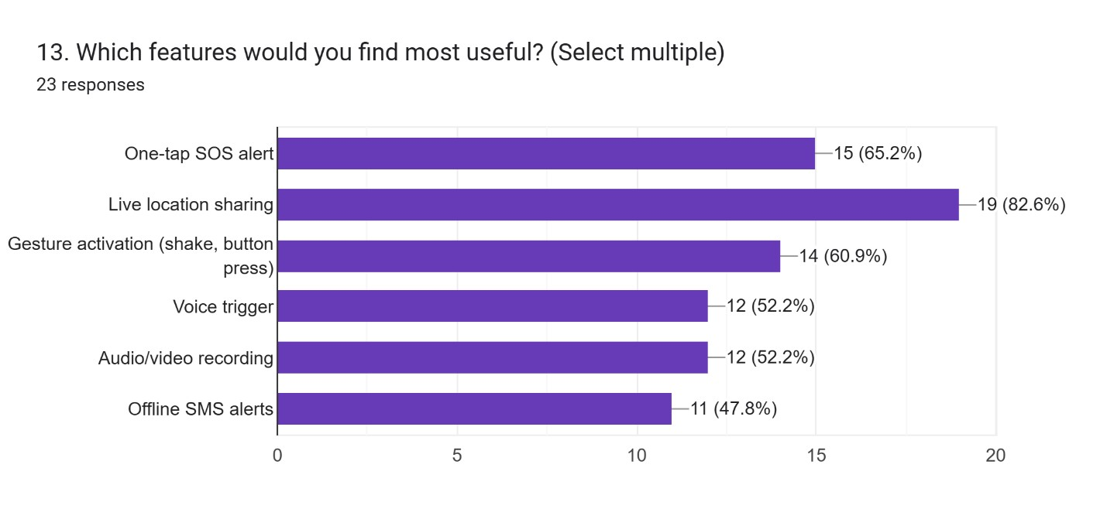
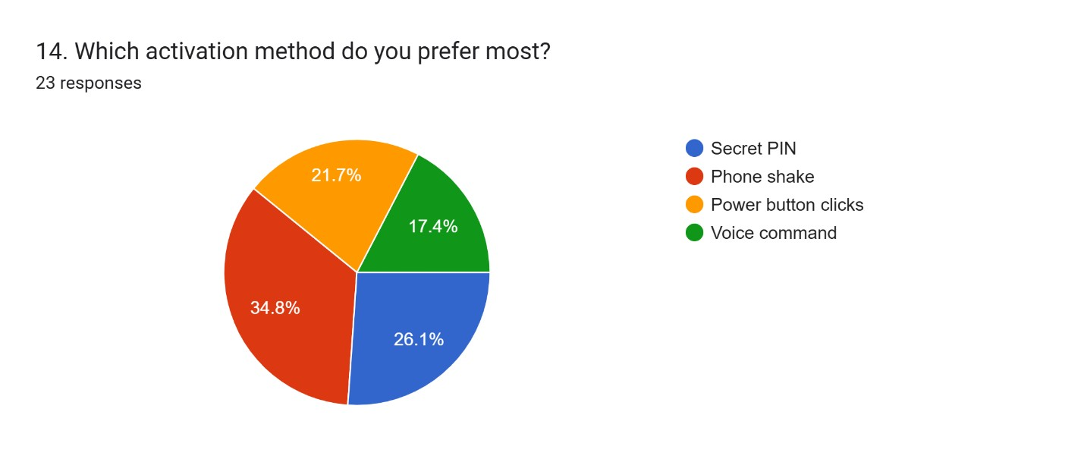
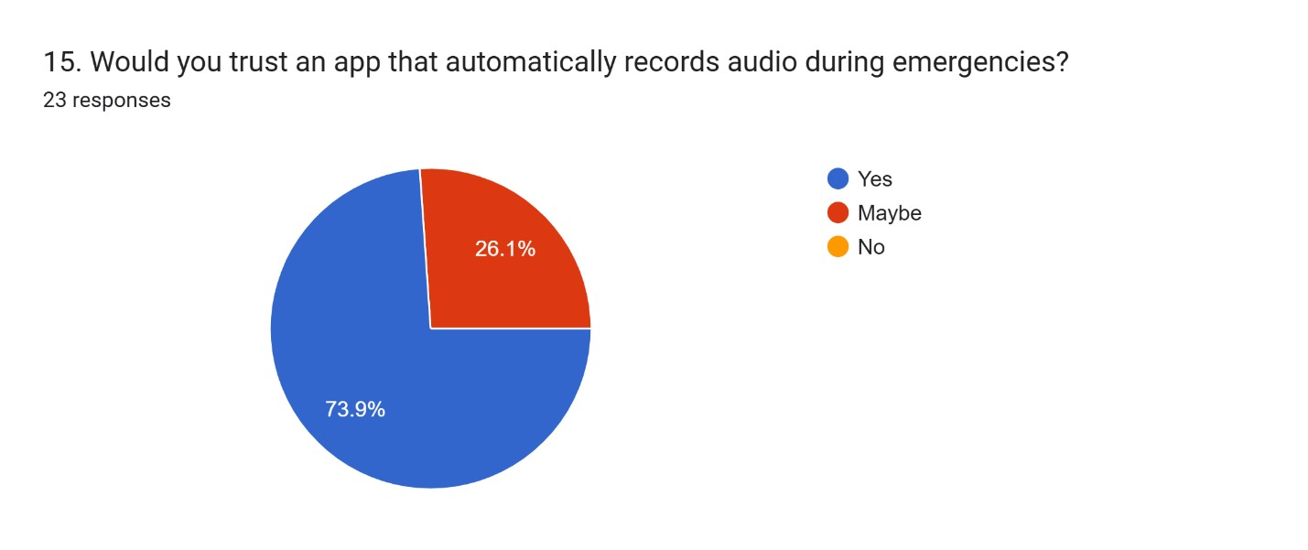
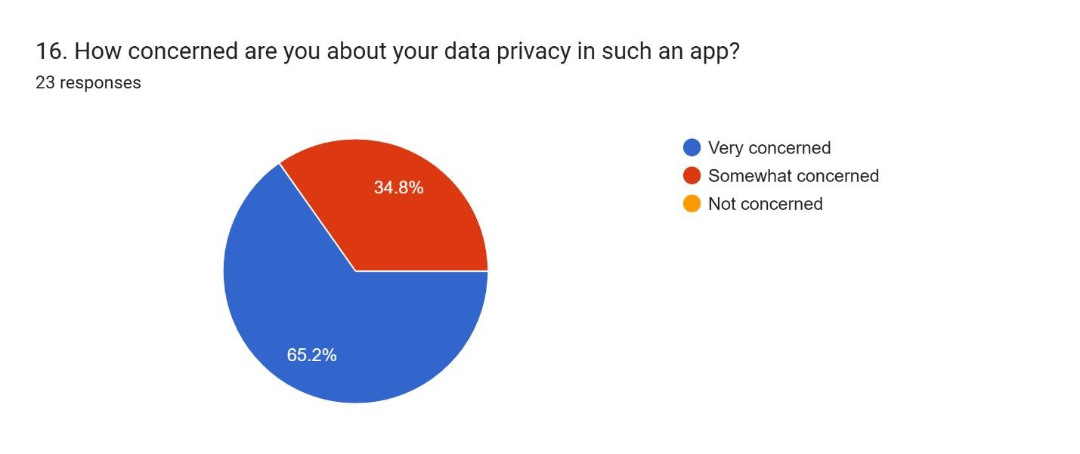
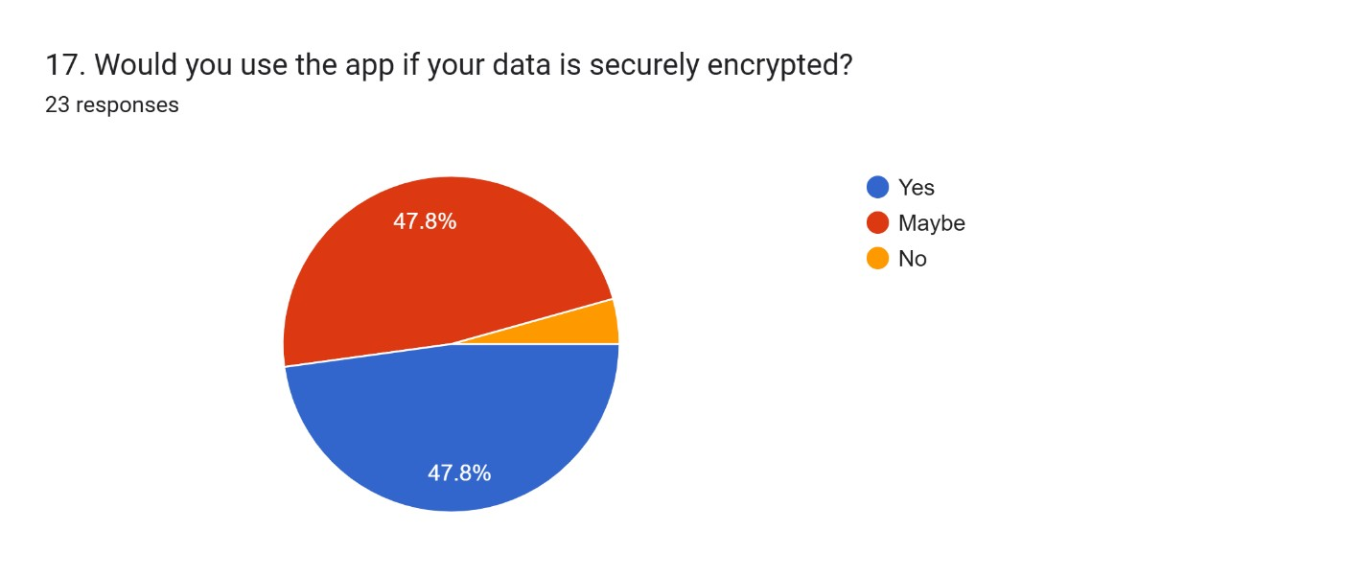
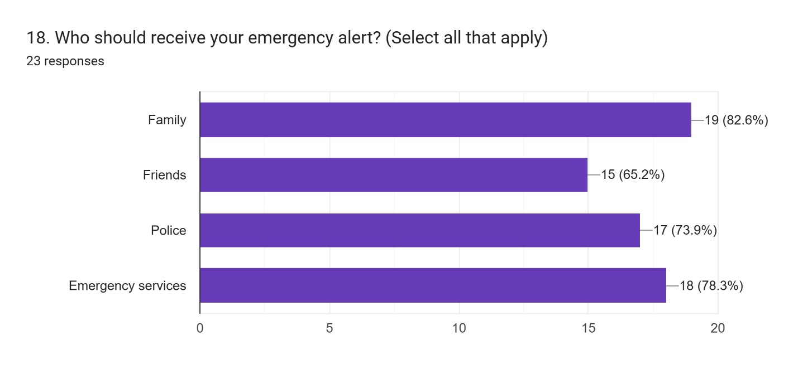
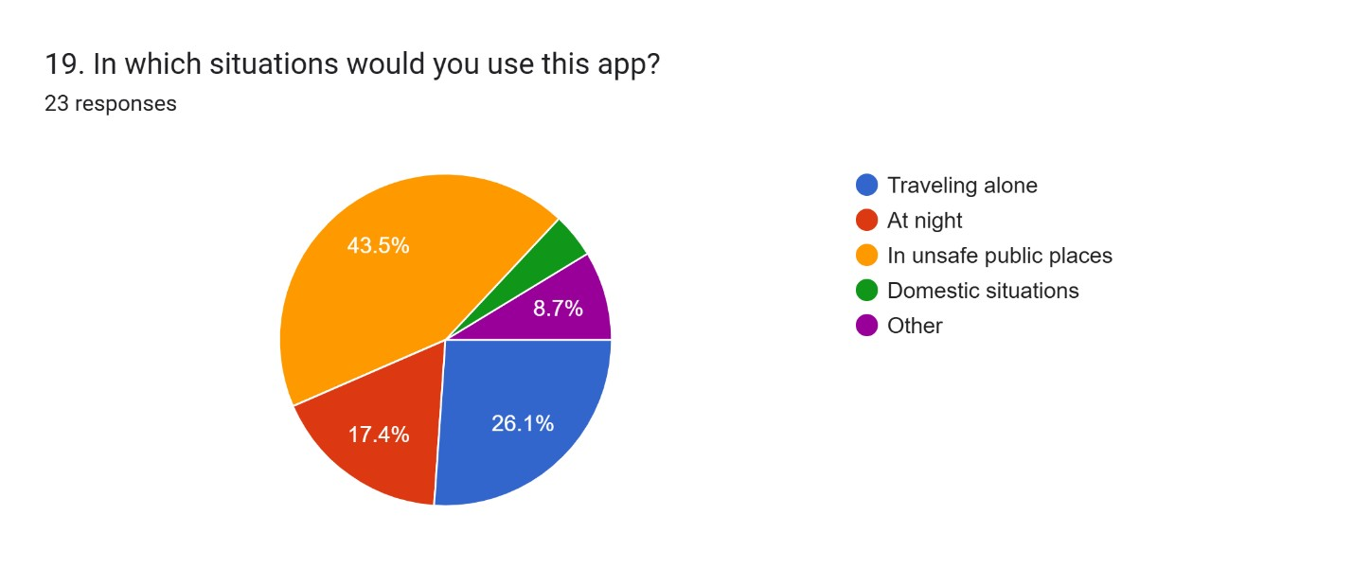
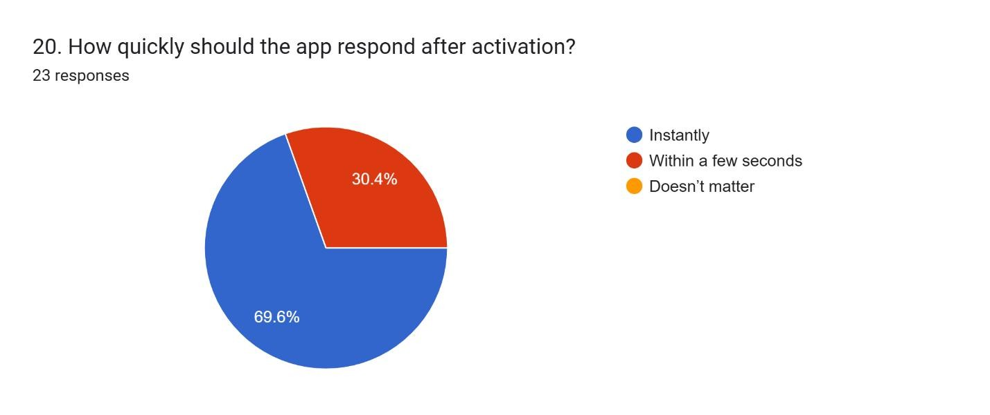
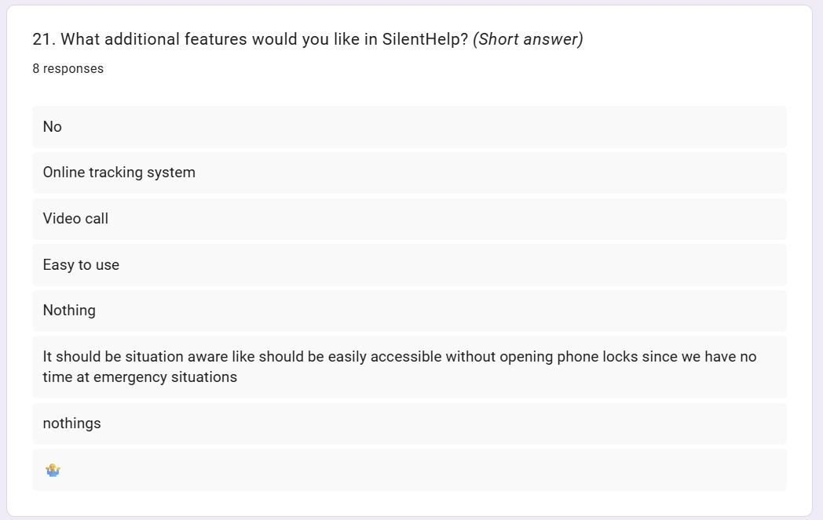
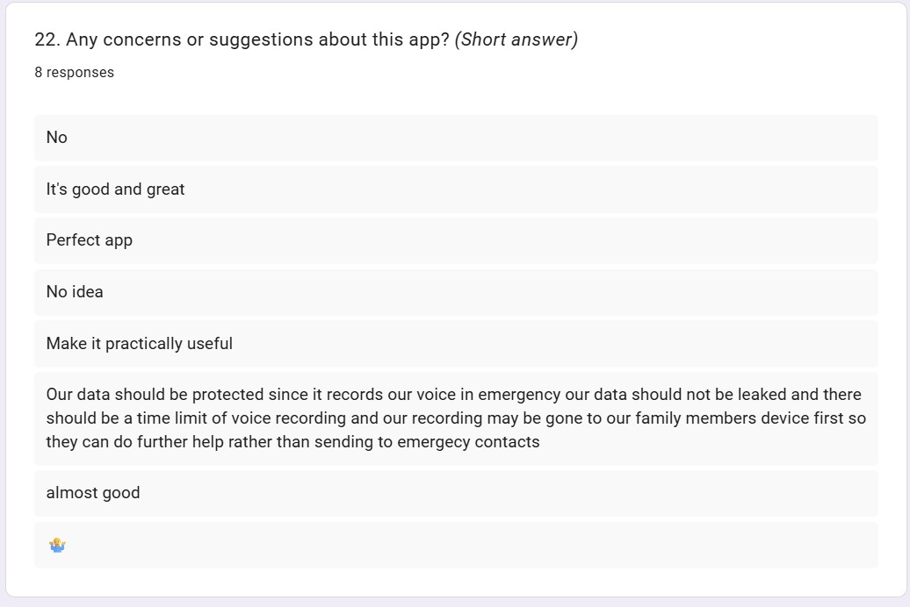

Anything related to LR (Screenshot of relevant resources)

Google Scholar
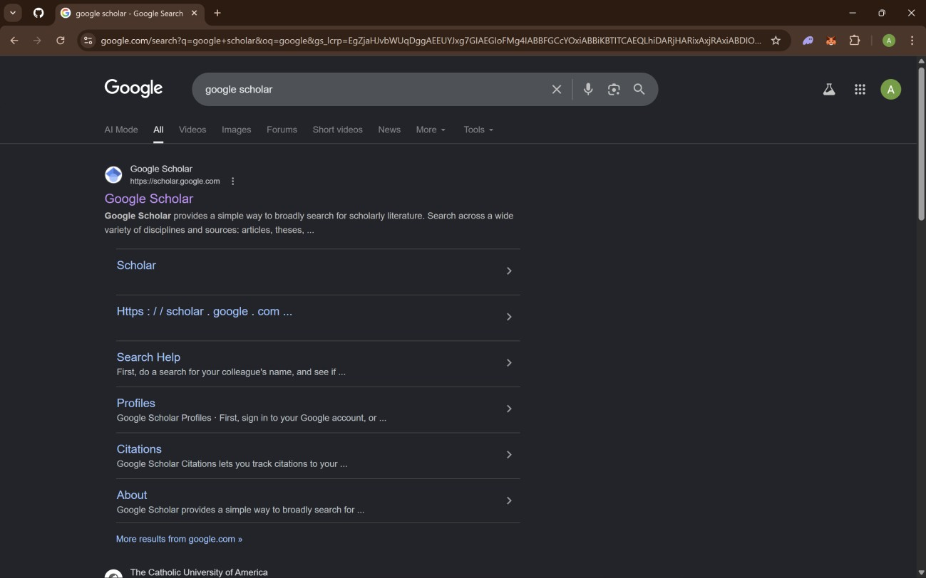

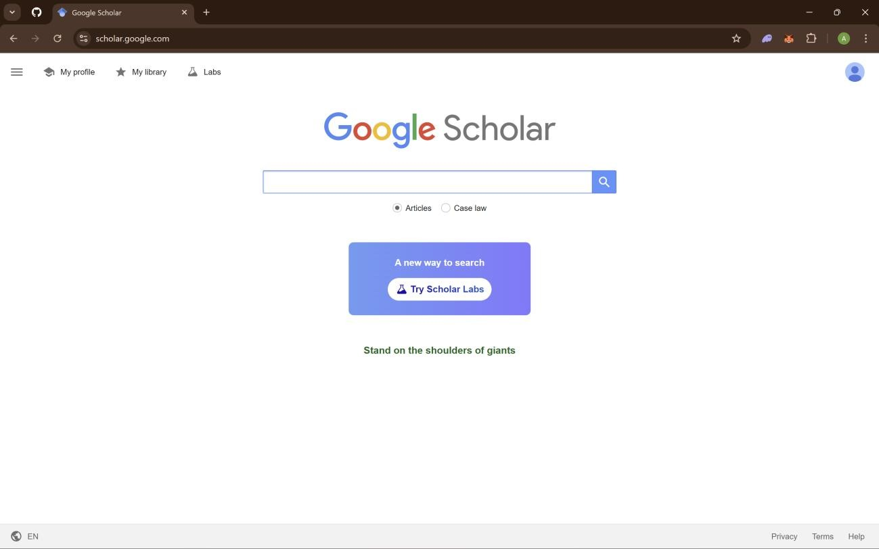
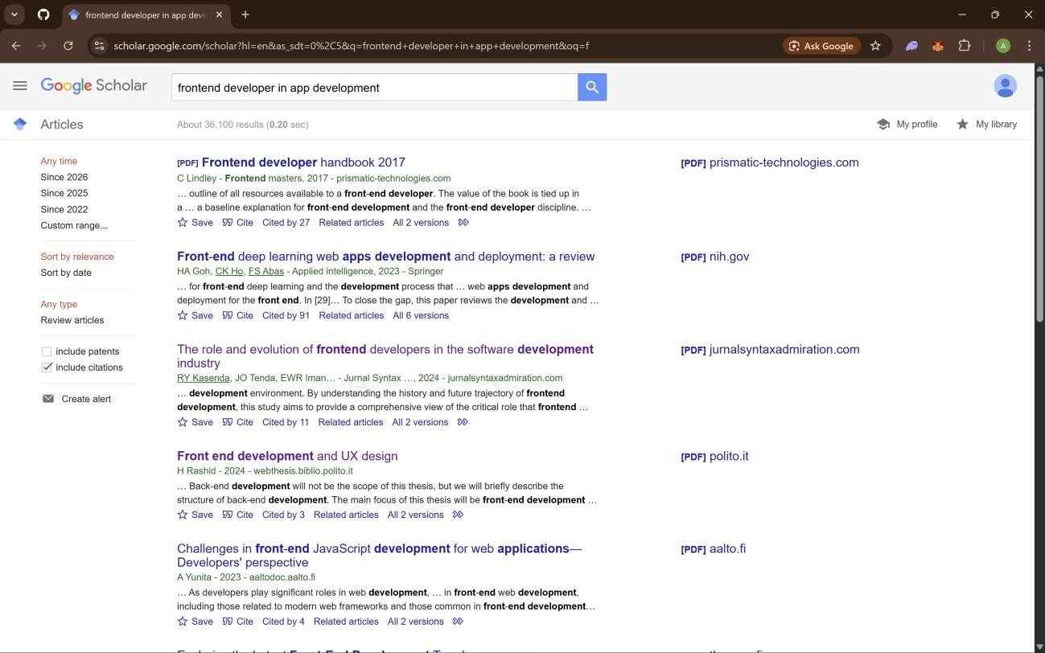

Survey form (questionnaire and the report)

Raw Data (All collected data that is not processed)

Weekly reports (scanned weekly reports)

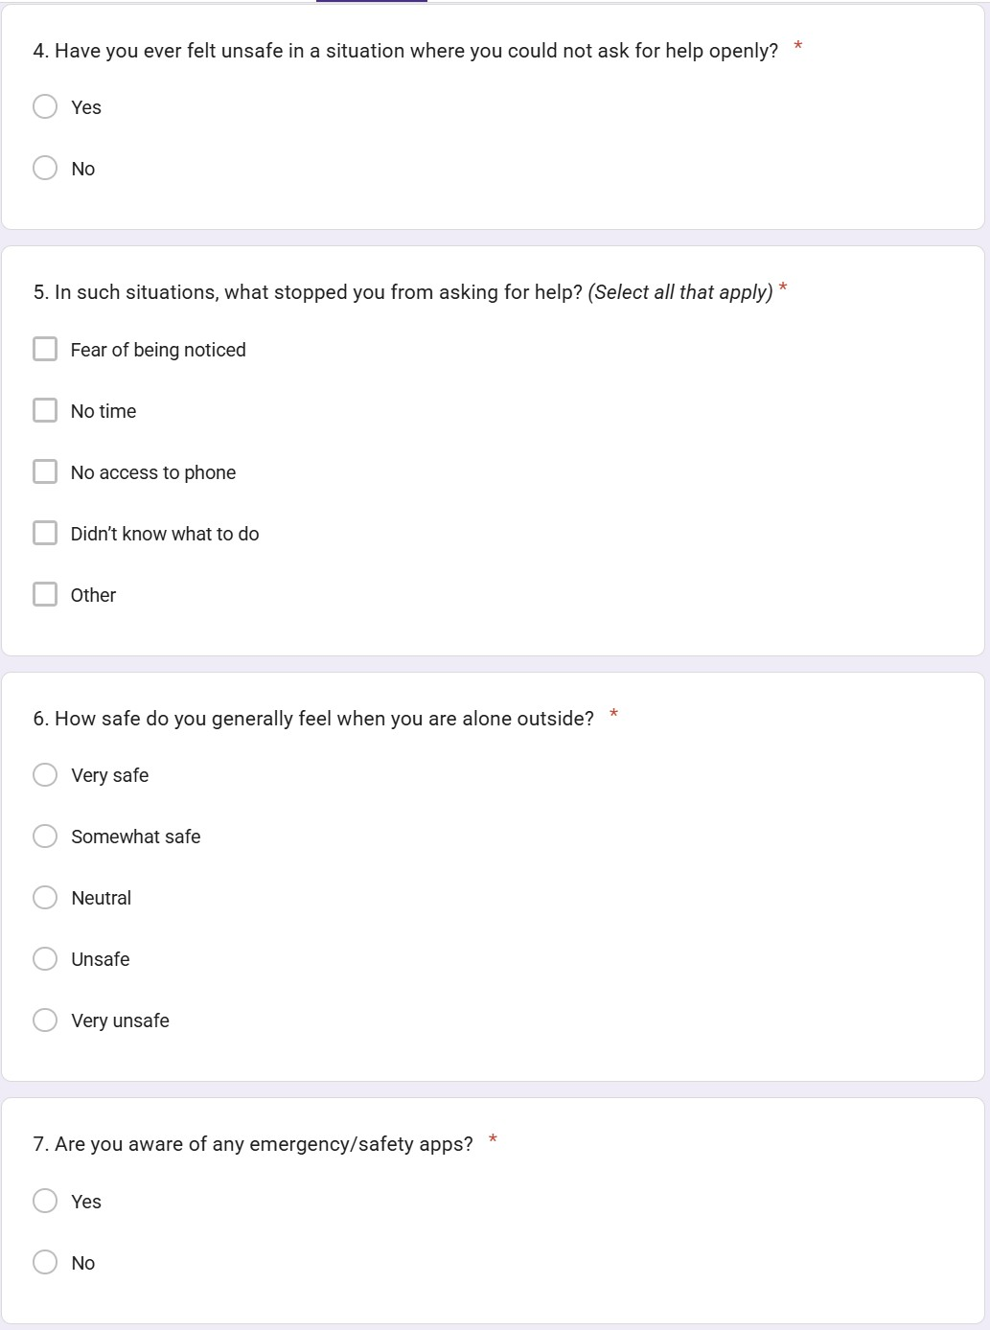

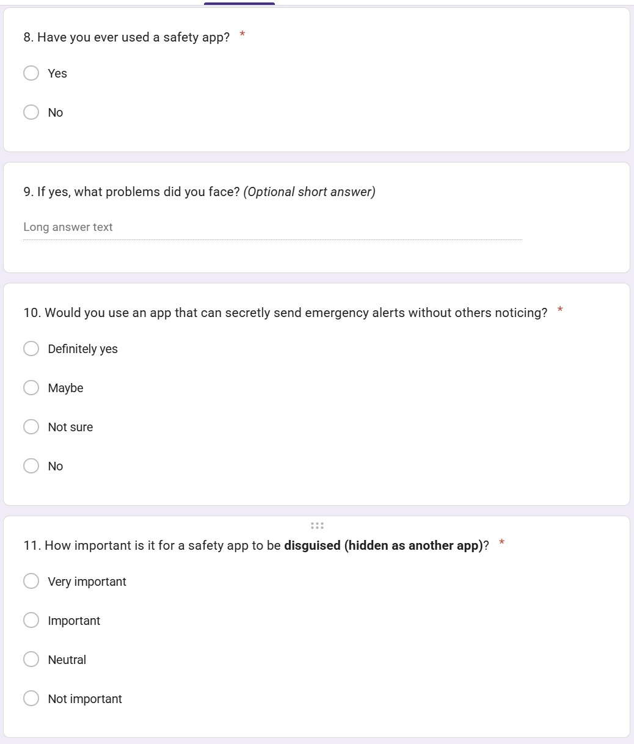
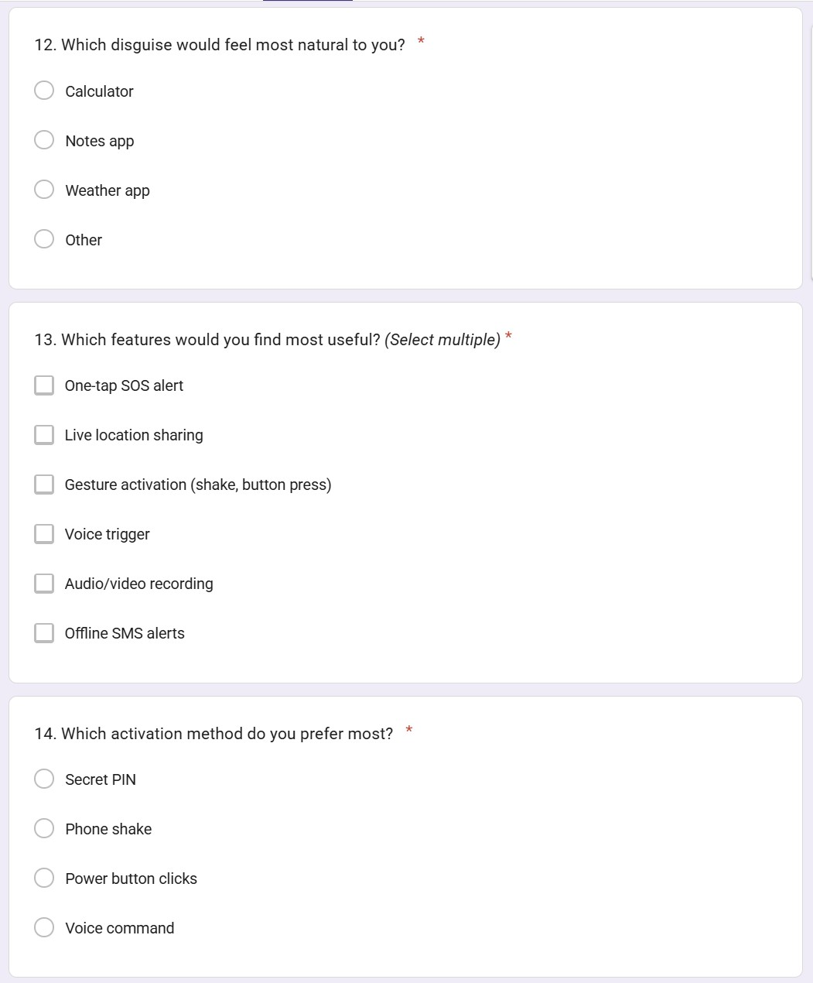
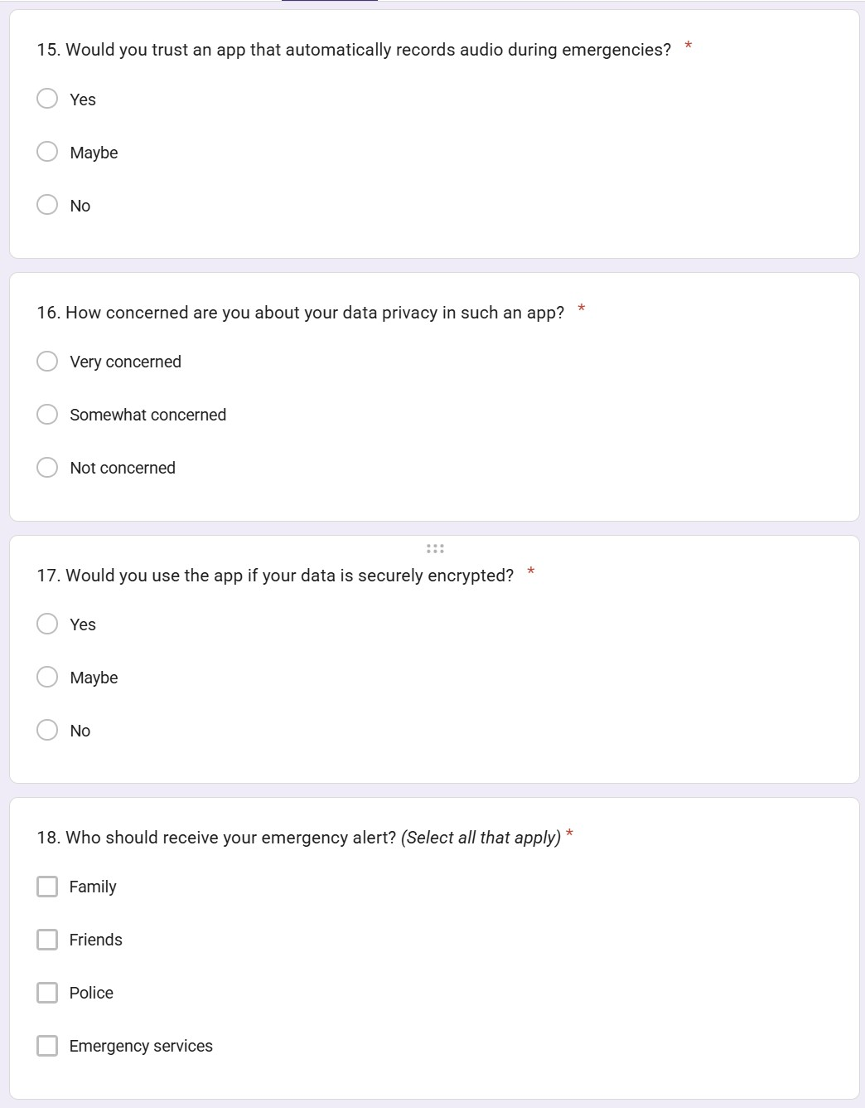
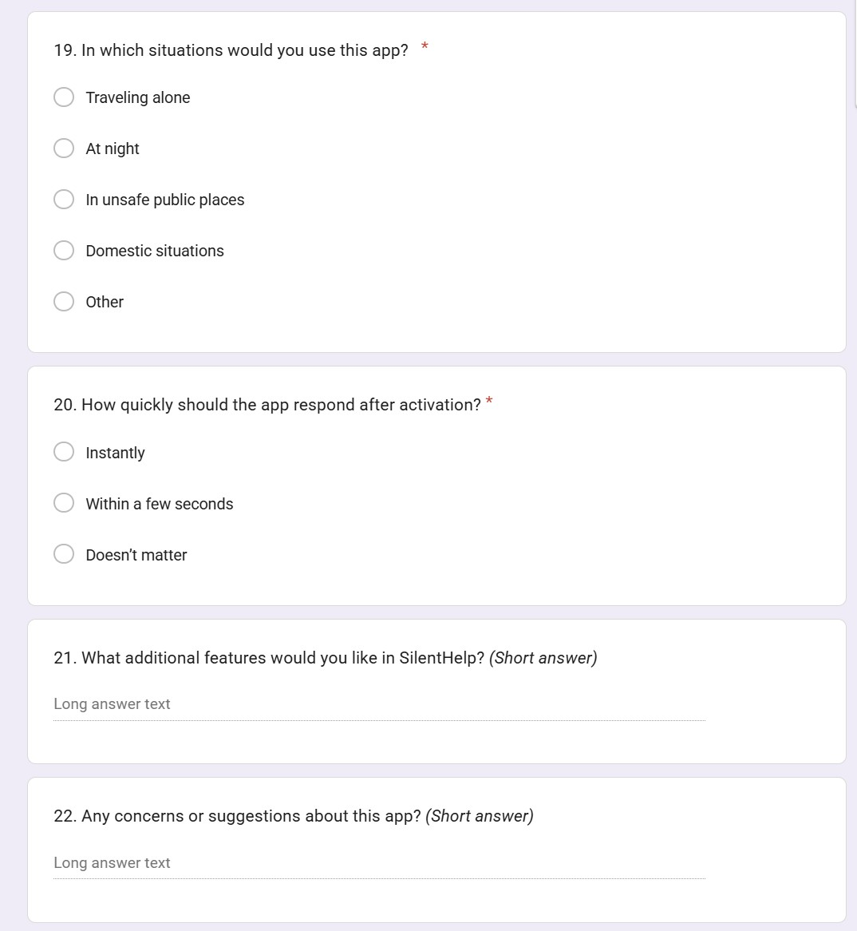

Raw Data (All collected data that is not processed)
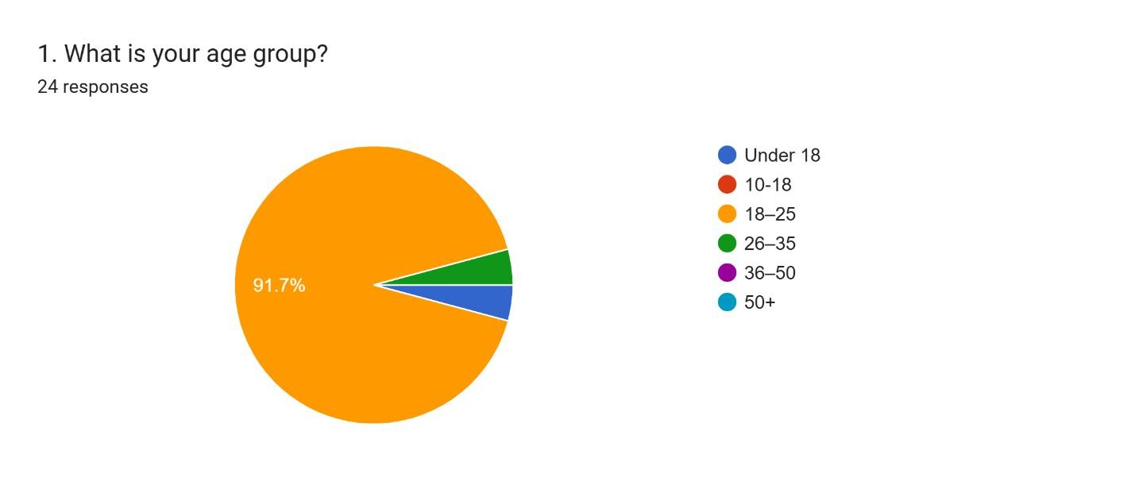
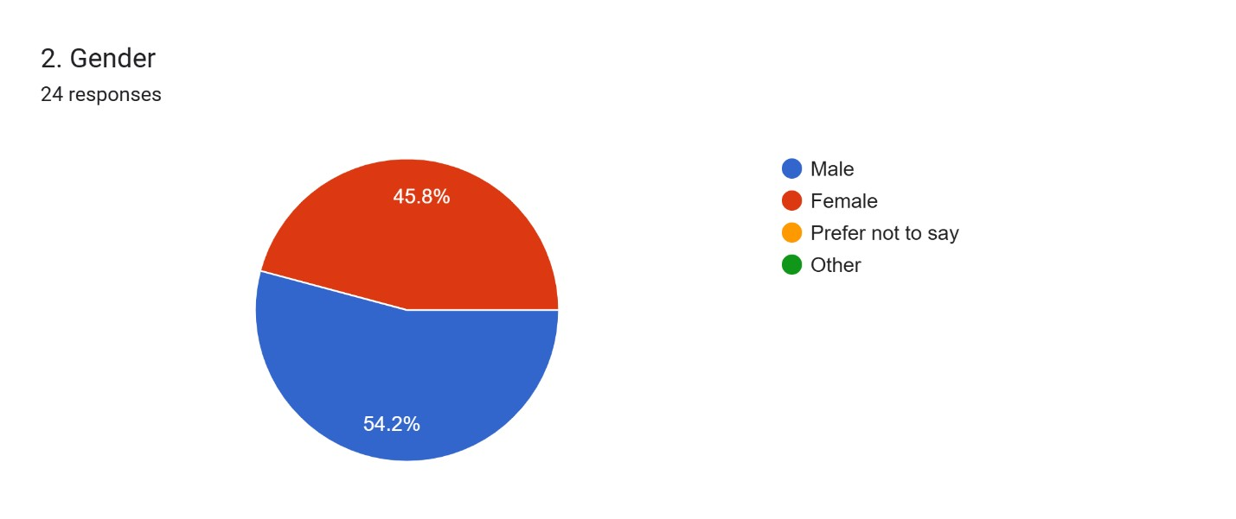
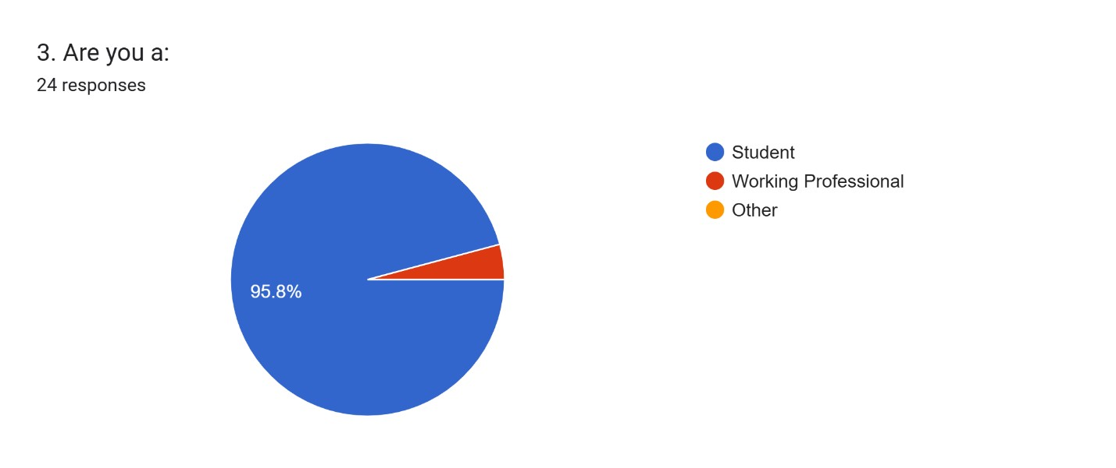
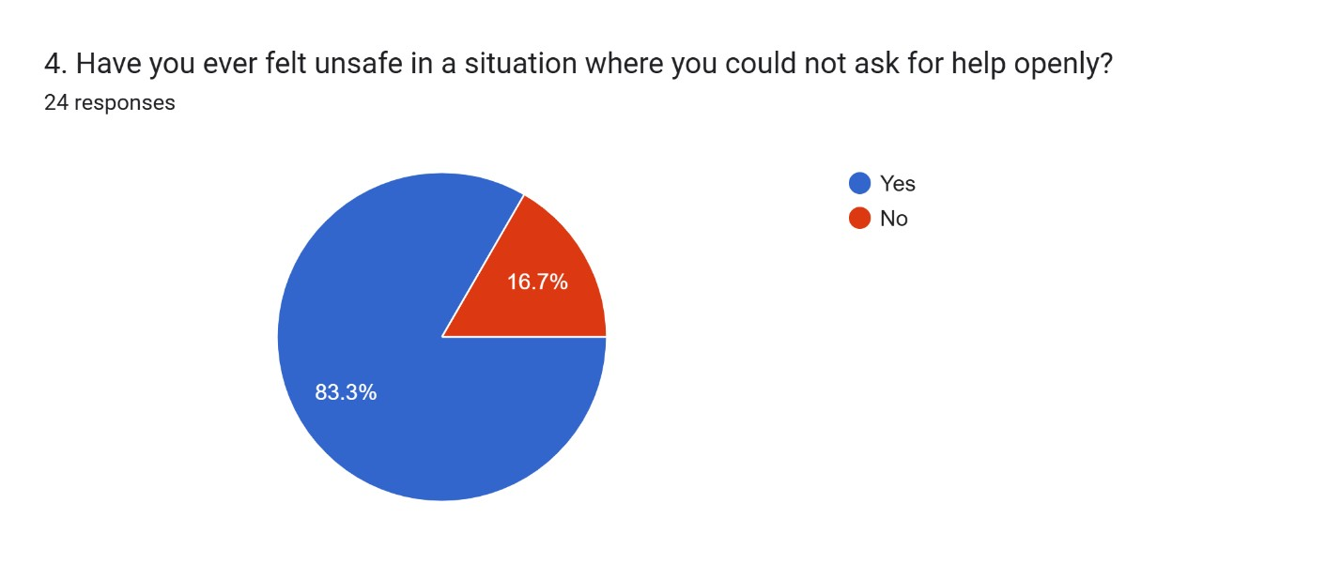
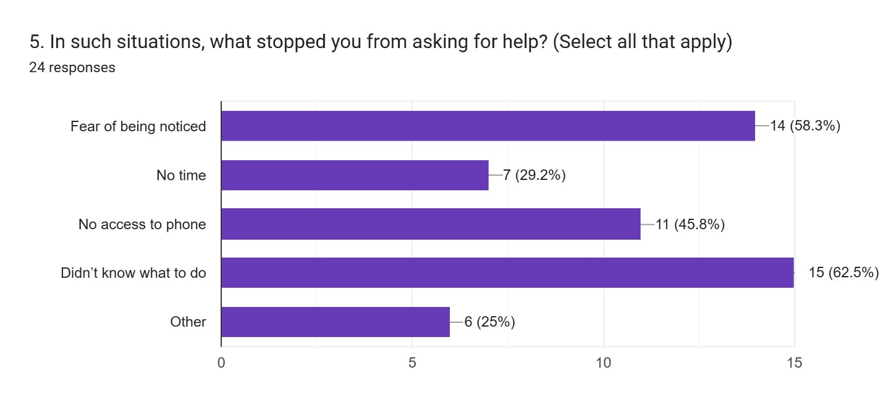
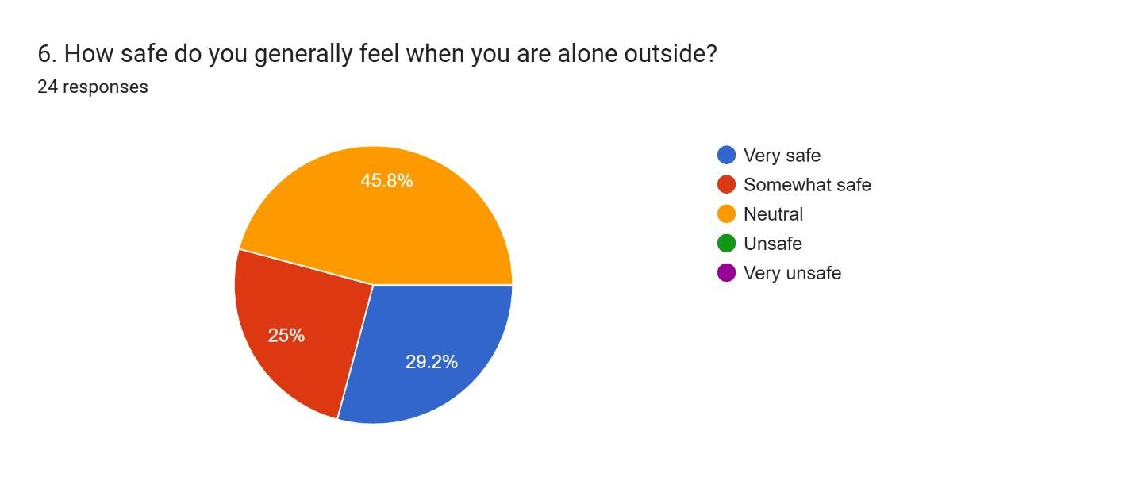
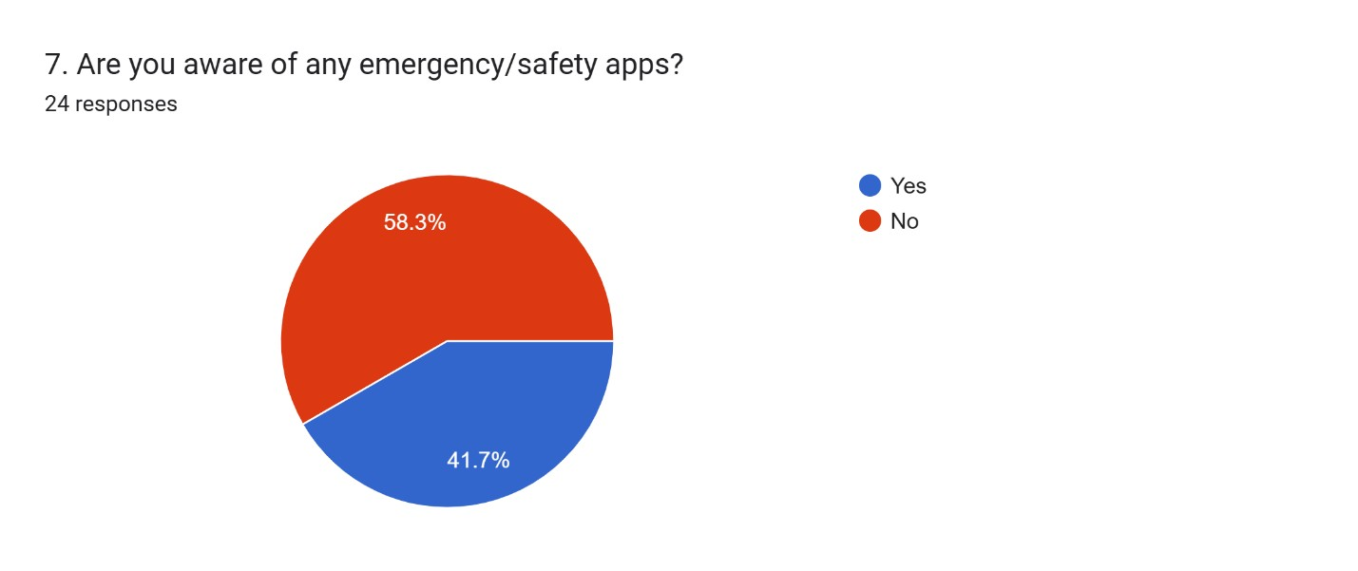
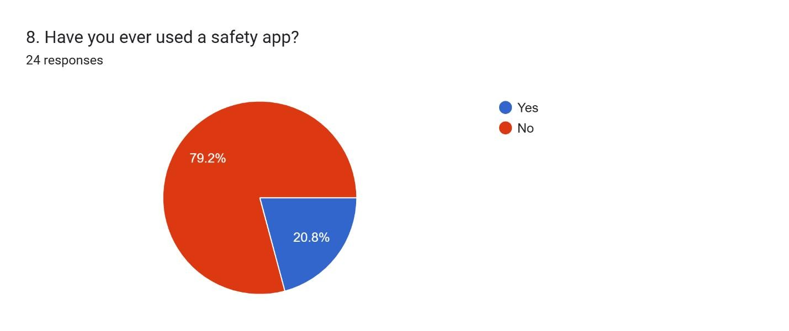
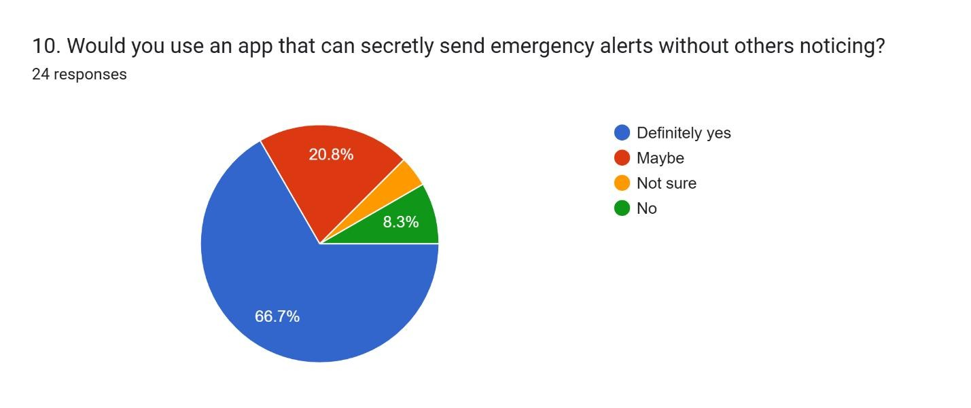
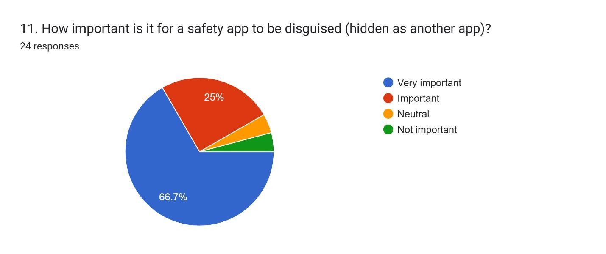
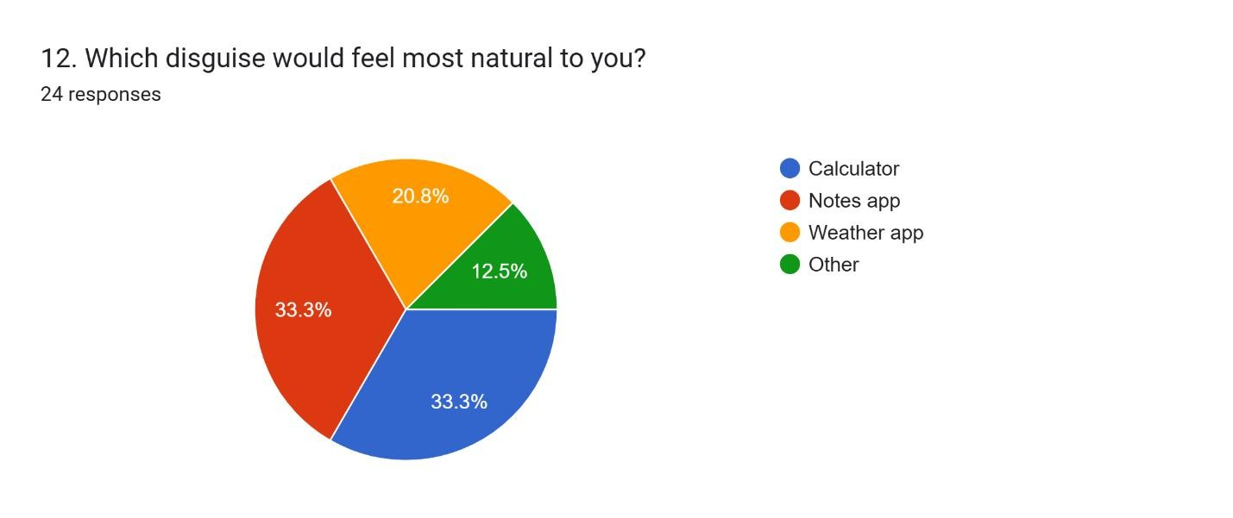
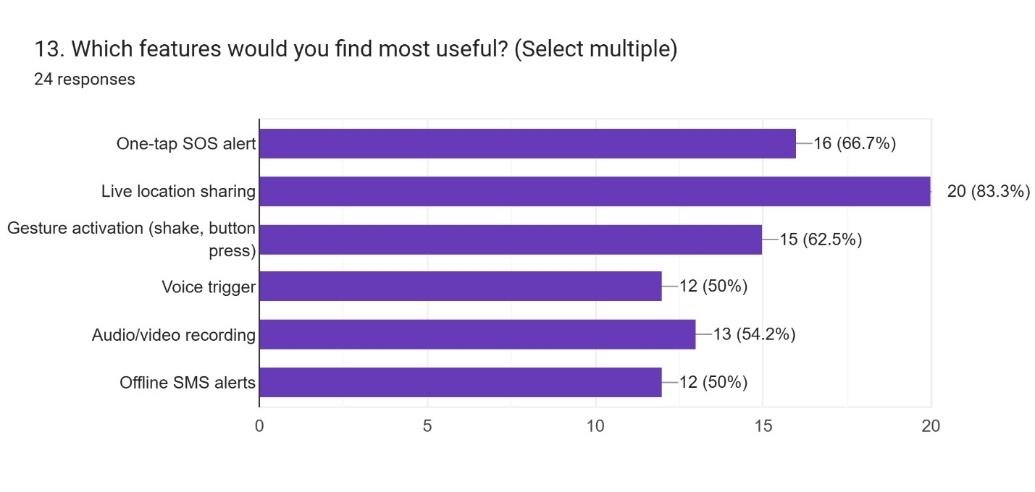
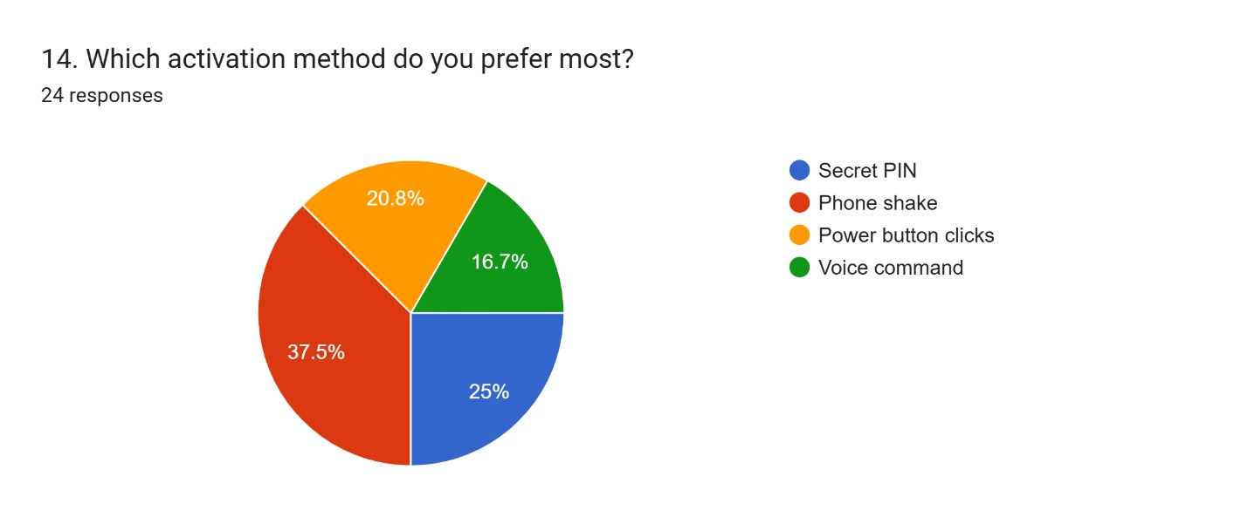
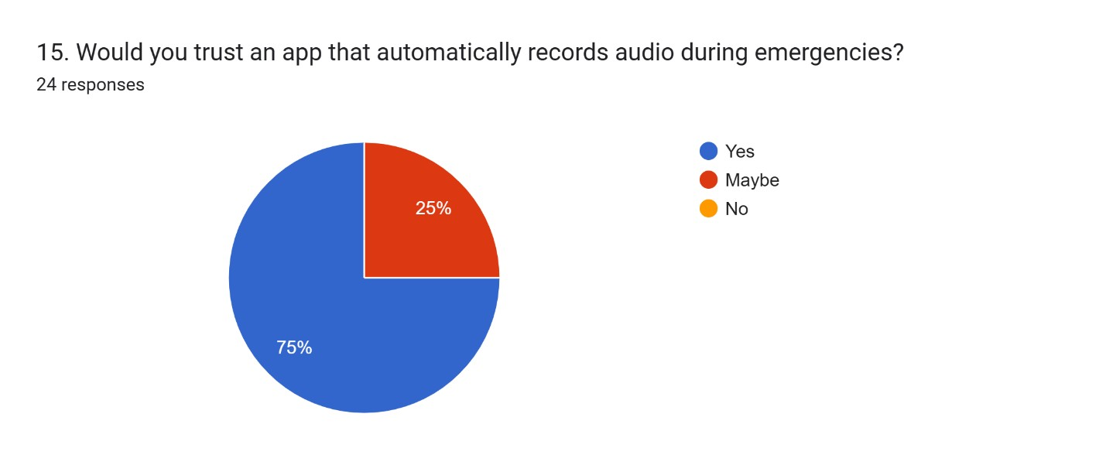
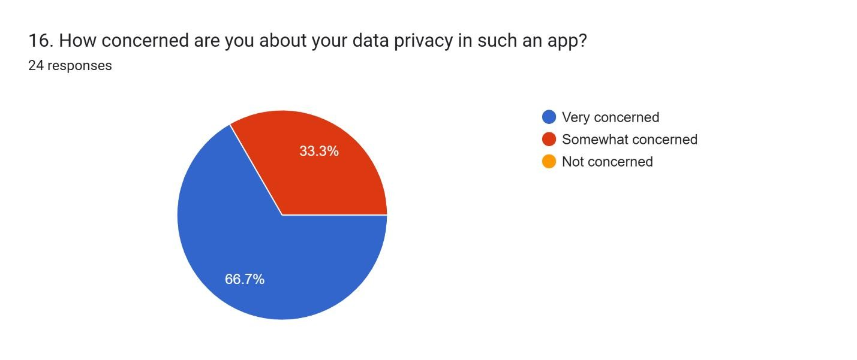
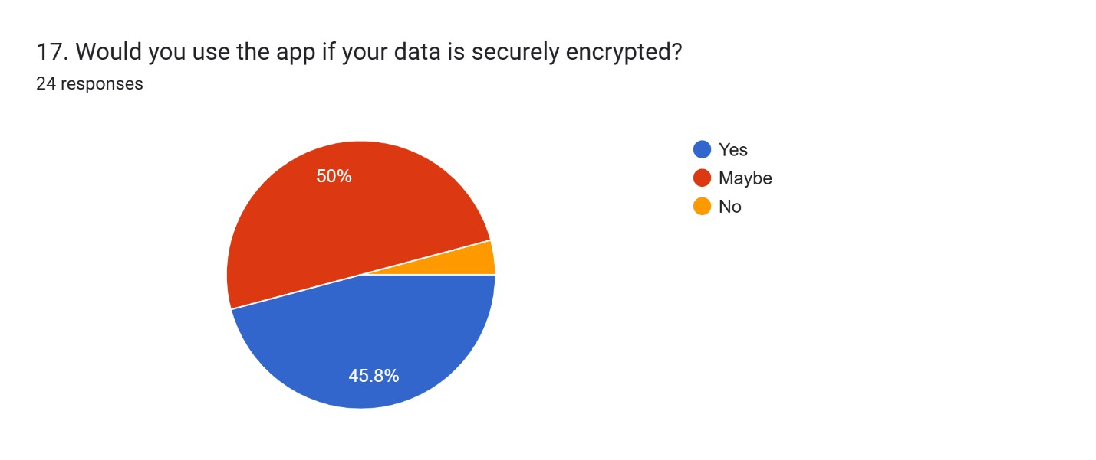
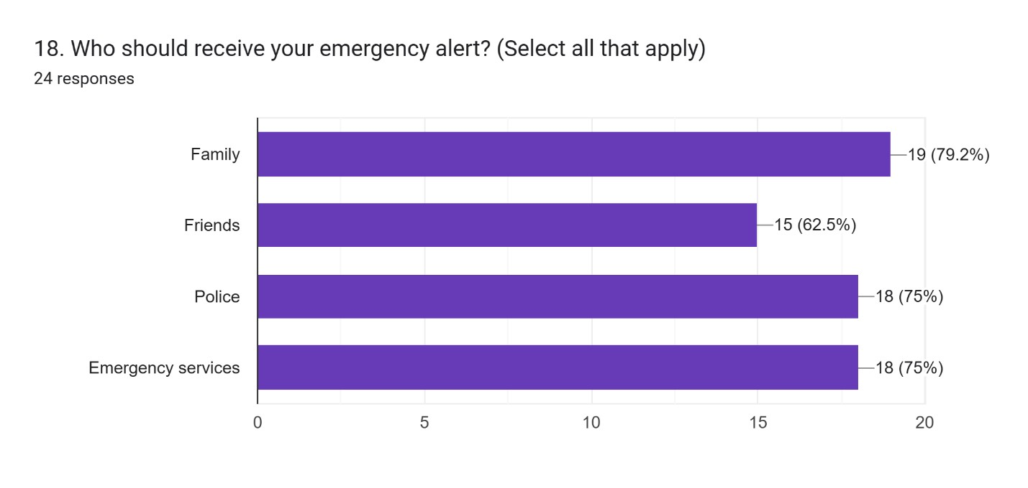
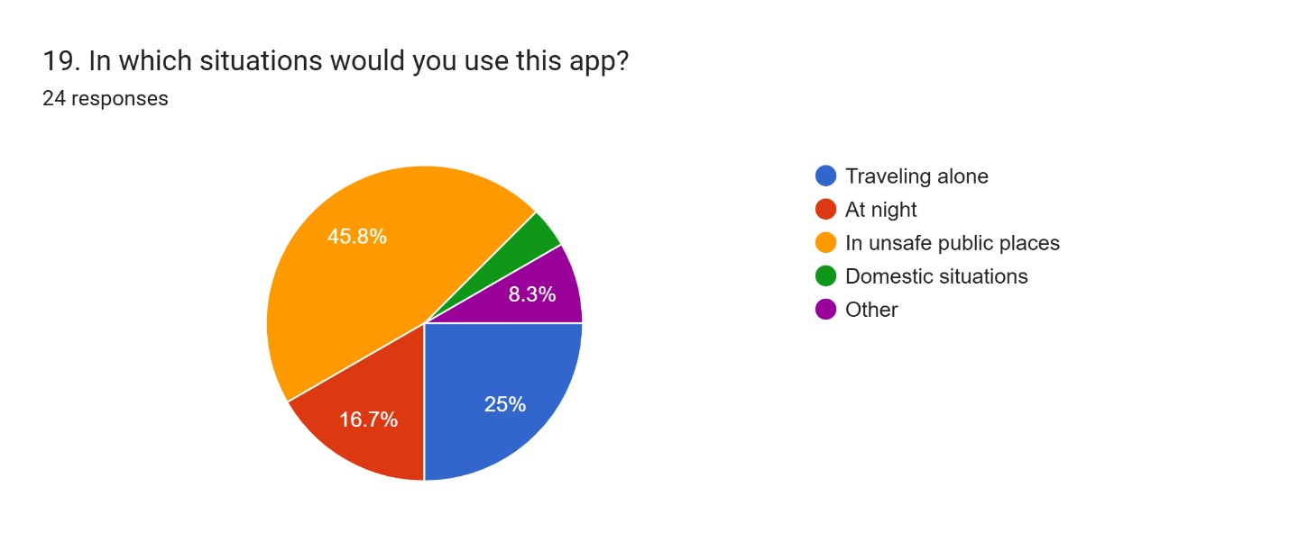
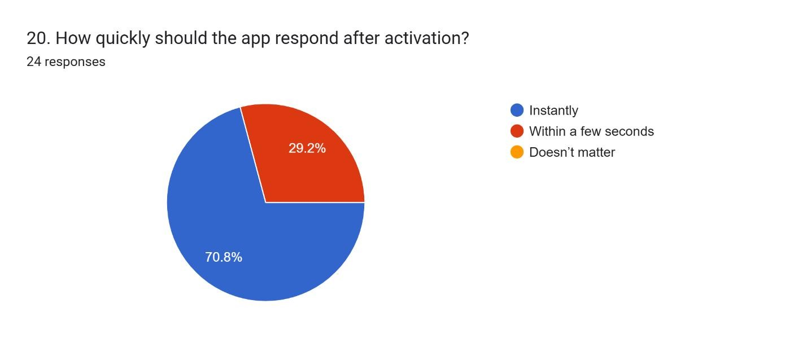

Weekly reports (Scanned Weekly reports)
